Use the Following Chart to Answer Questions 1-5
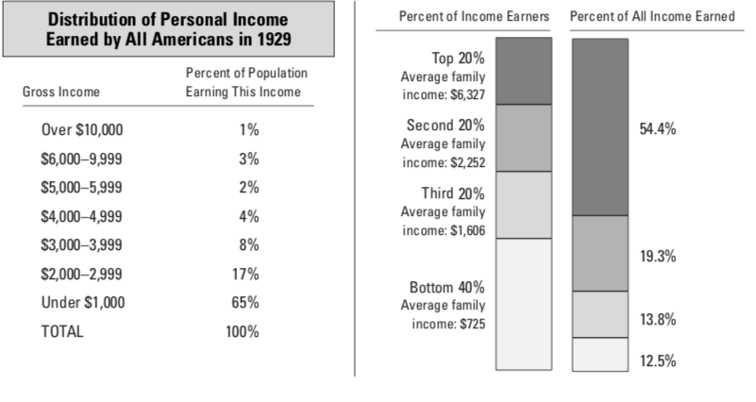
- What percent of the population in 1929 had a gross income between $3,000 and $3,999?
a. 4 percent b. 8 percent c. 12 percent d. 17 percent
- Which group of income earners had an average income of $6,327?
a. top 20 percent b. second 20 percent
c. third 20 percent d. bottom 40 percent
- The top 20 percent of the population earned 54.4 percent of all income earned in 1929. What percent did the bottom 40 percent earn?
a. 12.5 percent b. 13.8 percent c. 19.3 percent d. 26.3 percent
- In 1929, how much more did the average family in the top 20 percent earn than the average family in the bottom 40 percent?
a. $725 b. $881 c. $1527 d. $5602
- What percent of all income was earned by the third 20 percent of income earners?
a. 12.5 percent b. 13.8 percent c. 19.3 percent d. 54.4 percent
Use the following Chart to Answer Questions 6-
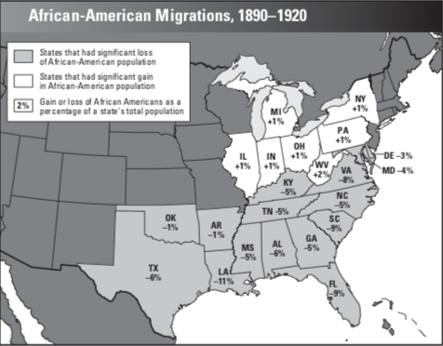
- By what percent did the population of African Americans in Louisiana change between 1890 and 1920?
a. –11% c. 0%
b. –7% d. +11%

- By what percent did the African-American population change in New York?
a. –3% c. –1%
b. +1% d. +3%

- What did Tennessee, Kentucky, and North Carolina have in common during the period represented on the map?

a. All were northern states.
b. All experienced a decrease in percentage of African-American population.
c. All experienced an increase in percentage of African-American population.
d. The percentage of African-American population remained the same in all.

- Which state had the largest percent increase in its African-American population?
a. Louisiana b. West Virginia c. Florida d. Indiana

- What trend does this map illustrate?
a. The movement of African Americans to the North
b. The movement of African Americans to the South
c. The discrimination faced by African Americans in the South
d. The immediate effects of the abolition of slavery

- The Harlem Renaissance refers to
a. a struggle for civil rights led by the NAACP.
b. a population increase in Harlem in the 1920s.
c. a program to promote African-American owned businesses.
d. a celebration of African-American culture in literature and art.

- Charles Lindbergh was famous as a(n)
a. politician. b. inventor. c. composer. d. pilot.

- What music is typically attributed to this time period and to members of the Harlem Renaissance?
A. polka B. jazz C. rap D. classical
- What was the Harlem Renaissance?
A. the government rebuilding certain sections of New York City in time for World’s Expo B. when Josephine Baker was banned from performing her banana dance in public areas
C. African-Americans working side by side with their white counterparts to create art D. flowering of African-American literature and art in the 1920s, mainly New York City
- Which gangster, or organized crime boss, was responsible for the St. Valentine’s Day Massacre of seven men and who was only later arrested for tax evasion?
A. John Dillinger B. Paul Giotta
C. Al Capone D. Donald Rumsfeld
- What was the making of illegal alcohol called for the most part?
A. Amazing Alcohol B. Bathtub Gin
C. Cotton Mouth D. Dandelion Wine
- What was a “speakeasy”?
A. the slang used by young people B. secret bars serving alcohol
C. a new method to learn English D. Al Capone’s automatic weapon
- What allowed organized crime to become so very well established?
A. the Teapot Dome Scandal B. the Red Scare
C. Flappers D. Prohibition
- What was the 21st Amendment to the Constitution?
A. No one in the US could buy, sell or transport alcohol B. it was the act used to try to enforce Prohibition
C. no one could challenge anti-morality laws
D. it repealed or took away Prohibition
- What was “Prohibition”?
A. no one in the US could buy, sell or transport alcohol
B. women were not allowed to wear skimpy bathing suits
C. women were not allowed to vote in political elections
D. men were forbidden to travel to Communist countries

- Who was Charles Lindbergh?
A. an Olympic athlete
B. a home run king
C. assembly line inventor
D. nonstop NYC to Paris pilot
- Which of the following was NOT a famous jazz musician of the 1920s?
A. Duke Ellington
B. Louis Armstrong
C. Lil Pump
D. Billie Holiday

- The Ku Klux Klan was at its peak during the 1920s,
who is NOT a group that they targeted with their hatred?
- Divorced people
- African-Americans
- Catholics of any color
- White factory workers
- Jews and immigrants

- Flappers, as a group, were known for all of the following activities EXCEPT ONE
- Smoking
- Drinking
- studying at college
- wanting independence
- bobbing or cutting their hair short
- What nationality were Sacco and Vanzetti?
A. Russian B. Serbian C. Italian D. French
- Sacco and Vanzetti were two men whose execution demonstrated that
- The United States was fearful of foreigners
- the Supreme Court was fair and thorough
- the United States welcomed honest immigrants
- the Justice System is always appropriate to the situation
- “The Red Scare” was a movement that showed how much our nation feared the possibility of peasants overthrowing our government and establishing
A. Anarchism B. Idealism C. Communism D. Zionism

- What happened on October 29, 1929?
A. WWI ended.
B. The Stock Market Crashed
C. Racial Riots Began in Harlem
D. It was the first Halloween.
- The act that limited the amount of Immigrants to the United States was known as the what?
- The Quota Act
- The Emigrant Act
- The Hindenbergh Accord
- All of the Above

- What depression hit in 1921 that affected many farmers living in the South?
A. The Farmer Depression
B. The Farmers Association of USA Depression
C. The Chinese Quota Depression
D. The Agricultural Depression
- Who was Marcus Garvey?
- the man who ate the most goldfish
- a famous barber who bobbed women’s hair
- the man responsible for the Teapot Dome Scandal
- a grand wizard of the Ku Klux Klan
- spoke for African-American pride
32. Who was Amelia Earhart?
A. the first woman to fly solo in an airplane
B. the first woman to swim across the English Channel
C. the first woman to run a marathon competitively
D. the first woman to run for political office

33. What were women protesting for in the 1920’s?

A. The Right to Marriage
B. The Right to Vote

34. A major change in the film industry in the 1920’s was the introduction of …
A. Talking in Films, known as ‘Talkies’
B. Cartoons
C. Colour
D. The Boll Weevil

35. Paying for an appliance in the 1920’s was made easy thanks to these type of monthly payments known as ?
a. Instalment Buying
b. Monthly Buying
c. Instalment Credentials
d. Tin Cups

- One way the Ku Klux Klan terrorized African Americans was by
- taking them into fields and lynching them.
- writing racist letters to the government.
- working them to death without pay.
- having them thrown out of the country.
- The Red Scare of the 1920’s was fuelled by the fear that
    - Another war would start.
    - Communist ideas might spread in the United States
    - Italian immigrants might start illegal businesses
    - Worker’s strike might take a violent turn.
38. Some American writers of the 1920s called the "Lost Generation" because they
- returned to Paris where most of them were originally from.
- appreciated the Jazz Age and its rebellious youth culture.
- expressed the pain of racism experienced by African Americans.
“I, too, sing America
I am the darker brother.
They send me to eat in the kitchen When company comes,
But I laugh,
And eat well,
And grow strong.
Tomorrow,
I’ll be at the table When company comes. Nobody’ll dare
Say to me, ‘Eat in the kitchen,’ Then.”
- What is the main theme of these lines?
- African American pride and faith in the American Dream
- Integrated dining practices of the 1920s
- The Lost Generation and its relation to society
- The loss of morality in the Jazz Age.

- The Roaring Twenties were called that for all of the following reasons EXCEPT ONE
a. people were trying to overcome the horror of World War I
b. there were so many new inventions and accessibility to cars
c. people smoked, drank, rebelled against the previous generation
s. there was a pending economic depression headed toward them

41. Sacco and Vanzetti were two men whose execution demonstrated that
  - the United States was fearful of foreigners
  - the Supreme Court was fair and thorough
  - the United States welcomed honest immigrants
  - the Justice System is always appropriate to the situation

    - Flappers, as a group, were known for all of the following activities EXCEPT ONE
a. smoking
b. drinking
c. studying at college
d. wanting independence
e. bobbing or cutting their hair short
True or False
    - After WWI the U.S. economy suffered a downturn that led to hard times in the 1920’s
  - True
  - False

- The 18th Amendment put an end to the prohibition era
  - True
  - False

- Trumpeter, Louis Armstrong, invented the Jazz Solo, when one musician steps out from the band to play alone.
  - True
  - False

- The 1920’s are known as the Jazz Age
  - True
  - False

