TOPOGRAPHIC MAPPING

Name:_________

Block: ________

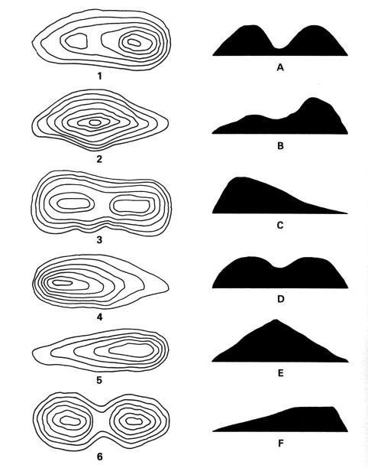
1. _______
2. _______
3. _______
4. _______
5. _______
6. _______

Part 1
Try matching the contour line images (On the Left) with the Horizontal Image on the Right the

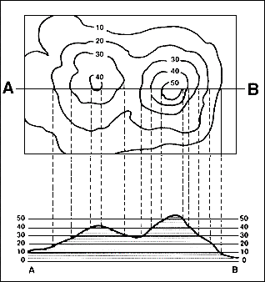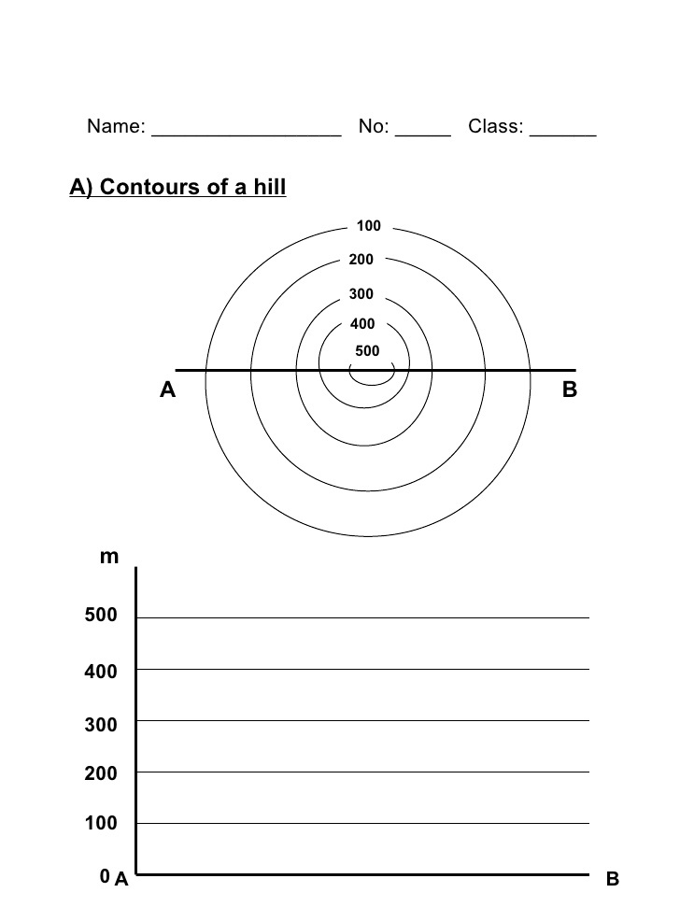
Cross-Section Profile

- Draw a line between two points. (Example: A to B)
- Using a piece of a paper, place your paper between the two points.
- Mark each point that crosses your line. Write down the ELEVATION of each point.
- If your line crosses a river, building, or bridge mark the points it crosses and write down what the object is.
- Once you’ve done that, create a graph (X and Y/Horizontal Line and Vertical Line)
6) Plot your graph points.

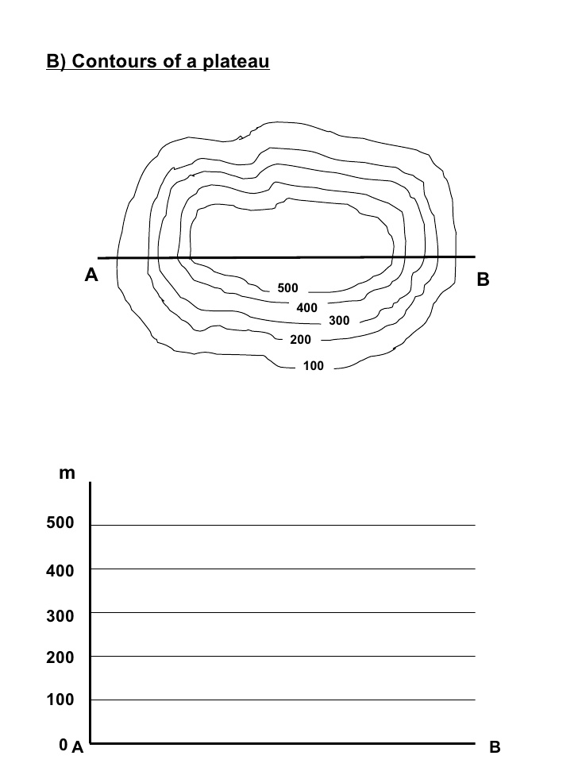

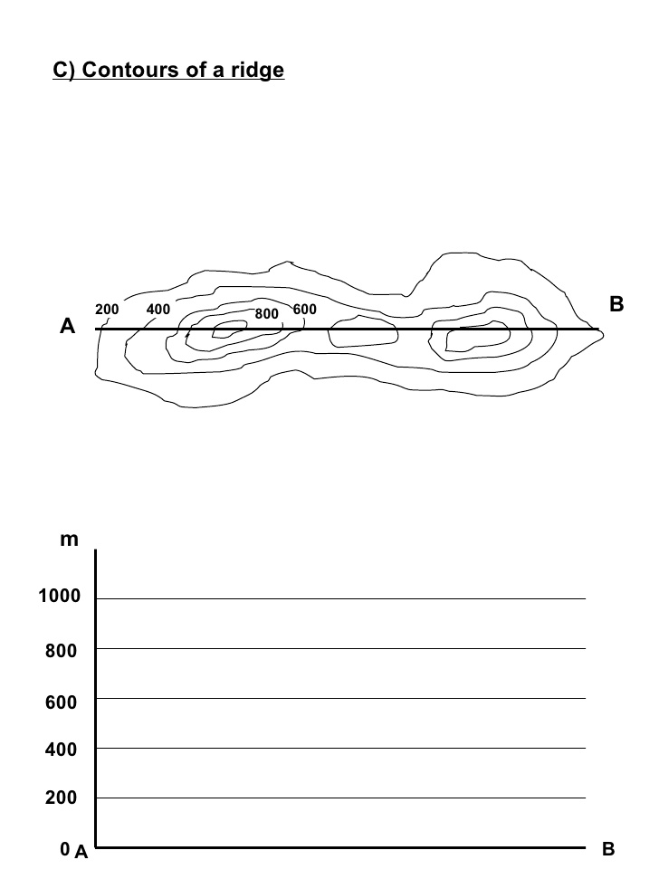

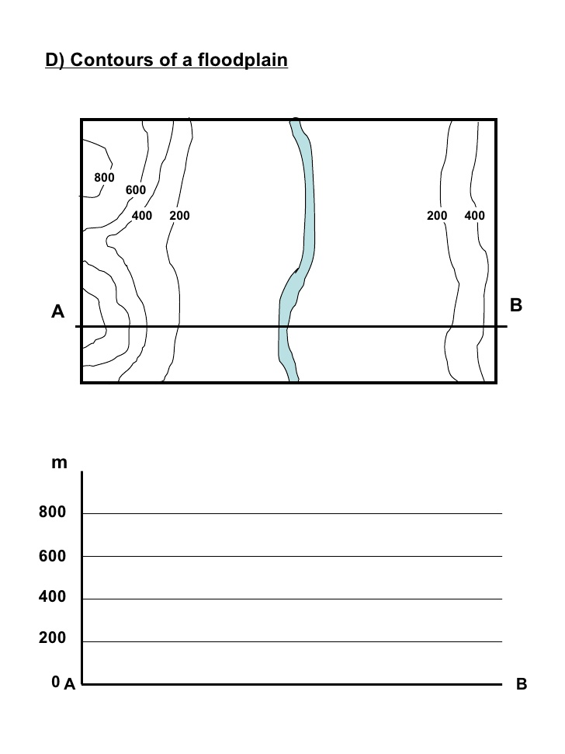

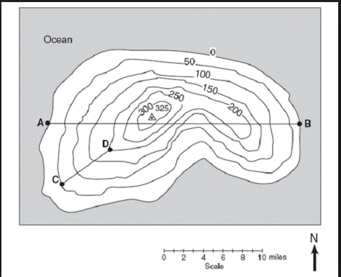
- What is the distance between
  - Point A to Point B
  - Point C to Point D
- What is the elevation gain between
  - Point C to Point D

3) Draw a Contour profile from point A to B.
Contour Lines Mastery

I want

