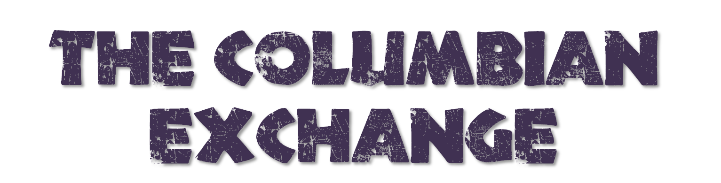
What is it?
Summarize the Columbian Exchange in your own words….

Food, Goods, Ideas, and Animals Before the Columbian Exchange
The New World The Old World
