UNIT I:
The roaring twenties

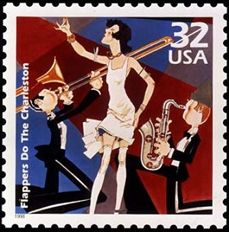

Name: ______________ Block: _______

1920’s VOCABULARY

1. Return (Back) to Normalcy - President Harding’s idea for the US to return to life as it had been before World War I.

2. Prohibition – 1920 – 1933 – alcohol was illegal

3. 18th amendment – banned the sale, manufacture, and transportation of alcohol

4. 21st amendment – ended prohibition

5. Anarchist - person against organized government

6. Communist – people who want government ownership of all property.

7. Red Scare - period during the 1920’s where people feared communism; communists and anarchists were arrested and foreigners were deported

8. Nativism - wanting to preserve America for native-born white Americans and limit immigration.

9. Quota Act – limited immigration. This law discriminated against people in Southern and Eastern Europe by limiting immigration from these countries more than Northern and Western Europe.

10. Harlem Renaissance - rebirth of African American culture in Harlem; African American musicians, artists, and writers settled in Harlem.

11. Installment buying - buying on credit. You could buy a product for a small down payment, take it home and then make monthly payments with interest.

12. Prosperity - state of growth, with rising profits and full employment.

13. Boom – a time of great economic activity and growth.

14. Bull market - when the stock market is doing well; the steady rise in stock prices.

15. Bear Market – when the stock market is NOT doing well; the steady decrease in stock prices.

16. Buying on margin (credit) - buy a stock for a 10% down payment from a broker.

17. Stock market crash - a sudden and steep drop in the price of stocks, eventually becoming worthless.

Read the following introduction to the Roaring 20’s:
The “Roaring Twenties” was a decade in which nothing big happened—there were no major catastrophes or large events—at least until the stock market crash of 1929—yet it is one of the most significant decades in U.S. history because of the great changes that came about in American society. The Twenties were known by various images and names: the Jazz Age, the age of the Lost Generation, flaming youth, flappers, radio and movies, bathtub gin, the speakeasy, organized crime, confession magazines, Hemingway and Fitzgerald, Charles Lindbergh, Babe Ruth, Bobby Jones, the Great Crash, Sacco and Vanzetti, Al Smith, cosmetics, Freud, the “new” woman, the Harlem Renaissance, consumerism—all these images and more are part of the fabulous Twenties!
The 1920s provided something of a roller coaster ride for the American people. The euphoria surrounding the end of World War I was clouded by the great flu epidemic of 1919, the Red Scare of that year, and the frustration and bitterness left over from the fight over the ratification of the Treaty of Versailles. The progress made toward reform under progressive Presidents Roosevelt and Wilson slowed to a crawl, as many Americans began to feel the need for a break from the moral intensity of the Progressive Era.
The 1920 election resulted in a Republican landslide. Harding/Coolidge received 16,152,200 popular votes and 404 electoral votes compared with Cox/Roosevelt totals of 9,147,353 popular votes and 127 electoral votes. Most memorable about the election of 1920 is that for the first time women had the right to vote.
Though the Twenties was a decade of enormous social change, myths about the era sometimes exaggerate the reality of that strange and often troubling time. While consumerism boomed and many new inventions—radios and telephones, for example—became everyday items for many Americans, it was also a time of much bitterness, conflict, and disappointment. The economic boom left many in the dust, America’s traditional openness to immigration was severely cut back, and racial tensions rose. Prohibition, the “noble experiment,” caused ordinary citizens to resort to criminal behavior, even as government often winked and looked the other way.
Following the Great War, as the only major Western nation not devastated by that conflict, Americans felt pretty good about themselves. The continued economic growth, political conservatism, and general absence of concerns over foreign affairs led Americans to think of themselves as “having it made.” Proof of America’s spirit and achievements seemed to be personified by Charles Lindbergh as he made his historic flight from New York to Paris in 1927. But the 1920s also saw deep divisions in the country despite the “roaring” atmosphere brought about by bathtub gin, speakeasies, flappers, women voting, jazz, sports, and all the rest. Then at the end of that self-satisfied, raucous, and somewhat grumpy decade, when the expectations of many Americans knew no bounds, the stock market crashed and the Great Depression hit.
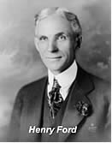
During the 1920s everybody seemed to be buying everything, and businesses set out to meet the demands of consumers, producing new products in record-breaking quantities. Cars, radios, appliances, ready-made clothes, gadgets, and other consumer products found their way into more and more American homes and garages. Americans also started buying stocks in greater numbers, providing capital to already booming companies. All the signs pointed upward, and starry-eyed men and women began to believe that it was going to be a one-way trip, possibly forever.
Henry Ford’s assembly line not only revolutionized production, it democratized the ownership of the automobile. Ford showed that handsome profits could be made on small margin and high volume. By 1925 his famous Model T sold for less than $300, a modest price by the standards of the 1920s. Americans had never had it so good. (Many, of course, would not have it so good again for a long time

The Twenties were also known as a time of revolution in manners and morals, when young men, and especially young women, threw off many of the social restrictions of the Victorian era and began conducting themselves in ways that scandalized the older generations. Young women liberated themselves in everything from hairstyles and clothing to deportment and public behavior, smoking cigarettes and drinking from flasks of illegal bootleg whiskey and bathtub gin. The ’20s were known as the jazz age and saw the rebirth of the Ku Klux Klan, divisions between town and country that went beyond mere style, the Harlem Renaissance, an enormous growth in production of items such as automobiles once seen as luxuries, and a general feeling of near euphoria, as if for the middle and wealthy classes, at least, things would just keep going up.
The Twenties were in another sense a reactionary decade—a reaction against Victorian ideas of morality that saw young men and women openly defy what their parents still viewed as proper behavior for relationships between the sexes. Young people went wild, in the eyes of some, though studies have suggested that there was more talk than action. It was also a rebellious age, in which women continued the process of breaking out of older social patterns as they had begun to do during World War I. They changed their dress styles, cut their hair short, smoked in public, and were not above taking a nip from a flask of Prohibition whiskey.

•PREDICT: Based on your reading and knowledge, what are some things you think we’ll be learning about in this unit? LIST AT LEAST THREE PREDICTIONS BELOW:

Based on the Reading: Fill in how the following changed during the 1920’s. LIST as many examples as you can find from the reading…

Automobile  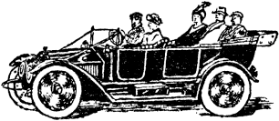 |   Women | 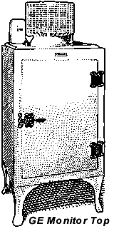  Appliances
 |  | What’s installment buying?

Background Information
During WWI
- Men were called to serve their _____________.
- Women took jobs in ______________ making war supplies to help support the war effort.
- War was ________________ business for the U.S.
- The economy ________________ due to the war.

After WWI
- After WWI, _________________ returned home from Europe and took their jobs back.
- _______________ were forced back into the home, often against their will.
- Some women kept factory jobs, which _____________________ many Americans because now some men didn’t have jobs.
  - Factories had cleaned up during the War, wages were good, 10 hour working day, safety equipment.

Farm Pains
- An Agri. depression in early 1920's contributed to this urban ___________________.
- U.S. farmers lost agri. markets in postwar ___________________
- At same time agri. efficiency ____________________ so more food produced (more food = lower prices) and fewer labourers needed
- so farming was no longer as prosperous, and bankers called in their loans (farms repossessed)
- American farmers entered the _____________________ in advance of the rest of society
- __________________ Americans in this period continued to live in poverty
- _____________________ kept them in de facto slavery
- 1915 - boll ___________________ wiped out the cotton crop
- White landowners went bankrupt & forced blacks off their land

The Roaring Twenties: AKA The Jazz Age
Politics and Prosperity in America
(The Boom before the Bust)
A return to isolationism after WWI

1920’S POWERPOINT

Answer the questions and fill in the blanks while viewing the PowerPoint presentation during class.

1. What types of changes were brought about in the 1920’s?
- ______________
- ______________
- ______________

2. What are SOCIAL changes?
- People’s ________________
- The way people __________________ with one another
- Society as a __________________

3. What is economic change?
- Changes in the production, __________________, and _________________ of goods and services

4. What is political change?
- Change in the ____________________
- The way people think about ________________________
- Change in _______________________

Now let’s look at some of the SOCIAL changes that
took place in the 1920’s

New Role for Women

- The fast-changing world of the 1920s produced new roles for women
- Many women entered the workplace as nurses, teachers, librarians, & secretaries
- However, women earned less than men and were kept out of many traditional male jobs (management) and faced discrimination

The Changing Family
- American birthrates declined for several decades before the 1920s
- During the 1920s that trend increased as birth control information became widely available
- Birth control clinics opened and the American Birth Control League was founded in 1921

Education and Popular Culture
- During the 1920s, developments in education had a powerful impact on the nation
- Enrollment in high schools quadrupled between 1914 and 1926
- Public schools met the challenge of educating millions of immigrants

MOVIES

5. How did movies change in the 1920’s?
- From silent movies to ____________________
- Let’s look at a clip of one of the silent films from that era
- Some famous silent movie stars include: Charlie Chaplin, Clara Row, and ____________________

6. What was the first “talkie”?
- The ______________________
- Pretty appropriate for the decade
- Let’s watch a little clip from this first talkie movie… Nothing like going to the movies today!
- Even Mickey Mouse started talking during this time period!
- He made his talking debut in ______________________
- Let’s watch a clip from his first talking cartoon…

MUSIC: The JAZZ AGE

7. What was the new kind of music and what was different about it?
- The ______________________
- A faster paced style
- The first original music of the United States

8. Who founded this music?
- Started by ________________________ in _______________________

9. Who were two famous musicians of the time?
- Louis ____________________
- Bessie ____________________
- Let’s listen to a couple clips from their songs

DANCE

10. What was the new dance that kept pace with the new music?
- The _______________________
- A dance that kept pace with the ______________________music
- Let’s watch a clip of the Charleston…

WOMEN AND FASHION

Define flapper: _________________________________________________________________________________________________________________________.

11. What changed about women in the 1920’s?
- The Trend: the skirts and dresses grew ______________________and sleeker, along with their hair! Short hair, short skirts and wanted to dance
- Women were nicknamed ________________________: this signified the new independence of women

13. How did these young women offend the older generation?
- She offended the older generation because she defied conventions of _______________________ (aka traditional behavior)

14. What aspects of flappers are shown in the drawing?
List them all below…
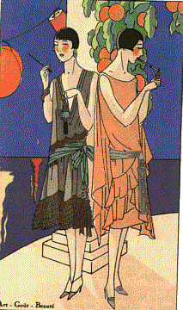

HARLEM
RENAISSANCE

- Between ________ and __________, the Great Migration saw hundreds of thousands of __________________ move north to big cities
- By 1920 over 5 million of the nation’s 12 million blacks (over _______%) lived in cities.

15. What was the Harlem Renaissance?
- Rebirth of _______________________Culture
  - Through intellect and production of ___________ art, and ___________ African-Americans could challenge racism and _____________________ to promote racial and social integration.

17. Who was a poet of the Harlem Renaissance?
- Poet ____________________Hughes
- One of his most famous poems was titled Dreams

18. What was the message of his poem Dreams?

Dreams
By Langston Hughs

Hold fast to dreams
For if dreams die
Life is a broken-winged bird
That cannot fly.
Hold fast to dreams
For when dreams go
Life is a barren field
Frozen with snow

Message? (Answer Below)

19. Who was an artist of the Harlem Renaissance?
- The artist Williams H. _____________________
- Johnson painted thousands of pictures, many of which are now on display in the ______________________in Washington DC

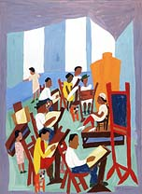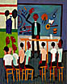

21. Who was a famous singer of the Harlem Renaissance?
- Singer: ______________________ Holiday
- Yes she was a girl….

- Let’s listen to her sing one of her most famous songs: Strange Fruit
STRANGE FRUIT
Southern trees bear a strange fruit
Blood on the leaves
Blood at the root
Black bodies swinging in the southern breeze
Strange fruit hanging from the poplar trees
Pastoral scene of the gallant South
The bulging eyes and the twisted mouth
The scent of magnolia sweet and fresh
Then the sudden smell of burning flesh
Here is a fruit for the crows to pluck
For the rain to gather
For the wind to suck
For the sun to rot
For the tree to drop
Here is a strange and bitter crop
Lyrics by: Lewis Anderson
Originally sung by: Billie Holiday
22. What is she referring to as “strange fruit” in the song?

THE GOLDEN
AGE OF SPORTS

23. Who were some of the sports greats in the 1920’s and their sports?
- BASEBALL: ________________ 60 home runs in 1927, played most of his career for the New York Yankees
- GOLF: _________________, Started “The Masters”, competition that still exists today for golf
- TENNIS: ____________________________
- COLLEGE FOOTBALL: ________________, the “galloping ghost”, _________ Rockne,
- SWIMMING: _________________________, swims the English channel in 1927,

RADIO

24. When was the first radio broadcast?
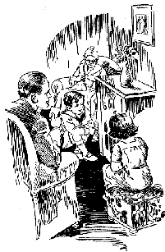
- The first radio station was KDKA Broadcast and it had its first broadcast on November 20, ____________

25. Why was the radio important?
- Radio provided for the whole __________________
- Entertainment, _________________ and ____________

FADS: 1920’s
The Wonderful Age of Nonsense

Define fad: ______________________________________________________________________________________________________________________________________________

26. What were some of the new fads of the 1920’s?
- Marathon Dancing: _____________________ the last couple standing wins! These could usually last for _________________!
- Flagpole _____________ Record: Shipwreck Kelly, _______________ sat for almost 13 hours!!

Literature

Famous authors from this time period include:
- Ernest __________________: A passionate young author who used history and experience to write his books, including A Farwell to Arms (about WWI), The Old Man and the Sea
- F.Scott __________________: A young author who best captured the mood of the Roaring Twenties, including The Great Gatsby, The Curious Case of Benjamin Button

POLITICAL CHANGES
IN THE 1920’S

WOMEN’S RIGHTS

Protests: In front of the White House.
Alice Paul: led protests outside the White House, arrested for ________________ ______, increased people’s ________________ of women’s rights

27. What was the 19th Amendment?
- “The right of the citizens of the United States to vote shall not be denied or abridged by the United States or by any state on the account of _______”
- Women are now guaranteed the RIGHT TO VOTE!!!

PROHIBITION

- _______________ had long believed alcohol led to crime, child & wife abuse, and accidents
- Supporters were largely from the rural south and west
- The church affiliated Anti-Saloon League and the Women’s Christian Temperance Union helped push the 18th amendment through

28. What was the 18th Amendment?
- “The manufacture, ________________ or ________________ of intoxicating liquors within the United States…is hereby prohibited”
- Closing the saloons: Usually __________________
- Why not the local police?
- Because ________________ would pay off ________________ public officials, and judges to look the other way. This is why the FBI had to step in. They are a national police enforcement group out of Washington D.C.

29. What kind of illegal activities occurred during Prohibition at speakeasies?
- Raids on Speakeasies: Served illegal ________________ and provided illegal ________________
- Define Speakeasy:
- Define Bootlegging:
- Organized Crime: ________________ : Most famous gangster of the 1920’s, became rich and powerful from ________________ Was sent to jail for tax evasion because the FBI couldn’t catch him with his other illegal activities

30. What was the 21st Amendment? Signed into law in 1933
- The eighteenth article of amendment to the Constitution of the United States is hereby ________________
- This means we got rid of the prohibition law, alcohol is now legal

Anti-Foreign
Sentiment

31. What was the Red Scare?
- Fear that ________________ would take over the United States
- Immigration: The Immigration ________________ was passed into law in 1921
- This law ________________ new immigrants to 3% of the nationality already in the United States

32. How did the Red Scare affect the Sacco and Vanzetti trial?
- Two Italian immigrants accused and convicted of ________________ and sentenced to death. They both swear they did not commit a crime.
- Many believed their conviction was the result of ___anti-foreign/ nativists_____ sentiment during the 1920’s
- Problem was the men were convicted with very little evidence. This court case led to a rise in ____nativism___ (a distrust of foreigners)

The re-emergence of
The Ku Klux Klan

33. Who was the KKK against?
- The Klan in the 1920’s: membership grew to an estimated __4-5 million___
- Now this group ________________ not only against African-Americans but added ________________ and ________________ to its hate list
- Tactics: Used ________________ and violence, lynching, and ________________ crosses as a warning

Economic Change
In the 1920’s

Advertising

34. How did advertising change in the 1920’s?
- Old and new: magazines, ________________ billboards, and advertising on the radio, advertising before ________________
- Today’s advertising was born in the 1920’s. New tactics, including ________________ people!!

Automobile

35. How did the automobile affect society in the 1920’s?
- Model T built by the _________ motor company 1909-1927
- Affordable to the average American
- Cars produced: 1920: ________________ 1929: ________________
- By late 1900’s: One car for every ________________ Americans
- Promoted other industries like ________________ steel, and ________________ Created new service ________________
- ________________ had to be built
- Now we need to build gas ________________ for cars to refuel

36. What is installment buying or buying “on credit”?
- When you buy on credit you put down one ________________ and then pay the rest ________________ until the loan is paid off
- Home owners wanted all of the new ________________ and appliances that were available. If they didn’t have the cash for it, they could buy it using credit and pay it off later, with ________________
- New purchases included: the automobile, electric ________________ toaster, vacuum, ________________, radios, and ________________

Stock Market Crash
October 1929
The End of the 1920’s

37. What caused the stock market to crash?
- The stock market crashed when there was a sudden and steep drop in the price of ________________ Stockbrokers were calling in their ________________ so people were trying to make money. This caused the price of stocks to ________________ steadily and eventually become worthless.
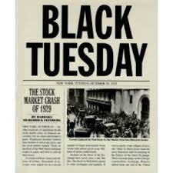
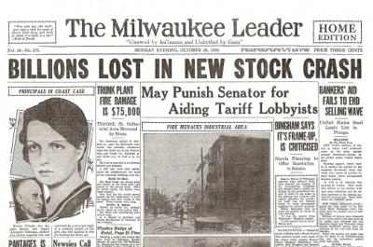

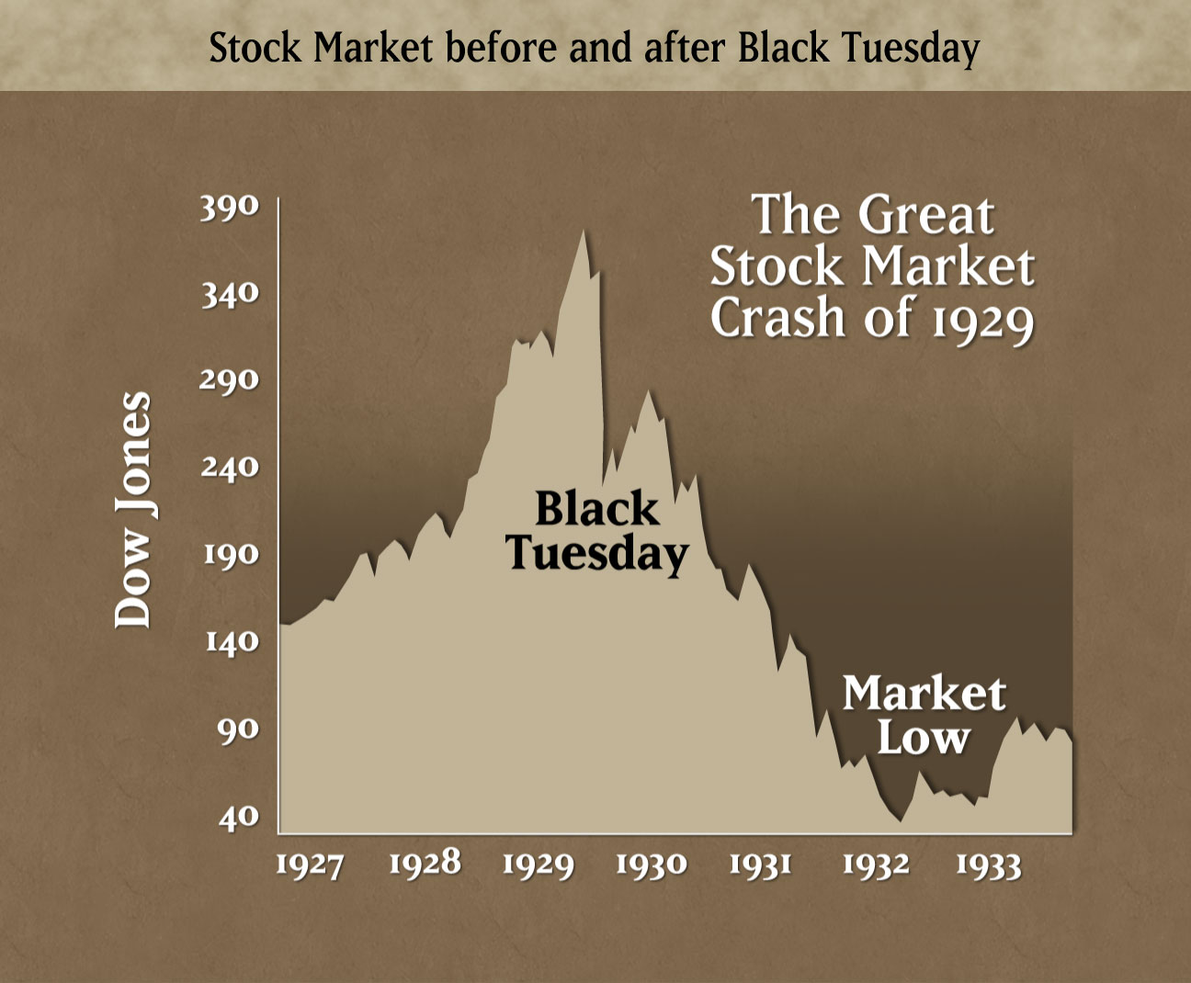

Blue Skies
Written by Irving Berlin (1926)
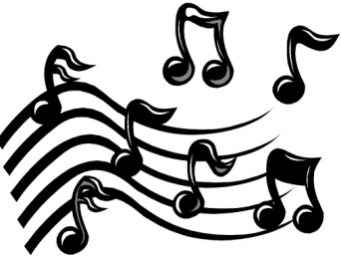
I was blue, just as blue as I could be
Ev'ry day was a cloudy day for me
Then good luck came a-knocking at my door
Skies were gray but they're not gray anymore
Blue skies
Smiling at me
Nothing but blue skies
Do I see
Bluebirds
Singing a song
Nothing but bluebirds
All day long
Never saw the sun shining so bright
Never saw things going so right
Noticing the days hurrying by
When you're in love, my how they fly
Blue days
All of them gone
Nothing but blue skies
From now on
Verse [2]
I should care if the wind blows east or west
I should fret if the worst looks like the best
I should mind if they say it can't be true
I should smile, that's exactly what I do

During the 1920’s radio and movies were popular forms of entertainment. Up until this point in history, movies had been silent, the technology for adding sound did not exist. A “talkie” was the nickname given to the first movies that had sound.

This song was one of the songs that appeared in the first full length "talkie," "The Jazz Singer" in 1927. It is also one of the most popular songs of the 1920’s and has been remade by many artists over the years.

- How do these lyrics and the mood of the music relate to what you have learned about life in the 1920’s? Give me at least 3 specific examples:

1920s candy
- 1920 - Baby Ruth were made and named after President Grover Cleveland's daughter instead of the baseball player.
- 1922 - Mounds candy bar were first made
- 1923 - Milky Ways were invented and designed to taste like Malted Milk, made by the Mars family.
- 1923 - Reeses cups are made, which are now still known as one of the top selling candies.
- 1924 - Bit-o-honey were made for the first time
- 1925 - Mr. Goodbar were created and are known for the combination of creamy milk chocolate and crunchy peanuts
- 1926 - Milk Duds were formulated, the original idea for the milk duds were for them to be perfectly round, finding that wouldn’t work, the word "dud" was used.
- 1927 - Raisinets were invented
- 1928 - Heath Bars were made for the first time
- 1929 - Twizzlers company is established and creates the gummy
- Late 1920s - Butterfingers were made, and were the second top selling candy at that time. They were made by the same company that made Baby Ruth bars.
- 1930 - Snickers were designed and were named after the family’s horse.
- Lifesavers – 1912 named after the floatation device, created as a summer candy alternative to chocolate which would melt. The 5 flavor roll came out in 1935

Jazz Age Glossary:

The 1920’s were an extraordinary few years for language in America. Dozens of new words and expressions were created for this roaring decade. Many will sound familiar to you today!

Belly laugh: a loud, uninhibited laugh
Big cheese: an important person
Bunk: nonsense
Cat’s meow: anything wonderful
Cheaters: nickname for eyeglasses
Crush: an infatuation or liking of another person
Fall guy: someone who takes the blame even when they haven’t done anything
Flapper: young girl in the 1920’s
Gatecrasher: a person who attends a party and wasn’t invited
Jalopy: old car
Kiddo: a familiar form of addressing someone you know
Pushover: a person or thing easily overcome
Scram: telling someone to leave or go away
Swell: when something is nice or marvelous

