History of Knights
Like most periods in history, the era of knights evolved gradually. The term "knight" originates from the Anglo-Saxon name for a boy: "cniht". Indeed, most early knights were not much more than hired "boys" who performed military service and took oaths of loyalty to any well-to-do nobleman or warlord offering the most promise of money or war booty.
In the chaos and danger of post-Roman Western Europe, the population had very little organized governmental protection from brigands and conquering warbands. Knowing there was safety in numbers, local lords (who could afford it) gathered around them young, fighting-age men to fend off rebellious vassals or conquering neighbors. These men, in turn, were rewarded with war booty for their service and loyalty. Soon, grants of land were made so the young soldiers could receive an income from those lands and afford the high cost of outfitting themselves with the accoutrements of war, such as horses, armor, and weapons. The era of the medieval knight had begun.
It wasn't long before some knights began to treat their land grants as hereditary rights (usually transferring ownership to the eldest son upon death), thus beginning the rise of knights as a "landed" class whose importance went beyond simply being a military "free-agent". Knights soon found themselves involved in local politics, the dispensation of justice, and numerous other required tasks for their sovereign, or liege lord.
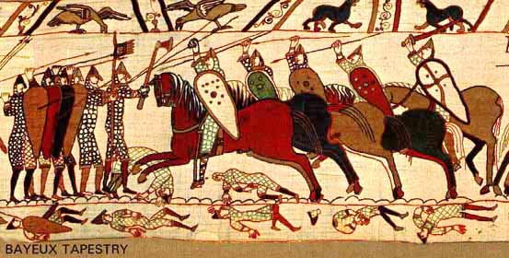
Early medieval Norman knights charging English foot-soldiers at the Battle of Hastings (1066 C.E.) from the Bayeux Tapestry
The knight's effectiveness depended greatly on his ability to stay mounted on his horse during combat. With the advent of the stirrup during the 8th and 9th centuries, a man could brace himself on horseback as he charged the ranks of his enemy, transferring the power of man and charging horse onto his opponent. This "shock" combat by mounted men armed with a spear or couched lance, and protected with armor, proved a powerful military innovation.

Medieval Armor:
Armor of a Knight
Protecting oneself in battle has always been a concern for any soldier, and medieval knights were no exception. In fact, it was their protective armor that helped define them as a military unit and social class. Armoring one's self during the Middle Ages was a great expense that only the wealthy could afford.
Among the earliest metallic armor to be worn by medieval knights was chainmail armor, consisting of tens of thousands of interlocking rings woven painstakingly by hand to form a shirt, coif, or leggings. Because of the mild steel produced in medieval times each ring had to be riveted to keep all the rings from spreading and opening under the weight of the piece. Underneath the metal armor the knight would wear a padded garment known variously as an "aketon," or "gambeson." To this defensive equipment he added a shield, usually made of leather-covered wood, and a helmet (see Knights And Armor's Helmet Page) . As the medieval arms race progressed and new, more powerful weapons were developed (such as the longbow and crossbow), chainmail became ineffective on its own.
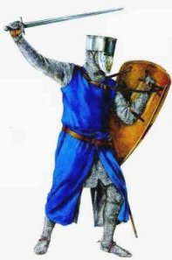  A knight in chainmail armor |   Example of chainmail armor
Late in the Middle Ages plate armor began to appear (ca. late 13th/early 14th century), first as reinforcements to vital areas such as the chest and shoulders, and finally as a complete suit (ca. early 15th century). The medieval "knight in shining armor" that most people think of is the fully plate-armored knight. Chainmail armor was now relegated to protecting smaller vital areas that could not be covered with plate armor, such as the groin and under the arms. The shield became smaller, or disappeared altogether as it became unnecessary and redundant.

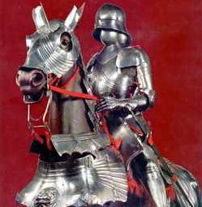
A fully plate-armored knight
Ironically, it was soon after the development of the full suit of plate armor that the medieval knight's advantage in battle began to wane. With the effective use of gunpowder weapons (ca. 15th/16th century) the face of combat changed. The cumbersome armor of a knight proved ineffective and impractical against new weapons and tactics. The knight and his plate armor were now relegated to ceremonial duties and displays. These "ceremonial" suits of armor are usually very ornate, featuring extensive fluting, intricate engravings, and other decorative features more at home in the world of fashion than battlefield utility.
Weapons of a Knight
The sword was a standard fighting weapon long before the evolution of the medieval knight. Nevertheless, the medieval knight found the sword to be an effective weapon. Medieval swords usually were made from a mild steel (low carbon steel). Most swords were double-edged, and featured a crossguard, hilt, and pommel. Many surviving examples of medieval swords feature some form of engraving, such as a prayer, or the sword owner's name. How elaborate the sword was decorated depended upon its owner's wealth, with some of the more intricate ones encrusted with jewels and fine engravings.
Apart from the sword another standard weapon of a knight was the lance. Lances were usually made of wood, with metal tips. In the early Norman period lances appear to have been little more than spears. As the Middle Ages progressed, lances developed a stouter appearance, including the addition of handguards and specialized metal tips. As a weapon, the lance enabled the knight to take advantage of his superior position on horseback as it provided the length necessary to engage opponents while still mounted. After the lance became broken or dropped the knight could rely on his sword, dismounting if necessary.
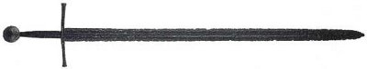
Remains of a medieval sword (ca. 1250-1350 C.E.)
Other weapons finding use in the hands of the medieval knight were the axe, mace (metal club), and war hammer. It was, however, the sword and lance that the knight more often than not depended upon as his chosen weapons.
For the knight's opponents on the ground who had to answer his advantageous longer reach, they developed assorted long-handled bladed weapons that went by many different names (pike, halberd, etc.). Archers were always a concern for the knight as they could hit targets from a distance. Many knights believed archer's methods to be cowardly, as they did not engage in hand-to-hand combat, but struck from afar. Nevertheless, archers became an integral part of medieval warfare, and were decisive factors in famous medieval battles, such as Crécy (1346) and Agincourt (1415).
The weapons of a knight still hold fascination for many people today. Weapons catalogs, Medieval and Renaissance Faires, and museums continue to draw attention to the brutal and deadly weapons of the medieval knight
Life of a Knight
Training for knighthood during medieval times usually began at an early age. Often the prospective knight was sent to live with a relative or lord who had the resources to train the young boy in use of weapons and, most importantly, the skills to handle a horse in combat. A knight-in-training would often serve as a squire (assistant) for an established knight, attending his needs, helping him don his armor, and making ready his horse and weapons.
Once his training was completed and he reached "fighting age" (usually around 16-20 years old), he would ceremoniously become a full-fledged knight. The ceremony became more elaborate as the Middle Ages progressed, until only the richest nobles or a king could afford to "knight" someone.
The new knight now served his liege lord (which may or may not be the king himself), bound to offer military service up to 40 days a year in peace time, more, as needed, in war time. Military duties included castle guard, serving in the lord's "bodyguard", and participating in battle.
Apart from military duties the knight could also participate in administering justice (as part of assizes--a medieval form of our modern juries), manage his estates (which was his prime source of income), and continue to hone his combat skills in tournament.

Alnwick Castle, Northumberland, England
The Tournament
The tournament in the early Middle Ages (ca. 800-1200 C.E.) was often a meleé, resembling actual combat in groups that could result in injuries or even death. Men were taken hostage and held for ransom, horses and armor confiscated by the captors. As kings and churchmen grew concerned over this senseless loss of life and resources new regulations and safety measures were put into effect. The meleé was replaced by individual combat events (among them the joust), and new innovations in armor specifically designed for the tournament made it somewhat safer.
Chivalry
The word, "chivalry", comes from the French word, "chevalerie", which means "skills to handle a horse". The ability to handle a horse, especially in combat, was of utmost importance to a medieval knight. As the Middle Ages progressed, the term "chivalry" began to take on new meanings.
It was around the time of the preaching of the first crusade (1095 C.E.) that the Christianization of knights began in earnest. With the crusades as a "holy war" the pope needed the support of the nobles and knights of Europe to help him with his agenda of ridding Jerusalem of Islam, and returning the "land of Christ" to Christian sovereignty. By bestowing the title of Christian warriors to the knights, the pope had begun the evolution of a code of conduct that all knights were supposed to follow.
The protection of the poor, women and children, and defense of the church were just some of the chivalry codes that a knight was supposed to always obey. In combat when nobles and knights were taken prisoner, their lives were spared and were often held for ransom in somewhat comfortable surroundings. This same code of conduct did not apply to non-knights (archers, peasants, foot-soldiers, etc.), who were often slaughtered after capture.
However well intended this "chivalric code" was, it rarely affected most knights, who plundered, slaughtered, and looted often when given the chance. Our modern notion of knights is very much based in the ideas of chivalry, and it is the survival of medieval romantic writings that tend to show knights as the chivalrous ideal, that sways our view of medieval knighthood.
Heraldry
Heraldry (symbols identifiable with individuals or families) originated as a way to identify knights in battle or in tournaments. With the advent of the "great" or "barrel" helm (ca. early 13th century) an individual's face became concealed. It therefore became necessary to create a method to distinguish ally from enemy.
Heraldic symbols ranged from simple geometric shapes such as chevrons, to more elaborate drawings of real or mythological animals. As with the honor of becoming a knight, heraldic insignia became hereditary, being passed on from father to son, or with the family name. Eventually heraldic symbols also came to signify kingdoms, duchies, or provinces as a medieval forerunner to our modern national flags.
Heraldic symbols were often worn on the knight's surcoat (thus the term "coat of arms"), shield, helmet, or on a banner (standard) that could serve as a rallying point for knights and others scattered in the chaos of battle. The standard was always to be elevated as long as the battle continued, and therefore was guarded well. A standard taken down would signal the allied combatants that the cause was lost and it was time to flee the field of combat.
Today heraldry is usually associated with individual families' coat of arms. Researching heraldry has become a hobby for many people. The art and science of heraldry, with its medieval beginnings, is still alive and well in our modern world.


