Unit III:
Genocide
Rwanda

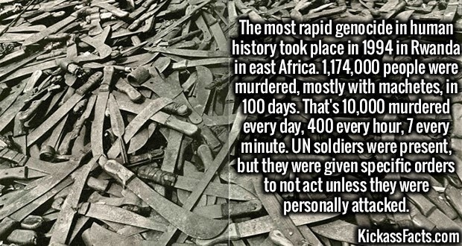

Name: _________________

The Rwandan Genocide: A Civil War Between the Hutus and the Tutsis

Genocide

Between ___________ and ___________ of ___________, an estimated ___________ Rwandans, from the group known as ___________, were ___________ in the span of ___________ days.

Who were the Hutus and the Tutsis

- The ___________ and ___________ are two groups of people that settled in present day ___________ close to two-thousand years ago.
- Some ___________ believe the Tutsis migrated from present day ___________.
- Over time they worked ___________ and ___________.
- They developed a single language (___________) and one set of religious and philosophical beliefs.
- Long ago, ___________ and ___________ were one nation. The Hutu and Tutsi lived here.

Working Together

- The Hutus and Tutsis were ___________ and raised ___________.
- With fertile soil and regular ___________, the region where the Hutus and Tutsis lived eventually became the most ___________ populated ___________ on the entire African ___________.

A Division Begins

- In the 18th century, when Rwanda ___________ as a ___________ and populous ___________, its rulers began to measure their ___________ in the number of their ___________.
- The ___________ were “___________ in ___________”. They were the elite and ruling class.
- On the other hand, the ___________ had ___________ ___________ and less power.

Hutus vs. Tutsis

- The ___________ were the ___________ – around ___________ %. But they were considered commoners.
- The ___________ were the ___________ – around ___________. But they were considered the elite, ruling class because of their ___________ ___________, large number of ___________, and large number of ___________.

Marriage

- Although there were some families that intermarried, most ___________ married Hutus and most ___________ married Tutsis.
- This ___________ ___________ and the way Hutus and Tutsis began to ___________.

Physical Appearance

- Because the Hutus and Tutsis did not usually intermarry, their offspring began to develop similarities in their features.
- The Tutsis were often very ___________, ___________, with narrow features, and fair ___________.
- The Hutus were often ___________, ___________, with broader features, and darker ___________.

Colonization

- The ___________ were the first Europeans to ___________ Rwanda.
- They did so in the early ___________.
- The Germans ___________ to ___________ off other countries that wanted to attack ___________ (the Hutus and Tutsis). This helped to protect Rwanda and make it strong.
- After ___________, the United Nations decided that ___________ could no longer rule ___________.
- The country was now under the ___________ of the United Nations, and it was to be ___________ by ___________.

Belgium Brings Further Division

- Belgium decided to ___________ the ___________ system (that had already been put into place) to their ___________.
- The Belgians ___________ the ___________ and gave them ___________ and western-style ___________.

Why did the Belgians do this?

- The Belgians did this because they could ___________ ___________ easier this way.
- The Belgians also favored the Tutsis because they ___________ more ___________ in their ___________, ___________ features. They ___________ against the ___________ because they ___________ less ___________.

Q: How do you think the Hutus felt about this?
________________________________________________________________________________________________________________________________________________
________________________________________________________________________________________________________________________________________________
Q: How do you think the Tutsis felt about this?
________________________________________________________________________________________________________________________________________________________________________________________________________________________________________________________________________________________________

Identification Cards

- After creating laws that gave special privileges to the Tutsi, the Belgians ran into a ___________ … how could they be sure who was a Tutsi and who was a Hutu?
- Physical ___________ identified some, but not all.
- The solution: Have every ___________ ___________ ___________ and carry an ___________ ___________.

What if you had no proof?

- If you could not give proof of your ___________, the Belgians would simply ___________ your height and other features.
- If you ___________ more European, they listed you has a ___________.
- If your ___________ were shorter, darker, stronger, etc. they listed you has a ___________.

Soon the Hutus got tired of this discrimination.
Q: What do you think they did? ________________________________________________________________________________________________________________________________________________________________________________________________________________________________________________________________________________________________________________________________________________________________________

PARMEHUTU

- The Party for the Emancipation of the Hutus is formed in 1959. It is called ___________.
- Hutus ___________ against the ___________ colonial power and the Tutsi ___________.
- 150,000 Tutsis flee to ___________ (which at the time was part of Rwanda).

Belgium Leaves

- In the 1960’s Belgium ___________ from Rwanda.
- Rwanda and Burundi split into ___________ different countries.

The Hutus fight the Tutsis

- Still angry at being ___________ and ___________ against for so many years, the ___________ fight the ___________.
- Many Tutsis are ___________, and many ___________ Rwanda.

Igniting Violence

- A well-known Hutu leader, Dr. Leon ___________ appeals to the Hutus to send the Tutsis “back to Ethiopia” via the ___________.
- Other Hutus said that they needed to clean up the “___________” and kill the Tutsi “___________.”

Negotiations – Aug. 1993

- Following months of negotiations, President ___________ (a Hutu President) and the RPF (_________________________________) sign a peace accord that calls for a return of Tutsi refugees.
- 2,500 United Nations troops are deployed to ___________ to oversee the peace accord.

Will there be peace?

- Despite a peace accord, the Rwandan president stalls in creating a unified ___________ in which the power is shared.
- At the same time, training of ___________ and violence ___________.
- An extremist radio station, Radio Mille Collines, begins to warn: “it is almost time for us to cut down the tall ___________.” This was code for, “it is almost time to kill all of the ___________.”

WARNING!

- Human ___________ groups warn the international community of an impending ___________.
- In March of ___________, the human rights groups are forced to flee ___________ due to the impending ___________. Only the Red Cross stays behind.

The U.N. Leaves

- The ___________ is forced to leave for a variety of reasons, including increased ___________ in Rwanda and world tensions following a crisis that occurred in ___________.

Genocide: A Day that will Live in Infamy

- April ___________, 1994 – President Habyarimana and the president of Burundi, Cyprien Ntaryamira, are ___________ down in a ___________ and killed.
- No one knows who shot down the president’s plane. There are theories that the Hutus did this and there are theories that the Tutsis did this.
- That ___________ … the ___________ begins.

The Genocide
- The Hutu ___________, at one point 30,000 people strong, ___________ any Tutsi that came in their ___________.
- They ___________ regular Hutu ___________ to do the same.
- In some cases, Hutus were forced to kill their Tutsi ___________.

The Death Toll

- In the span of 100 ___________, an estimated 800,000 Tutsis were ___________.
- They were killed primarily with ___________, ___________, and ___________.
- 100,000 of these were ___________.

Where was the help?

- While the ___________ was going on, the world sat back and ___________.
- No ___________ or ___________ was sent by the Americans or any other country.
- The ___________ were left screaming for ___________, but no one ___________.

An End to the Genocide

- By July, the ___________ (a Tutsi organization) captured the city of ___________. The government collapsed and the RPF declared a ___________ -___________.
- As soon as it became apparent to the Hutus that the Tutsis were victorious, close to 2 million fled to ___________ (now the Republic of ___________)

A New Government

- On July 19 a new multi-ethnic government was formed, promising all ___________ a safe return to ___________.
- Pasteur ___________, a ___________, was inagurated as president, while the majority of ___________ posts were assigned to ___________.

Justice for Genocide

- The new government of Rwanda continues to seek justice for the ___________ murder of close to a million people.
- Many people have been tried in court and found guilty of war ___________.
- ___________ have been put to death for their war crimes, and another ___________ are still in prison!!!

Rwandan Genocide Propaganda
Explain how each example of Hutu Propaganda would help lead to the Genocide and how it applies to the “10 Stages of Genocide”.
1. Translation: “What’s happening?” “They killed Habyarimana (Hutu President of Rwanda)” “We ask all our Hutu brothers not to let this crime remain unpunished. Get up. Get to work. Take your tools and eradicate this race of cockroaches. Find them in all the holes...”
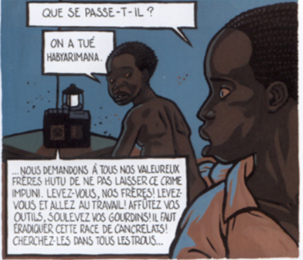

- ____________________________________________________________________________________________________________________________________________________________________________________________________________________________________________________________________________________________________________________________________________________________________________________________________________

2. "What arms could we use to destroy the inyenzi for good?" Beside the question is a photo of Gregoire Kayibanda, architect of the Hutu revolution and first president of Rwanda*. On the other side is a machete.

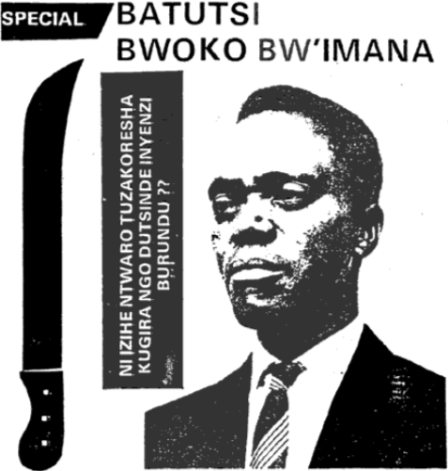

- ____________________________________________________________________________________________________________________________________________________________________________________________________________________________________________________________________________________________________________________________________________________________________________________________________________

3. The size of the nose and the color of the eyes were factors that determined whether a person was classified as Hutu, Tutsi or Twa.
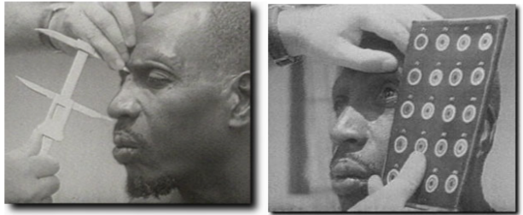

- ____________________________________________________________________________________________________________________________________________________________________________________________________________________________________________________________________________________________________________________________________________________________________________________________________________

4. 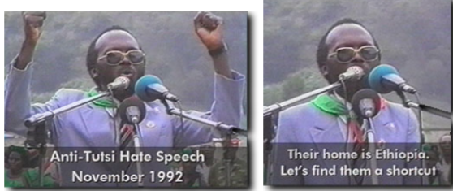

- ____________________________________________________________________________________________________________________________________________________________________________________________________________________________________________________________________________________________________________________________________________________________________________________________________________
5. Hutu 10 Commandments- 1990.
1. Every Hutu must know that the Tutsi woman, wherever she may be, is working for the Tutsi ethnic cause. In consequence, any Hutu is a traitor who: - Acquires a Tutsi wife; - Acquires a Tutsi concubine; - Acquires a Tutsi secretary or protégée.
2.Every Hutu must know that our Hutu daughters are more worthy and more conscientious as women, as wives and as mothers. Aren’t they lovely, excellent secretaries, and more honest!
3.Hutu women, be vigilant and make sure that your husbands, brothers and sons see reason.
4. All Hutus must know that all Tutsis are dishonest in business. Their only goal is ethnic superiority. We have learned this by experience from experience. In consequence, any Hutu is a traitor who: - Forms a business alliance with a Tutsi - Invests his own funds or public funds in a Tutsi enterprise - Borrows money from or loans money to a Tusti - Grants favors to Tutsis (import licenses, bank loans, land for construction, public markets...)
5. Strategic positions such as politics, administration, economics, the military and security must be restricted to the Hutu. 6. A Hutu majority must prevail throughout the educational system (pupils, scholars, teachers). 7. The Rwandan Army must be exclusively Hutu. The war of October 1990 has taught us that. No soldier may marry a Tutsi woman. 8. Hutu must stop taking pity on the Tutsi.
9. Hutu wherever they be must stand united, in solidarity, and concerned with the fate of their Hutu brothers. Hutu within and without Rwanda must constantly search for friends and allies to the Hutu Cause, beginning with their Bantu brothers. Hutus must stand firm and vigilant against the Tutsis and counter the Tutsi Propaganda.
10. The Social Revolution of 1959, the Referendum of 1961 and the Hutu Ideology must be taught to Hutu of every age. Every Hutu must spread the word wherever he goes. Any Hutu who persecutes his brother Hutu for spreading and teaching this ideology is a traitor.
- __________________________________________________________________________________________________________________________________________________________________________________________________________________________________________________________________________________________________________________________________________________________________________________________________________
VALENTINA’S STORY
Below is the story of one victim – out of many – of the genocide in Rwanda. Fergal Keane, a journalist who spent time in post-genocide Rwanda, met her and chronicled her story. Her name is Valentina, and she was only a young girl when genocide shattered her life.
When I first saw her nearly three years ago she seemed more shadowlike than human, a skeletal apparition lying on a camp bed in a country where dead bodies covered the roads and fields.
Her hand had been chopped in half and the wound had become infected. It had taken on an ominous black color. In addition, there were two deep gashes on the back of her head. There were no painkillers or anesthetics in the little room she shared with three other children. When it came to the time for changing her dressings the girl winced and cried in pain.
The nurse told me the child's name was Valentina. She was 13 and her family had been killed in a massacre carried out by Hutu soldiers and militiamen a few weeks before in the nearby parish of Nyarubuye. Valentina was among a small group of survivors. "She will probably die," the nurse said.
I left Rwanda shortly afterwards vowing never to go back. However, Rwanda did not go away, nor did the memory of Valentina and the other survivors of genocide. could people butcher children? What kind of man can kill a child?
I was still in search of the answer three years later when I returned. The country had changed dramatically. The schools had been reopened and the fields were full of peasants harvesting their crops. The sound of shooting had been replaced by the ancient chorus of African village life: crying babies, whinnying goats and the crowing of roosters. The church that had been the focal point of the massacre had been fixed up, the bodies removed and placed in a series of rooms nearby. These rooms had also been the scene of particularly brutal killings. Now the government was preserving them, replete with skeletons and moldering corpses, as a memorial to genocide.
Within minutes of arriving at Nyarubuye, I learned that Valentina had not died. Now, meeting her in front of the church, I saw a tall and beautiful 16-year-old nothing like the emaciated child of three years previously. As Valentina patiently told me her full, terrible story I found myself wavering between shock and anger.
The story of what happened at the church of Nyarubuye is more than a story about humanity's capacity for evil. It is a very particular story about the cruelty inflicted upon children by adults, people who were their trusted neighbors.
It began on a Friday afternoon in the middle of April. For days the Tutsis of Nyarubuye had sensed an impending disaster. They were aware that elsewhere in the country massacres of Tutsis had already begun. Ten days previously, the president of Rwanda had been assassinated, probably by members of his political circle.
His death--which was blamed on the Tutsis—triggered calls for a "final solution" in which all Tutsis and Hutu moderates were to be killed. It would result in the murder of all but a handful of Nyarubuye's Tutsi community.
The killing at Nyarubuye began with an attack on Tutsis at the local marketplace. After this, Valentina fled to the church with her family. That afternoon the killers arrived. Valentina recognized many of her Hutu neighbors among the more than 30 men who surrounded the church. They carried knives and clubs and were supported by soldiers from the Rwandan army.
Among the gang of men was Denis Bagaruka, a 56-year-old grandfather whose own children went to school with Valentina. She described what happened next: "First they asked people to hand over their money, saying they would spare those who paid. But after taking the money they killed them anyway. Then they started to throw grenades. I saw a man blown up in the air, in pieces, by a grenade. The leader said that we were snakes and that to kill snakes you had to smash their heads.
The killers moved into the terrified crowd of men, women and children, hacking and clubbing as they went. "If they found someone alive they would smash their heads with stones. I saw them take little children and smash their heads together until they were dead. There were children begging for pity but they killed them straight away," she told me. The killings took place over four days. At night the butchers rested and guarded the perimeter so that nobody would escape.

Other infants, crying on the ground beside their murdered parents, were taken and plunged head first into latrines. One of Valentina's classmates, an angel- faced little boy named Placide, told me how he had seen a man decapitated in front of him and then a pregnant woman cut open as the killing reached its frenzied climax.
"There was so much noise," he recalled. "People were begging for mercy and you could hear the militia saying, 'Catch them, catch them! Don't let them get away!'"
Valentina and Placide hid among the bodies, pretending to be dead. Valentina had been struck on the head and hands with a machete and was bleeding heavily. Following her child's instinct, she crawled to her mother's body and lay there. During the killing she had seen the militia murder her father and her 16-year-old brother, Frodise.
After several days Valentina crawled to the room where there were fewest bodies. For the next 43 days she lived among the rotting corpses, too weak to stand up and convinced that the world had come to an end.
"I prayed that I would die because I could not see a future life. I did not think that anybody was left alive in the country. I thought everybody had been swept away," she said.
She drank rainwater and rummaged for scraps of food. There was some wild fruit and some grain but she became weaker and weaker as the days progressed. In the weeks that followed, a few other children emerged from hiding places around the church. The stronger ones lit fires and cooked what food they could find, feeding the weaker ones like Valentina.
Then a new hazard appeared: wild dogs that had started to eat the corpses. "The dogs were coming at night and eating dead children in the other rooms. A dog came to where I was and started to eat a body. I picked up a stone and threw it at the dog and drove it away."
There comes a point in the telling of this story where the existing vocabulary of suffering becomes inadequate, where words wither in the face of an unrelenting darkness. As a reporter I found this the most difficult story of my career to tell. As a parent I listened to Valentina's story with a sense of heartbreak. I marveled at her courage but felt deep anger that his should happen to any child. It was difficult to keep those feelings in check when I confronted one of the butchers of Nyarubuye in the office of the local prosecutor.
Bagaruka, the grandfather who witnesses say was an enthusiastic killer, had recently returned from Tanzania. He had spent nearly three years there in the refugee camp at Benaco where he and his family were fed and cared for by the international community. The man who had helped to bring terror to the infants of Nyarubuye was nervous and evasive when I spoke to him.
"You have eight children, how in God's name can you help to kill a child?" I asked him. After a long pause he answered: "You see all those people in the church had children. Many were carrying them on their backs but none survived. Everyone was killed. We couldn't spare the children's lives. Our orders were to kill everyone."
He told me that he himself had been an orphan and a Tutsi man had been his guardian. Bagaruka had seen the man killed at Nyarubuye. "I almost become crazy. Because of his crimes, he has implicated some of his friends and neighbors, hoping to save himself from the firing squad.
Valentina hopes he will never return to the village. She now lives with an aunt and two other orphans. The aunt's husband and three children were killed at Nyarubuye.
The aunt told me that Valentina has a recurring dream. She imagines mother coming in the middle of the night. They embrace and then Valentina shows her mutilated hand to her mother, saying: "Mother, look what's become of me. Look what has happened to me." And Valentina wakes up crying and sees that her mother has vanished into the darkness. Then she remembers that her mother is dead and gone forever.

- What Impact do Stories like this have on the people reading them? Do they make a difference in hearing ‘first person accounts’ of historical events.

___________________________________________________________________________________________________________________________________________________________________________________________________________________________________________________________________________
___________________________________________________________________________________________________________________________________________________________________________________________________________________________________________________________________________
___________________________________________________________________________________________________________________________________________________________________________________________________________________________________________________________________________

