Name: ___________________________________________________ Period: ____
The Oregon Trail Computer Game Worksheet
Directions: Growing up, one of my favourite games in elementary school was the original Oregon Trail game. I loved that I could pretend to be a pioneer, compete against my friends and in a small way experience what the settlers went through while trying to travel westward.
Check it out here, and fill out the following worksheet as you do: (https://classicreload.com/the-oregon-trail-deluxe-1992.html).

- Why were Americans traveling to the Oregon Country? (1 point)

- What are some of the items that you purchased at the general store before setting out on the trail? (1 point)

- What is a yoke? How many did you buy? (1 point)

- Where are you starting off from? (1 point)

- What month did you choose to start your trip? Why did you choose this particular month? (1 point)

- Who did you pick to be when asked between the several people with different trades? Why did you pick this person? (1 point)

- What was one geographical challenge you faced while on the trail? (1 point)

- What was one biological challenge you faced while on the trail? (1 point)

- Did anyone in your party die? If so how did they? (1 point)

- What was the worst decision you made as a player of this game? How did this decision impact your progress? Answer in at least 2 complete sentences. (2 points)

- How does this game simulate what early settlers went through trying to get to the Oregon Country? Answer in at least 2 complete sentences. (2 points)

- If you were alive during this time period would you have risked your lives on the Oregon Trail to make it to the Oregon Country? Answer in at least 2 complete sentences. (2 points)

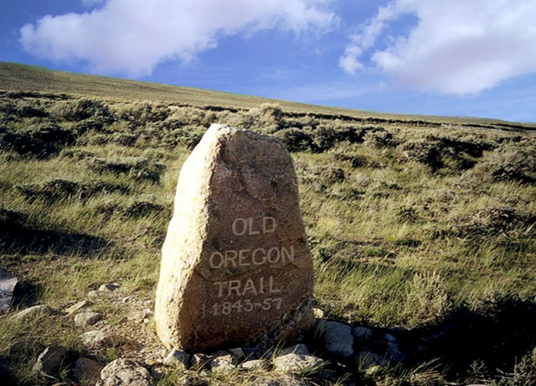 /15

