Event/Mode Ideas:
Last Stand/Stronghold
Well an idea I thought of right now is making a map that is maybe a little smaller than Deadlands and having a hill in the middle, that has a decently if not town sized forgotten castle succumbing to nature on it, but has some renovations. Around the castle would be (maybe a moat?) smaller towns around it maybe kinda far away.
The castle itself at the beginning (or not) could have some parts in it’s walls that are gone that need repairing, which also means that the enemy could destroy parts of the castle walls to make an entrance if the walls are built. A moat would also be around the castle as said earlier, but would shallow and crossable, but obviously it would slow down the player. Bridges would be connecting some if not all the entrances to the castle (maybe only 2 since it could make it impossible if players keep on destroying the bridges so the enemy couldn’t cross).
The point of this map would be one team has the castle/fortress and the other has control of the towns and while the castle has maybe 2 or 3 armories (factories in the future) and other structures, towns have these buildings split amongst them like any other map. So pretty much a last stand map that could be used for events. A time limit is something that could be optional too.
Obviously this idea need more work, but I think you guys would be interested in something like this for events and stuff.

Escort the Tank
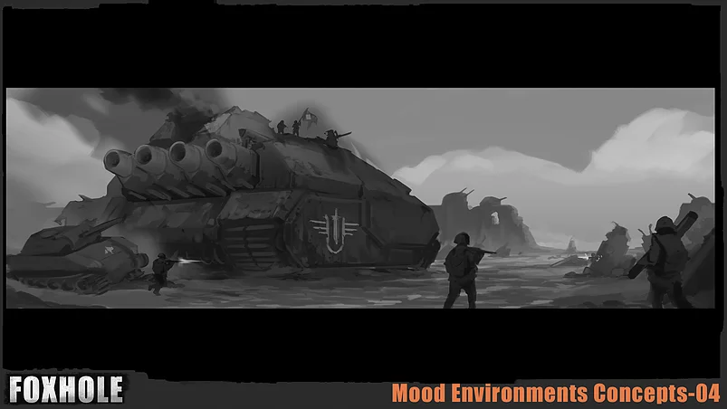
This event/mode is where one team has to escort this tank from the concept art or something similar to a certain location (most likely being the Bulwark which is a large wall going along the south border of the world map) and destroy the wall while the other team tries to stop and destroy the tank before it reaches the Bulwark.

This event/mode is something that would utilize the upcoming War Mode that the developers have talked about in the past. The way this would work is that depending on which team starts with the tank would decide if the tank starts in the very south or north of the entire world map. Thus the tank would have to travel guarded by that team to said objective while the other team defends and tries to find ways to sabotage and destroy the vehicle. Another thing would be that the tank would have to be manned by a crew controlling different parts of the tank’s mechanisms and maintaining it, which would make it so the tank doesn’t have a predefined path it follows.
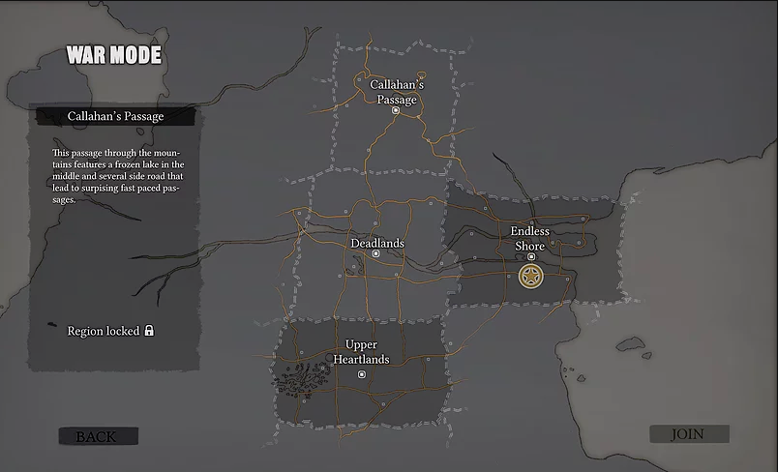

This leads into the idea that the tank would even at points (not specific points on maps) have to stop to be restocked with fuel, ammunition, and even repaired, these times would give the defending team the chance to attack the tank and would make for some interesting battles. Now if the tank is not destroyed along the way to its objective then it will reach the Bulwark, but just because it reaches the map and the wall doesn’t mean the offensive team wins. The tank must also destroy the wall to be victorious which will also be the chance for the defending team to give it their all to destroy the tank.

The tank would maybe have a crew of 3 or 4 players (Driver, Cannon Operator/Loader (or have the two as separate roles), Commander?), the roles are not things I have thought through as well, but someone if they want can give suggestions for the roles of the crew. The tank is obviously going to have tons of health and could possibly have different areas on it can could be damaged like it’s treads, cannons, etc that would hinder it requiring it to be repaired. The damage to it would also negatively affect its performance and show visually as well.

I also want to mention that this things would be monthly events not things you could choose from a browser list.

Artist/Creator - lercas

