Upper Heartlands Map Feedback – Salvage Nodes as Player Garrisons

Introduction:

For the purposes of map design, this document is to provide an inside-glimpse at witnessed player behaviour, and to show how salvage nodes can be used to shift the conflict hotspots onto areas of the map that are rich in features and interesting terrain. This is incredibly relevant on Upper Heartlands, since the wide-open spaces of the map tend to spread players out over a wide area, resulting in a fewer number of large-scale battles.
I believe it is in the interest of the game to want to bring players closer together, into more focused and concentrated locations without the need of artificial bottlenecks like bridges or mountain passes. The goal, therefore, is to try and manage the map's resources and salvage nodes into a fashion that increases the likelihood of organic, large-scale battles to occur.

Salvage Nodes are Not Resources:

Most players use the salvage piles next to the factory. The question has been raised whether there is even a purpose to salvage nodes further afield since a single salvage field can support half a dozen players easily, and since the salvage would need to be refined at the factory anyways, why mine it from so far away only to force a truck to carry it back for refinement?
Typically, we’ve seen players and teams organize themselves into this kind of an arrangement (fig 1)
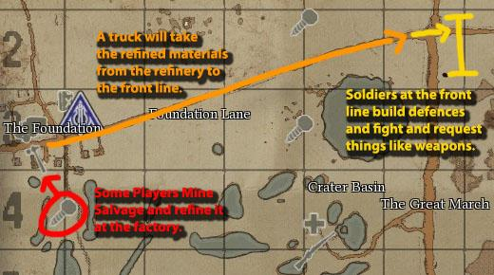
Conceptually, this kind of system is easiest to imagine and organize, because each individual player has a singular and straight-forward role. This system can be run, at minimum, with 3 players. One mining salvage, one transporting materials in a truck, and one at the front building defences and defending the line. However, the system is inefficient because after the truck drops off the build materials at the front line, he must return to the factory empty to get another batch of supplies.
The system is also doubly inefficient because the player mining salvage at the rear is 100% tasked with the burden of supplying the frontline. This player will be bored out of his wits, and, after only a short while, is unlikely to continue.
We have tried experimenting with a different system that has proven efficient and, most importantly, fun. I expect it to be in use far more often as more and more players become more cognizant. (fig 2).
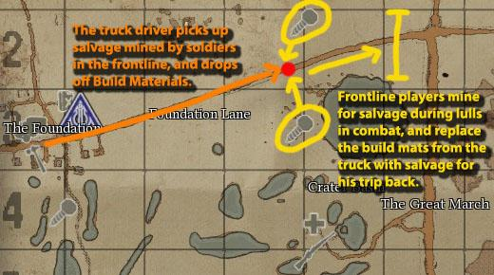
This system solves both problems presented in the first system. First, at minimum, this system can be run by 2 players, instead of 3. The soldier building defences on the frontline performs the double role of gathering salvage, and fighting. Since the enemy isn’t usually attacking all the time, breaks in combat can be spent productively mining for more salvage. This way, when the logistics truck arrives to drop off build materials, he returns to the home base loaded with salvage to, again, refine into more build mats to bring back up to the frontline.
This system also solves the problem of having a single guy mining endlessly for salvage. Since the bulk of players are generally already on the front line, having all of them mine in short bursts (5-10 minutes) will generate enough salvage to make mining unnecessary for long periods of time. In this way, you can guarantee your most vital players—the ones doing the mining—won’t get bored, since they’ll also be the ones doing all the fighting and base-building.
The major problem with this system is that the frontline cannot venture far from the salvage field. Since the majority of players will be by the salvage node, it follows that any base (FOB included) would most likely be best served close to the salvage, and all the defences should be centred around that.
What this means is that salvage nodes should not thought of as a resource, but as a player garrison. Large numbers of players are already centred around the salvage nodes. Use this knowledge to shape the map and guide naturally-occurring player behaviour toward interesting areas of the map.

A Study of the Salvage Node at Barrony Road

So for all the conditions of an efficient supply chain (as detailed above) to be met, we will need:
- A salvage node near the road.
- A secure roadway to a refinery.
- A position of strategic value that is worthy of protection.
On the map we can see many locations that might meet these conditions, but the one at Barrony Road (red) is arguably the most significant. (Fig 3)
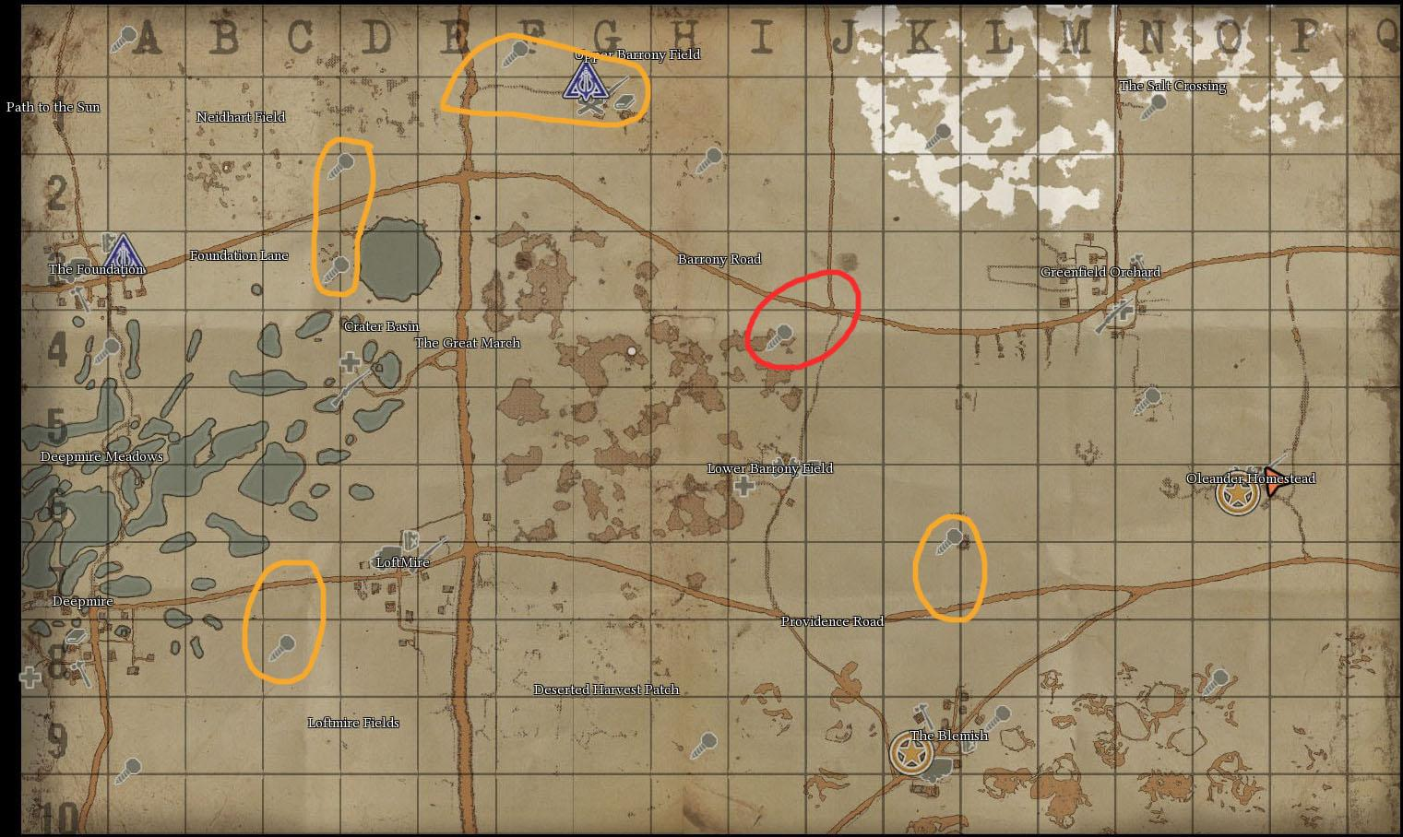

Although we see more base locations on the west side of the map, this is not enough to draw conclusions about balance. To draw a more complete picture, we’ll take a look at the situation that arose during this past weekly war (War #12)
Wardens had taken the position at Barrony Road, while the Colonials had blitzed and taken hold of Upper Barrony Field in the first twenty minutes of the game. (fig 4)
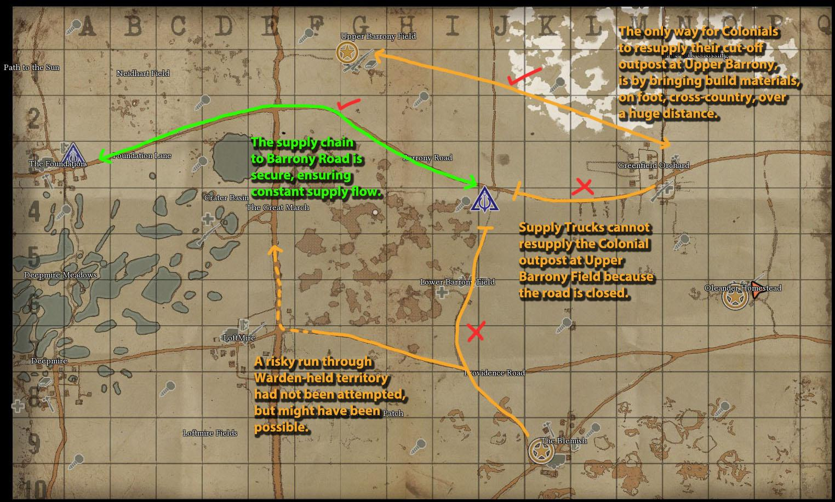
The result provides an excellent case-study of why the roads are, in fact, the new bottlenecks of the Upper Heartlands. Just because the Colonials had the stronger position at Upper Barrony road, without an adequate means of sending supplies to it, it was essentially being cut off by a warden base nearly three full grids away.
Because the Warden FOB was placed next to a salvage node, it allowed all the players there to simultaneously defend the crossroad, as well as mine salvage to keep the base stocked with build materials without the need of a mindless rear element mining salvage non-stop. In this way, we can see how the salvage node acted as a kind of player garrison to keep the fighting concentrated in the crossroad. And we can use this information to shape the map in more interesting ways.

Three Ways to Naturally Alter the Conflict Hotspots

From a map design perspective, we can put considerable emphasis on the salvage nodes when determining where players are going to be, and then steer players toward interesting ‘conflict hotspots’. We’ve already established that roads are important for pushing the line, but what about the towns? The interesting geographical features? There’s a beautiful rocky outcropping area in the southeast corner of the map that will never see action because it is strategically insignificant. Even on the Deadlands, a tried-and-tested map, we’ve seen whole swathes of exciting territory go completely unused.
I wrote this guide to help us all to understand player behaviours, which will help to steer the map design in a direction that will:
- Organically centralize conflict to make the battles more large-scale, and intense.
- Shift conflict areas to locations on the map with unique features such as towns, or valleys.
- Do all of this in a way that doesn’t limit strategic options.
As an example, we'll look at LoftMire as an example of how we can use salvage nodes to shift the conflict hotspots to their ideal locations. Below shows the theoretical thought-process of a player who would have just spawned into LoftMire. (fig 5)
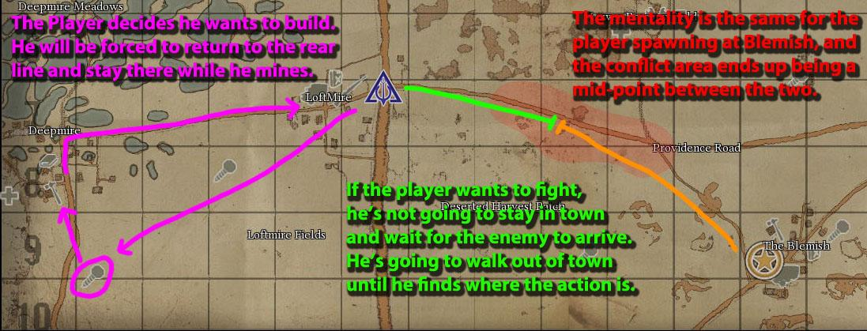
If the player decided to build defences, he’s going to end up heading away from the action and toward the salvage node/refinery at Deepmire, which will mean that the map design has effectively drawn a player away from the conflict. If the player decides to fight, he’ll wander off down the road to the east.
With the exception of the road, the area between Blemish and Loftmire is fairly bland and featureless, and will inevitably devolve into a linear tug-of-war along the road. Worse than that, is that when one side begins to win, the fiercest fighting almost always occurs at the edges of town… never within it—which is where it would be most interesting for the battle to take place.
The dilemma presented above is simple: For the player spawning at LoftMire, there is no clear-cut impetus to remain in the town and defend it. There is no active garrison. Every player is filtering out of the town and into the field in one direction or another until the FOB runs out of soldier supplies and players stop spawning there altogether. What this inevitably boils down to is that conflict will occur outside the town until such a time that the town is, one way or another, left undefended, at which point the town's FOB is easily destroyed and flipped to begin the process again.
Therefore, if we want players to fight in the town, we must give defenders a reason to stay in the town. So that when the enemy attacks, there will be soldiers standing at-the-ready to defend it. These kinds of conflicts—with a mass of enemies approaching a well-fortified and manned position—are the ones that players will often remember.

Method 1: Salvage Nodes as Garrisons

Remember from earlier that salvage nodes could be thought of as a kind of garrison. Players will congregate in these fields and remain there for long periods of time while they gather salvage. It is likely that they will remain there until a direct threat to their position calls them to action. So the first method of increasing action/conflict in an area should be obvious. Simply add a salvage node as a feature of the town. (Fig 6)
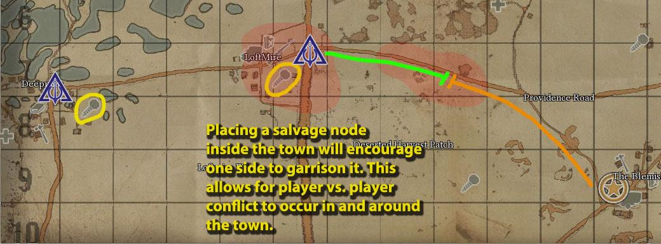
(Note: You may noticed that the salvage node in Deepmire has moved as well, I'll talk more about that in method three)
Now it's true that players will naturally wander east down the road in search of action, there can be no helping that. But the important part is that for the players that would like to build, instead of returning to Deepmire, they can stay and mine inside the town itself and act as a kind of garrison for it. This way, when the enemy attacks, there will be players already there, ready to defend.
The point here is that we need to give players a reason to stay in the town, or else no fighting will occur within it.

Method 2: Heavy Activity Conflict Hotspot

It is understandable that LoftMire was never meant to be a zone of heavy conflict. It exists in the no-man's land between the two starting locations, and presently acts as a kind of 'activity deadzone'. This is not bad, necessarily, since it means the war will go on for longer. However, I want to continue using this as an example of how to use the salvage nodes to make a much more heated 'combat hotspot'.
If the idea is to make LoftMire an interesting terrain/map feature, then it would make sense to place salvage nodes on opposite sides of the terrain feature. Add a salvage node to the east. (Fig 7)
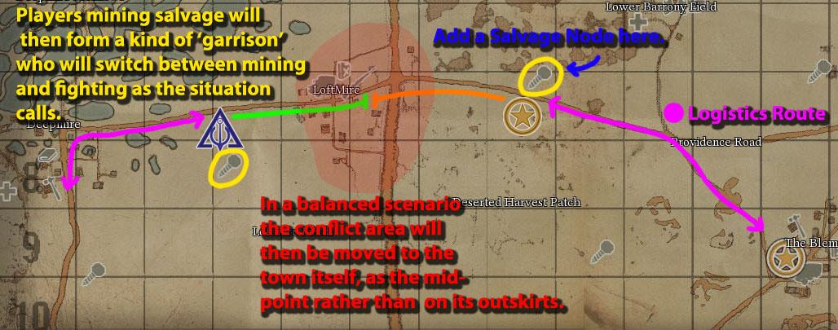
This is the ideal scenario. Neither side will hold the town, but both sides will be in a position to attack it. Players deciding to mine for salvage will instead be acting as a garrison for their own FOB on the city outskirts, while the players in search of combat will find themselves attacking the town with rapid frequency.
Now, consider the events if one side captures the town and places an FOB inside. Once again, let us consider the mentality of a player recently spawned at this new FOB. (fig 8)
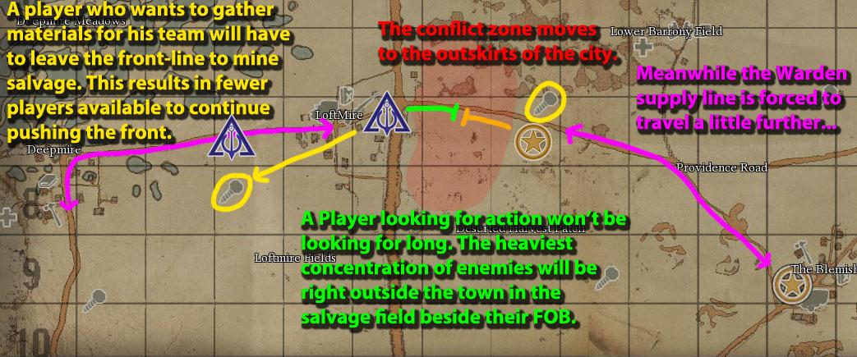
The mentality of the player is strikingly similar to the existing scenario. Players are pulled in two directions out of the town, rather than encouraged to remain within it. In this way, the side with the winning initiative will be at a disadvantage to help bring the scenario back into equilibrium.

Method 3: Low Activity Conflict Hotspot

If it is intended for LoftMire to be an area of light, sporadic fighting, then we could consider removing the salvage nodes nearby it for either side. Presently, there is a salvage node on the warden side which would give the Wardens automatic-control of the town, and displace the conflict hotspot (the mid-point toward blemish) to the east of LoftMire, onto the open road. In order to make LoftMire a battlefield, this node would need to be removed to make the town a mid-way point between Deepmire and Blemish.
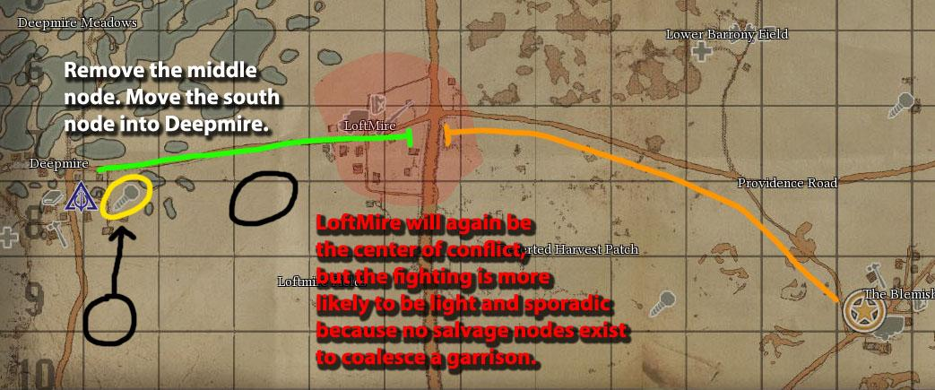
In addition, since we now know that salvage nodes should be treated less like resources and more like player garrisons, if the salvage node is away from the town, then the fighting is likely to only occur in the fields surrounding the salvage node. Instead, switch the factory with the salvage node, so that the player garrison ends up inside the town, and place the factory on the outskirts as the resource for the enemy to hamstring in an attack.
If you leave both factory and salvage node inside the town, you'll end up with a fortress like we always see at The Spine in the deadlands.

