In a Colonial POW hospital in an unknown location, some time after the Upper Heartlands CW. A newly arrived Warden soldier discusses the latest Colonial UN News Report - The only newspaper they had available, with whoever around was willing to listen.

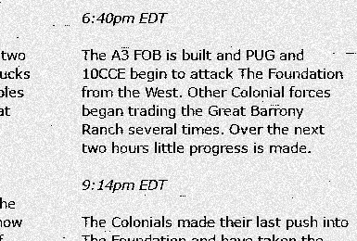

"Over the next two hours little progress is made"

Well that was a dry statement. Colonials and their damn propaganda. The way I remember it is the epic 50 vs 20 defense of the Alamo Ranch by the Randoms. I was there, I’ve seen all of it.

The infantry rush on the outskirts of the Ranch, the shuffling of medics desperately keeping people alive. Rebuilding the entire Ranch from scraps we looted off the dead bodies, bringing every clip of ammo and every bandage back to the Town Hall to be recycled and reused. Spending the last of our materials for Soldier Supplies that were trickling down ever so slowly. All while waiting and hoping that the Randoms in Foundation find that one truck that wasn't coalition locked by the clans that abandoned us.

The struggles of being outnumbered, outgunned, outsupplied, with Colonial foxholes being so close we could see the stitches on their covers. Waves and waves of Colonial attackers, each wave bigger and better equipped than the last, each wave failing to take us out, but chipping away at what defenses we had left.

The feeling of joy when the truck finally made it through, the driver having to move off-road to avoid any Colonial surprises. Then going right back for one more trip, trying to get one more shipment through. It was our lifeline from Foundation, a fresh supply of materials to allow us to patch up our defenses and prolong the inevitable for a little more time.

The distressed voice of Foundation Random Commander that the west Foundation walls have been breached, and that we were at danger of losing it completely. We knew that we were spread too thin, most of us were holding for our lives at Ranch. We knew that there was no way they could defend it on their own. We knew that if we lost Foundation, all was lost. We knew what we had to do.

The sound of the evacuation sirens blaring, reminding us to leave no one and nothing behind, as the evacuation truck made it through one last time. The shuffling of men desperately gathering whatever we could get our hands on. The frantic loading of all the medical supplies we had left, that we will ever have left. The nail-biting wait for the production of the last batch of Soldier Supplies to bring with us. There was no way to get any more after that, so we waited, even as the Ranch Town Hall was being shelled. The moment they were done we loaded the truck with all the men we could fit, with all the rest running behind it on foot. We retreated back to Foundation, proud of what we did at the Ranch. But without a moment's rest, immediately we went back into the fight, holding breach after breach in the walls surrounding our last town. Even then, as the walls were crumbling and Colonials were pouring in from all sides, some of the Randoms were still out there, still trying to conduct raids on their outpost, still trying to relieve the pressure. We all did our best, but still, I wish I could have done more.

But yeah, from the Colonial POV I guess it was just "little progress being made".

---

Author’s note: This write-up is a sort of an “Ode to the Randoms” after the recent Community War. Although the war was lost pretty early on and Warden clans bailed already, the defense of Great Barrony Ranch was the best time I had in Foxhole so far. You may have noticed that the story wasn’t exactly in-universe. This is because everything that I wrote about actually happened in-game: the scavenging for items, the off-road truck deliveries, the evacuation (complete with siren PA system roleplay), all of that just coming together from a group of Randoms who didn’t want to give up. Thank you guys, you know who you are.

