Alright this is going to be long so strap in for your own safety.

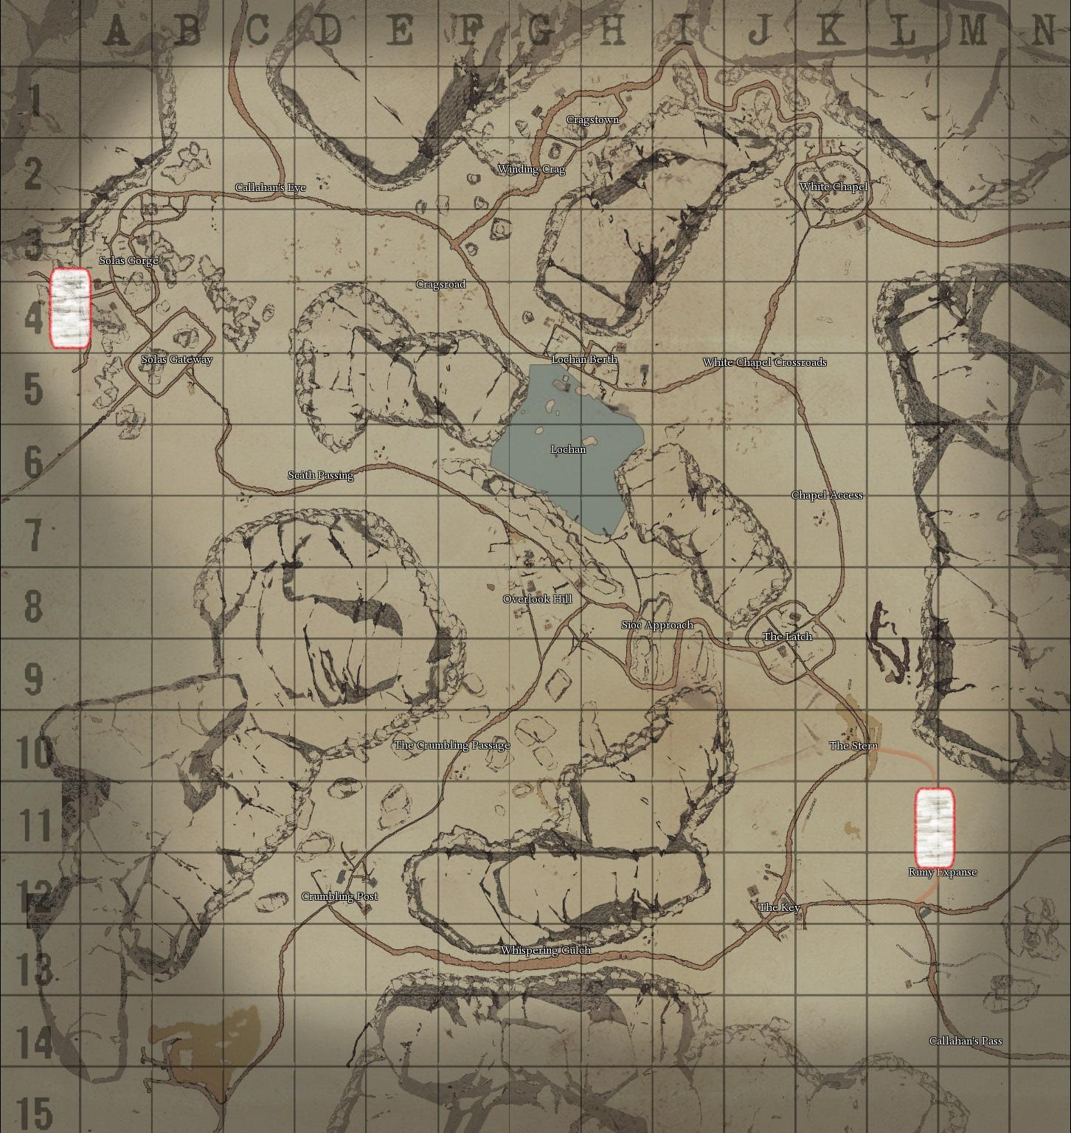
Airfields are now a thing. They're placed somewhere 2/3 in the side's territory, located to the side of the map. Planes take off in the direction opposite to the enemy’s side, ideally. Let's take Callahan's Pass.

That would be The Stern and Solas Gorge.

They contain a hangar, armament station and a fuel station. Also a workshop.
Hangar is where planes are constructed. This happens in two stages, first the frame is built out of refined materials, then the rest out of basic materials.
Armament station is like an armoury, but makes bombs and aircraft-specific ammo. Planes can be loaded with standard 7.62 and .50 (where applicable) in a pinch, but it forces frequent reload
and sacrifices accuracy.

Fuel station converts normal fuel into plane fuel. Planes don't accept unrefined fuel.

Now here's the deal. The air battle map is separate from, but connected to, the ground map.It uses the ground map as "background", but it's in fact just a still picture of it, upon which player-made structures are overlaid (in very small scale to represent the altitude), and soldier locations are roughly shown as tiny black dots. The game now checks if a building/soldier is in an area with dense foliage or in a building, and does not show them on the air map if that's the case. Explosions and long periods of gunfire are represented by flashes and smoke.

Planes are limited to two classes of biplanes, transport craft, gliders and bombers. They always fly level and turn with A and D, and change speed with W and S. So essentially like ground vehicles, but maintain momentum. Turning prevents gunners from firing in the direction they logically wouldn't be able to fire at. Plane pilots can look around with right-click like you do with mortar/binoculars, but with less range. As the plane gains speed, their view slowly, automatically moves forward, requiring them to manually look what's behind them.

On the ground, planes move around very slowly and can't handle uneven terrain at all, making starting from anywhere outside of the airfield borderline impossible. If the terrain allows it, the plane will pick up speed, and eventually, lift off. This transports the plane to the "air battle" map. If even terrain ends before the plane has accelerated enough, it crashes but can be repaired. Planes can reverse while on the ground for sake of player sanity.
Landing and taking off doesn’t include any advanced calculations. Just simple speed times negative or positive altitude change, unique to each plane. A few meters off the ground the plane just despawns and appears on the Air map.
Planes cast large, clearly visible shadows while coming in for landing or soon after lift-off. Bombers cast shadows even from the air battle map.

Landing is done by holding X. It causes your view to move to a "landing indicator" that shows where your plane will land with it's current speed. Holding S to slow down will make the indicator more accurate, and once you're moving slow enough, you're transported to the ground map, to the place where your landing indicator pointing. You still have to lose speed on the ground, so you better land on the beginning of the strip.

Biplanes have two classes, I'm not honestly sure how to name them so let's go with "attacker" and "defender". They are entered and armed/refuelled just like halftracks.
Attacker is a single-seat, sturdy but slower plane with two forward-facing 7.62 machine guns that can only fire directly in front. The pilot is also able to drop grenades using the bomb view. The cockpit is open, so the pilot is able to use a handgun while in right-click view (and machine guns otherwise) should he wish so. Hopes of actually hitting something are next to none, but hey.

Defender is a two-seat, light and fast plane. The pilot is armed with a pivot-mounted 9mm SMG (uses normal 9mm magazines, can fire in a 90 degree arc in the front). The gunner is armed with a dual .50 rifle. Fire rate roughly equal or slower to the HMG, but holds 100 rounds per reload. Reload takes longer. It has a nearly 360 firing arc, but can't fire directly in front.

Now comes the fun part. Big planes. Their insides are also a different "level" on their own. When you enter through a door, you're transported to a location that shows the internals of the plane, where you can walk around freely, interact with fuel tanks, ammo racks, machine guns and the pilot seat.
You can't see the outside world while in here, so it doesn't have to be rendered at all. You only see if it's sunny outside or not. When you interact with a gun or the pilot seat (the plane won't start falling until 10 seconds or so elapse after the pilot has left the controls) your view switches to your plane in the air battle map. The directions in which you can zoom your view are defined by the side of the plane on which the gun/seat is located.

The big planes (with internals being walkable) are the transport, the glider and the bomber.

The transport is armed only with a rear-facing 7.62, but has several crates on board and up to 7 men can be in there comfortably. It's sturdy, but not armoured at all, and flies at moderate speeds. Okay turning. It can be easily used by paratroopers due to having two doors at it’s sides and a small loading ramp in the rear.
If crate carrying mechanics are introduced, it should be possible to attach a parachute to a crate and drop it off the ramp.

The glider is not fully true to it's name, as it uses a single engine to lift off. It's much less spacious than the transport in terms of crate loads, but can handle the same amount of men. It has a 7.92 on each side. Lightly armoured, but no fuel to ignite after it has lifted off. It starts losing speed right after reaching the air battle map and can almost make it to the opposite side of the map. It is much less prone to exploding upon landing - in fact, if the main body doesn't
hit anything, it will survive the worst crash landings possible.
The wings will be ripped off, but the main body will remain as a "structure", providing cover and fire from the mounted 7.62's. It is almost as cheap as the biplanes to make, requiring little refined materials. Easily harmed by incendiary ammo. Has a rear ramp for entering and exiting.

The bomber is a slow, barely mobile, but armoured flying brick. The pilot is armed with a forward facing 7.62, and there are two rear/side facing .50 seats. It has no crates on board and two men are very hard-pressed to pass each other walking down it. Uniquely, it hosts a bomb rack. Has a single side-door.

Ammo unique to plane guns comes in two variants - High velocity and Incendiary. High velocity shreds the frame, engine and the crew. Incendiary can ignite the wings, the entirety of the glider (it's made of easily flammable colonial bodies), fuel tanks and ammo racks.
Bombs come in high explosive, fragmentation and incendiary smoke flavours. High explosive is anti-structure, frag anti-infantry, and incendiary smoke works both as area denial and smoke cover.
A small, grenade-like version of frag bombs is available for the pilot of the Attacker.

Planes have specific hitzones resulting in damage to different components. These would be the wings, the engines, fuel tanks, ammo racks/bomb rack, and the fuselage. Any hit to the main body of the plane - if it defeats the armour - damages the fuselage and spawns pieces of shrapnel inside randomly, possibly injuring crew.
High-velocity ammo deals more damage to components, resulting in progressive loss of function, and is able to defeat armour. It does little to the wings, however. This type of damage destroys ammo inside ammo racks and causes fuel tanks to leak.
Incendiary ammo has no chance to defeat armour, but sets fuel on fire, draining it at a fast rate and causing damage to the entire plane and crew. It burns the cover of wings, reducing turning and max speed. If an incendiary bullet defeats armour and its’ “shrapnel” manages to hit an ammo rack, the entire thing goes up in flames, most probably killing everyone on board. Using an extinguisher as soon as the rack starts smoking can prevent this, but the time window is very small.

Basically, high-velocity will hurt that plane good no matter what and wrecks small planes, while incendiary can deal massive damage if it penetrates and ignites. If. Fuel tanks also aren’t the biggest targets, so hitting them is more luck than skill.
If the fuselage or an internal component catches on fire, fire will spawn on the inside of the plane, doing high damage to people without padded suits and moderate damage to these lucky fellas owning one. Fire extinguishers will put these out, also preventing further damage to these components.

A plane that ran out of fuel or suffered moderate damage will be forced into the landing mode right away, giving the pilot a few seconds to aim it at a road.
Heavy damage will have the plane immediately plummet to the ground, falling from the sky at a sharp angle, killing anyone caught underneath it and throwing around piles of flaming debris. The small biplanes are much less spectacular in their crashes, but still dangerous.

Bombers and the pilots of of Attacker planes can enter a bomb mode by pressing a key assigned to it, I propose C. This causes an indicator much like the landing indicator to appear, showing where the bombs will land. Bombing is more accurate at lower speeds. In case of bombs, a distinctive sound is played while they’re in flight, growing louder as it approaches the target. It takes roughly 10 seconds for a bomb to reach the ground. The Attacker grenade-bombs are silent, but low-damage and horribly inaccurate.

A skilled pilot can come in for a landing, but press X to start taking off again before his plane touches the ground. The time window is really small and if perfectly executed, it lets the plane be on the ground map for 7 seconds at most, much less if it’s performed within safety margins. This has the use of fly-by recon to see the full detail instead of moving dots, and allows the Attacker plane to engage ground troops directly with its’ guns and bomblets. This exposes the plane to fire from ground troops and the risk of hitting something is massive.

Clouds move through the air battle map at random at varying heights. Low clouds obscure the ground and reflect light, making everything above them shiny as hell, making it easy to notice planes, but hard to make out details. Medium clouds are the ones that fly level with the planes, obstructing view and concealing anything inside them. High clouds cast shadow, making planes less reflective, and turning the ground map portion below them into a sheet of blackness as light, by blocking moonlight.

Now, detection. All planes that are for some reason present on the ground are detected by watchtowers. While in the air, they trigger watchtowers only by flying directly over them, but they sound an air alarm if that’s the case. They are, however, detected by zeppelins, and their exact location is visible on the map, not just an “enemy in proximity” circle. The distance from the zeppelin until detection varies with the size of the plane, with the exception of gliders - they fly silently, and are only tagged on the map by direct observation by a player.

Plane crews require gas masks and padded suits. Without a gas mask, your view will get more and more obscured by splats of oil on your screen, to represent engine exhaust. You will also very slowly (few minutes) pass out, going into “critically wounded” state until you land.
Padded suits protect from the cold air, which over time drains your max (max, not current - if you thaw, you go back to 100% HP) max health. They also offer more protection against shrapnel, but only that. They slow you down a bit.
Fire extinguishers are self-explanatory. You can’t extinguish burning wings from the inside, though. Tough luck.

Parachutes automatically open if you exit a plane on the air map with one equipped. The location of your arrival is slightly randomized. To exit an airplane, you interact with one of its’ doors, allowing you to look outside. Pressing Q again will make your view go back to the inside of the plane, while E will make you jump. Small planes only require you to press Q.

Full repair can only be done in the hangar, but in-flight you can keep damaged components working by constantly hitting them with the wrench. If you stop, so do the components. Each damaged component requires a crew member to work on it. Engines are prioritized. Components completely destroyed and ones currently on fire are unworkable.

Zeppelins can be built at any location and manifest groundside as a fairly big concrete anchor. Fully completed zeppelins are spawned in as immobile objects on the air battle map and can be walked around - this is the only instance of soldiers outside of planes existing on air battle maps. Interacting with the anchor transports you to the zeppelin after a moment. They house several machine gun mounts and work as much more accurate watchtowers with a large field of observation. There’s an interactive scope on board that allows you to Sauron at the enemies, also displaying range to currently observed location, counting from the anchor. They can shrug off high-velocity rounds, but massed Incendiary fire can cause the entire thing to go up in flames.

Barrage balloons are like zeppelins, but cheaper and can’t be accessed by players. They are harder to take down and their heavy-duty struts make areas tricky to pass through for small planes, impossible to larger ones if densely deployed.
Anti-Aircraft emplacements are flak cannons crewed by AI. Their range isn’t very good and they get more inaccurate the further away (and faster) the target is. They fire at planes by simply spawning explosions on the air map. A single one is a deterrent, a couple of them - impassable. They are unable to target gliders unless a player is actively spotting one.

Intended balance goes like that:
Attacker defeats bomber and glider with it’s high firerate and thanks to their low speed, Defender defeats Attacker due to having a full degree of machinegun fire and has an easier time catching up to Transport.
Bomber is a serious danger to ground targets, but has to refuel and re-arm frequently, while being so slow that technically even utility planes can attack it.
Transport can’t really fly without escort, but it’s ability to transport troops and supplies cannot be praised enough.
Glider is very vulnerable in the air, but provides the ultimate shock troop experience.
Zeppelins have to be actively manned to defend themselves, but if they are, it’s a fair fight. Attackers have the benefit of burst damage to them, Defenders can do drive-by’s while evading fire thanks to the gunner.

Nothing of this is historically accurate at all. Military gliders didn’t co-exist with the rest of this but are too cool to pass up. Serious transport planes were also much closer to world war two than the rest of this. The whole “attacker and defender” thing is made up. Bombers were not armoured at all in the biplane era.
Reference pictures, proposed styles: