EARTHWORKS - Non-terrain mod approach.
Derpislav 02/04/2017

INTRODUCTION
Ah, trenches, trenches. Suggested so many times, with the answer always being “engine doesn’t support it.”
But what if.
This document compiles my suggestion on trench/earthwork introduction based on the already existing building system.

Danke schön, Dukesalt
Dukesalt, a like-minded community member with many great docs of his own and an unofficial proof-reader (read: I bug him eternally before posting anything) of mine suggested a partial construction system - earthworks in their “shaped mounds of dirt” form are created with the entrenching tool.
This serves as a foundation of sorts, upon which the wood-reinforced, rampart version is built with basic materials. With components, these are further upgraded into a concrete-poured version, full Normandy style.
I liked this, and I’m putting this in before the main suggestion itself as a “thank you” to him and anyone else that provided feedback.

MECHANICS
An “entrenching tool” is now either a part of spawning gear, or a low-cost Workshop option.
It has a build menu separate from the hammer, containing segments of earthworks of varying length.
These cost no materials to build at all, but the time requirement is MASSIVE, making defensive lines borderline impossible to build without combined effort of several squads - and certainly not under fire.
These defenses can be later upgraded using basic materials with barbed wire, tank hedgehogs and camo tarps. They have been suggested by others as buildables, so why not give them an unique model that is used when they “snap on” with a piece of earthwork?
These fortifications are immune to small arms fire and grenades. Only constant bombardment by mortars and up can level these structures. Entrenching tools can also disassemble them at a faster rate than they are build. Dozer blade engineering tanks (LINK WILL BE HERE) or assault guns also make short work of them.

These fortifications aren’t manned unless a foxhole/bunker is built on top of them - it receives an unique model in that case, turning into either a small platform for riflemen (foxhole) or a pillbox built over the trenches (bunker). These have the same upkeep mechanics as their counterparts (link).

Earthworks provide complete protection from explosions centered outside of them, but magnify the effects of both explosives and gas, turning even a single artillery shell into a trench-clearer. Gas creeps into trenches and deals additional damage, and gas grenades that landed inside of a trench last much longer.
Last but not least, the edges of earthwork textures have a “chameleon” quality to them - they partially take on the texture of ground they’re placed on, to blend in more naturally.

MODULARITY AND HOW IT WORKS
To put it simply, earthworks are buildings. However, they have deeper, “forgiving” foundations, that allow them to adjust to the terrain present. “Trench” is a misnomer, as they are located above the ground and artificially create the “tunnel”, but it’s simpler than explaining what I mean by “breastwork”, the proper term.
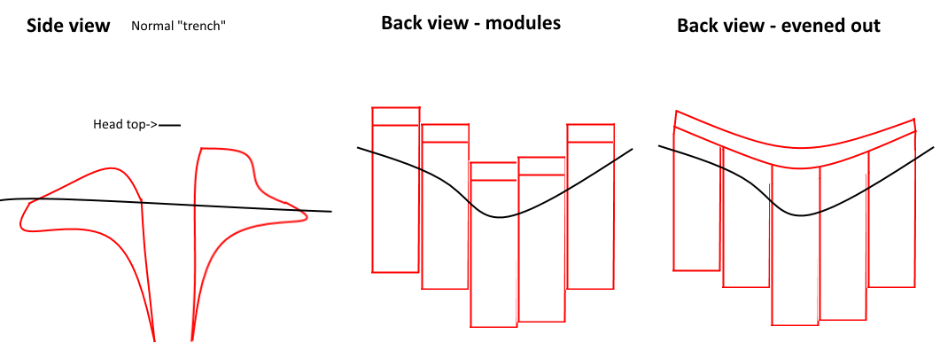
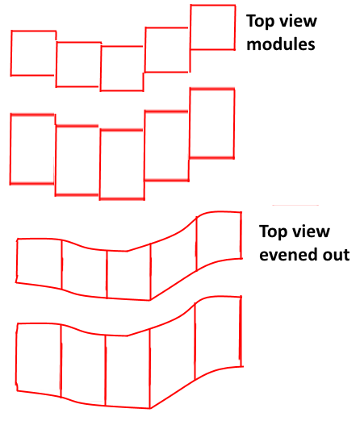
These buildings are placed as a line of metre-long “modules”. They individually adjust to terrain shape, and then draw an “averaged” line between themselves, along which the final model is created. This is re-drawn every time a new module is placed adjacent to the pre-existing ones, or some are destroyed. This shouldn’t affect server performance much considering the effort to build and destroy these, but hey, I’m not a programmer.

Optionally, these modules use the same mechanic when it comes to their horizontal layout, allowing players to create winding and turning trenches - purely optional as it might be even harder to implement than the base idea, it is illustrated to the left nonetheless.

The firing nest is a trench-like module and merges with them. The mortar pit accepts connections with trenches, creating entrances to the pit.
FIRING NEST
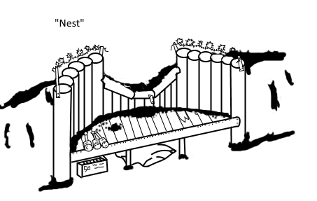
Whereas the classical trench forces you into the standing position to be able to even see the other side, these nests provide a crouched alternative, ideal for heavy weapons or marksmen. Every nest has a tiny inventory to it. If an ammo can is placed in it (link), it becomes linked to the machine gun/ammo can in the hands of soldiers using it.
A heavy machine gun can be placed here.

MORTAR PIT
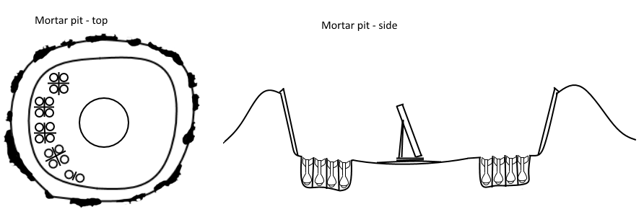

The mortar pit provides excellent protection from infantry attacks and counter-shelling, on top of having in-built shell storage. Shells stored in the ground (the model simply shows boxes partially dug into the earth) can be detonated by any explosive weapon dropped directly into the pit, but they won’t magnify the explosion due to more or less safely facing down. They will be completely lost in that case, though.

The mortar pit, like the nest, links to the mortar/projectile pouch (LINK WILL BE HERE), refilling them in a no-hassle way and slightly boosting reload and handling rate.
ARTILLERY RAMP
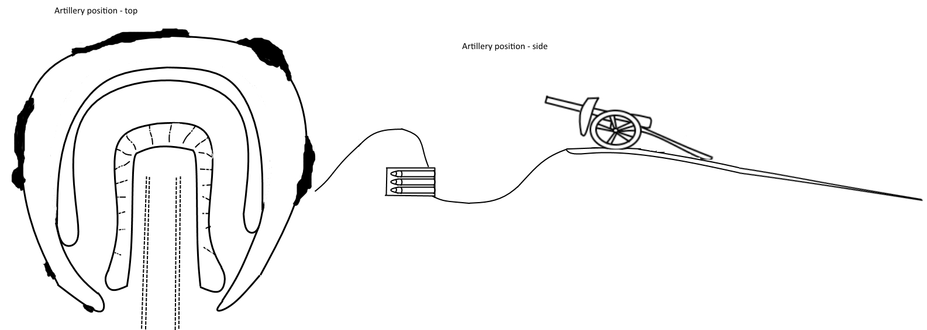
The artillery ramp is not modular and does not connect with trenches - it serves the same functionality as the mortar pit, although for the big guns. The platform is capable of supporting artillery, howitzers, and AI-crewed guns if properly transported (LINK WILL BE HERE). It’s storage accepts all heavy shells, but does not link to the gun itself. These still have to be manually carried.

