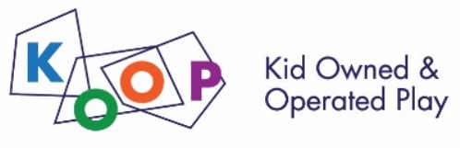
KOOP Adventure Play Spring Break Camp
at University Primary School Registration Form
Mail in or drop off this form with the payment to Christine at University Primary School, 51 Gerty Drive in Champaign, IL 61820 on or before March 10. (Checks made out to University of Illinois)
Note: You will not be fully registered until both the form and the payment have been received. Payments are non- refundable.

Details about the camp daily schedule, snacks/lunch and projects will be emailed prior to the beginning of camp. Ages: 4-12 (flexible.) This camp is open to the public!

Please indicate your choice:
Full Day (8:30- 5:30) -or- Morning (8:30- 1) -or- Afternoon (1- 5:30)

Camp Cost Per Session:
Full Day = $210 Half Day = $150 Total: $_______

Camper Information:
Camper’s First/Last Name: ____________________________________________
School: ____________________________________________________________
Parent/Guardian Name(s):_____________________________________________
Email:______________________________________________________________
Home Address:______________________________________________________
Phone Numbers:_____________________________________________________
Emergency Contact Name/Relation:_____________________________________
Emergency Contact Phone:____________________________________________
People authorized to pick up your camper other than parent or emergency contact:___________________________________________________________
__________________________________________________________________
Did this camper attend previous KOOP Camps or Events? Yes No
Allergies & Instructions for handling allergies if needed:_____________________
__________________________________________________________________
Special needs, interests or things we should know about your camper?________

