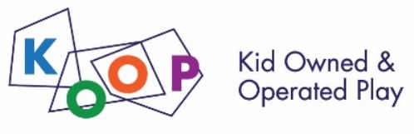
KOOP Adventure Play Winter Camp
at University Primary School Registration Form
Please return this form, with payment (made out to University of Illinois) to Christine Wyant at cwyant@illinois.edu or in person at University Primary School, 51 Gerty Drive in Champaign, IL 61820 on or before December 16. Details about the camp daily schedule, snacks/lunch and projects will be emailed prior to the beginning of each session. Ages: 4-12 (flexible.) This camp is open to the public!

Please indicate which session(s) your child will attend camp.
- December 21-23
Full Day (8:30- 5:30) -or- Morning (8:30- 1) -or- Afternoon (1- 5:30)
- January 2-4
Full Day (8:30- 5:30) -or- Morning (8:30- 1) -or- Afternoon (1- 5:30)

Camp Cost Per Session:
Half Day = $100 Full Day = $150 Total: $_______

Camper Information:
Camper’s First/Last Name: ____________________________________________
School: ____________________________________________________________
Parent/Guardian Name(s):_____________________________________________
Email:______________________________________________________________
Home Address:______________________________________________________
Phone Numbers:_____________________________________________________
Emergency Contact Name/Relation:_____________________________________
Emergency Contact Phone:____________________________________________
Names of Persons authorized to pick up your camper other parent or emergency contact:___________________________________________________________
__________________________________________________________________
Did this camper attend previous KOOP Camps or Events? Yes No
Allergies & Instructions for handling allergies if needed:_____________________
__________________________________________________________________
Special needs, interests or things we should know about your camper?________
__________________________________________________________________

