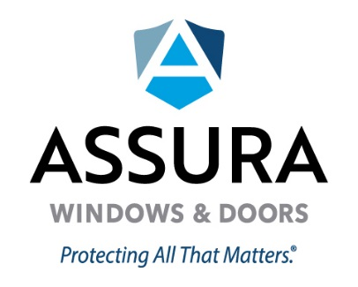

MAINTENANCE GUIDELINES
Owner’s Responsibility – Windows and doors require reasonable care and periodic cleaning. Coastal environments can be extremely corrosive and some finish deterioration is normal and should be expected. Product installed in coastal environments (within ten (10) miles of sea coast or other salt water source) require increased care. Maintenance is a warranty requirement and should be performed on a regular basis.
Window and Door Maintenance Guidelines- Thorough cleaning of all exterior window and door surfaces (including those not visible when the operating unit is closed) with a cloth every ten (10) months at a minimum, and more frequently if necessary to prevent the build-up of salt or corrosive residue. Clean glass, hardware, and frame surface with mild soap using a soft cloth. Wipe all surface dry with a soft cloth. Moving parts such as hinges, operator arms, and lock should be lubricated after cleaning. Inspect weather-strip regularly and replace if torn, cracked, brittle, or dislodged. Keep sill track and weep holes free of debris, using a vacuum or wipe thoroughly with a damp Any chips or scratches caused by others must be repaired immediately and not left exposed to the elements.
Product installed in coastal environments (within ten (10) miles of sea coast or other salt water source) require increased care and period cleaning at least monthly. Assura Windows and Doors LLC recommends 2605 Kynar paint for products installed within 10 miles of sea coast or other salt water source.
Screen Maintenance Guidelines – Remove screens and place on flat clean, dirt free surface. Clean screen mesh surface with a mild soap and water, using a soft brush. Gently spray with water for stubborn dirt buildup. Clean frame surface with mild soap and water using a soft rag or sponge. Rinse surface clean, dry frame surface, and reinstall.
Cleaning Tips – Do not use petroleum-based, abrasive or caustic cleaners or solvents. Do not use wire brushes, steel wool, sandpaper, abrasives or other similar cleaning tools which will abrade the costing surface.
Important Warranty Information - Failure to comply with these reasonable care and periodic cleaning requirements will void the Warranty. Documented proof of regular scheduled cleaning is required.

