 | - 3 facts they have learned in the lesson  - 2 questions they have or wonder about  - 1 personal ‘a-ha’ moment – they had during the lesson or 1 key concept they identified
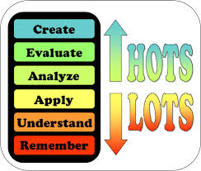 | Questions at Blooms’ levels  - 3 remember/understand  - 2 application/ evaluate  - 1 create/analyse

 | Questions or statements that link to a text (three level guide)  - 3 statements/questions “on the line”  - 2 statements/questions “between the line”  - 1 statement/question “beyond the line”  (AFL_1:FTT12)
 | - 3 things you Found out  - 2 Interesting things  - 1 Question you still have

