Name:
Date:
Rules for listening and speaking during reading time:
Did I keep my eyes on the speaker? | 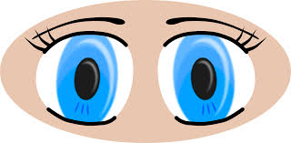 | 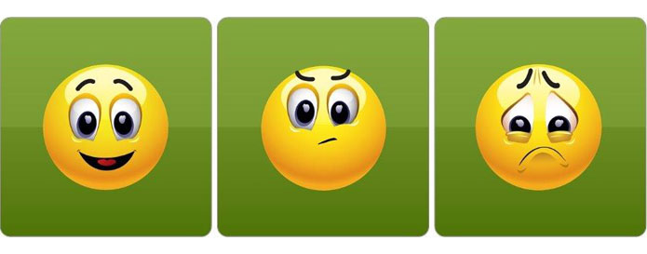
Did I sit in listening position? | 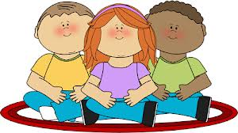
Did I listen while others were speaking? | 
Did I take turns speaking? | 
Did I raise my hand? | 

ا
Name:
Date:
Rules for listening and speaking during reading time:
Did I keep my eyes on the speaker? | 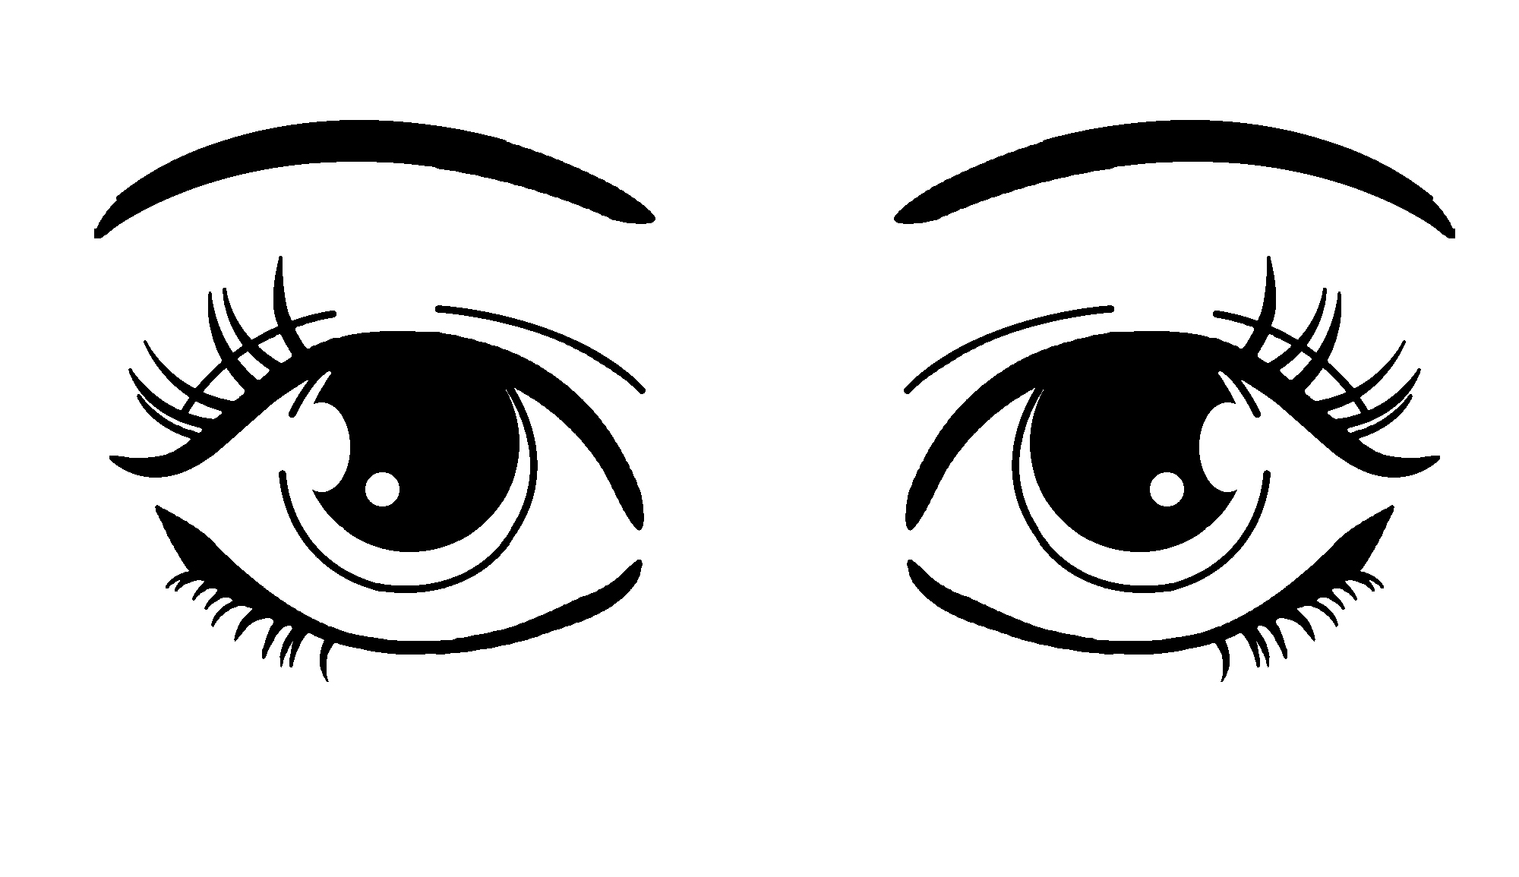 | 
Did I sit in listening position? | 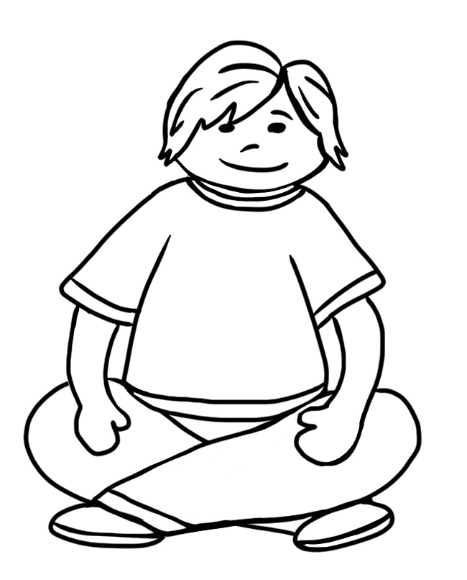
Did I listen while others were speaking? | 
Did I take turns speaking? | 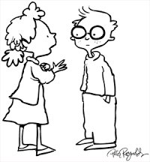
Did I raise my hand? | 