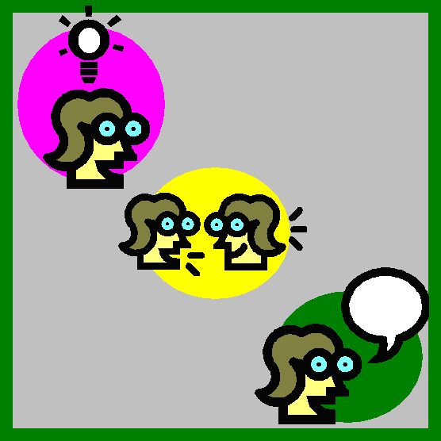 | Think-pair-share | Students think individually  They share their thoughts with a partner  They share their thoughts with the class
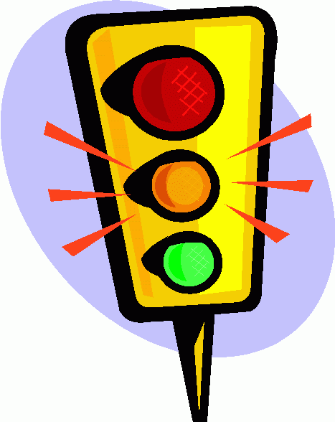 | Traffic lights | Green Light – understand very well / easy  Orange light = understand well/ok  Red light = do not understand/difficult
 | Plenary questions | What did you learn today?  What did you find easy?  What is difficult or confusing?  What do we need to learn about next?
 | Thumbs up/thumbs down | Students use this to indicate their level of understanding  Thumbs up = understand very well  Thumbs sideways = understand well  Thumbs down = do not understand
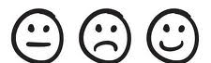 | Smiley face | Smiley face = Very well/easy  Straight face = well/ok  Sad face = Not well/ difficult
 | Short quizzes | Questions asked by teacher or students as a learning check
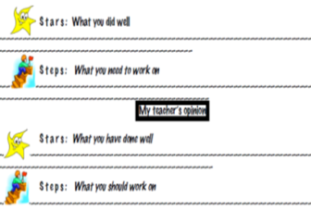 | Feedback form | A written form that is filled in by both the student and the teacher
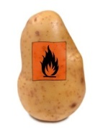 | Carousel Brainstorm/ Hot Potato | Students work in small groups to brainstorm answers to questions or responses to statements about the learning outcomes. Questions or statements are written on large sheets of paper and posted around the room. Each group records their ideas on one sheet of paper. At timed intervals groups move to the next paper where they read what the previous group has written, discuss, improve and add their ideas. Ideas can be added during the lesson. At end of lesson revisit to check if all main ideas have been listed. Discuss.
 | Mini whiteboards | Responses, answers or solutions are completed on whiteboards and held up. Teacher takes note of students who have grasped the concept and those who need further support.
 | Exit cards | Cards or notes that students hand to teacher or drop in a box when they leave the class. Students write their name and the answer to a question, solution to a problem or summary of the learning. The information from the cards is used to group students and plan for the next lesson.
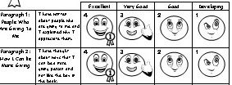 | Self-assessment rubric | Students assess themselves/their learning on a rubric.
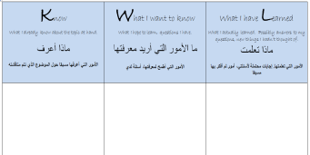 | KWL | At the beginning of a topic pupils create a grid with three columns –  What They Know;  What They Want To Know;  What They Have Learnt.  They begin by brainstorming and filling in the first two columns and then return to the third at the end of the unit (or refer  throughout)  Variation – extra column ‘How Will I Learn’
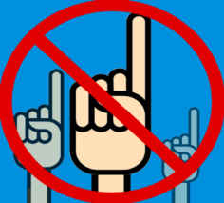 | Hands down | Tell pupils they should only raise their hand to ask a question, not to answer one.  The teacher then chooses pupils to answer, therefore gaining information on whether everyone is learning.  Write names on lollipop sticks and pull out at random to answer.  Write numbers on balls or counters that tally to register or seating position and re-use with every class.
X=Y | Questioning (X=Y) | Ask students why X is an example of Y e.g  Why is an apple an example of a fruit?  Why is a fox an example of a mammal?  Questioning in this way avoids factual recall and asks for the underlying reasoning to be made explicit
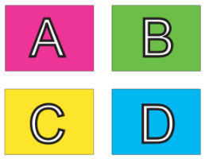 | Questioning  ABCD cards | Laminate a set of cards so every member of the class has four, with A, B, C and D written on them. Ask questions with four answers and pupils can show you their answer.  Encourage them not to look at other people’s response so as to copy
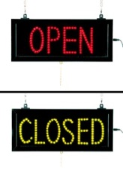 | Open questions | Closed questions can be useful but are not good for facilitating the use of abstract thinking skills, encouraging talking or eliciting understanding. Open questions are more likely to do this and thus to  Improve learning.
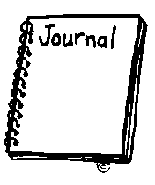 | Learning Journal | The teacher helps students to create a learning journal in which they can reflect on and review their learning.
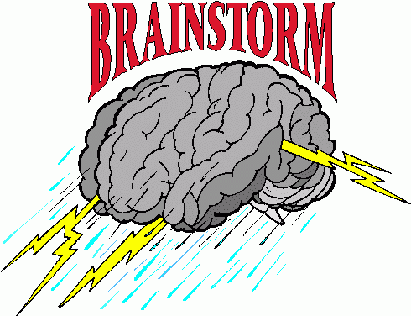 | Brainstorm | Students share existing knowledge or ideas about a subject or suggest ideas to solve a problem – good for activating prior learning.
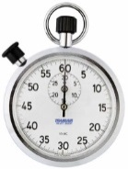 | Wait time | Increasing the wait time after a question allows students time to think and therefore to produce more considered answers.
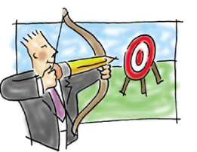 | Clear targets | The teacher puts learning outcomes on the board at the beginning of the lesson so that learning can be evaluated.
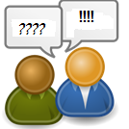 | Peer Evaluation | Students evaluate each other’s learning and feedback to each other. In the process they will also come to understand their own learning better.
 | Group Feedback  ا | Groups of students feedback to the teacher concerning self-assessment or peer-assessment of work.
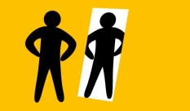 | Self-evaluation | Self-evaluation involves helping students to reflect on and evaluate what they have learnt and how they have learnt.

