 | A new opportunity today was…
 | Today I confirmed that …ا
 | I still wonder about

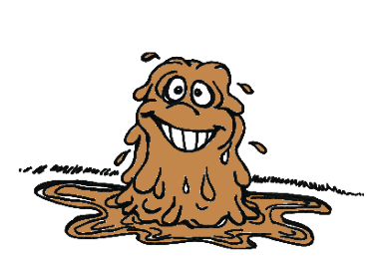 | Write down your muddiest, or most confusing point from the day’s lesson.

