QUICK WRITE/QUICK DRAW
There is evidence that students who create visual representations of ideas are better able to
understand and recall the idea. Teachers use a variety of activities that draw on non linguistic
methods to show understanding. For example, teachers ask students to make models, graphics,
mental pictures, and work kinaesthetically.
In this strategy students are encouraged to show their understanding in both linguistic and
WRITE
D
R
A
W

non linguistic ways (right and left brain learning).
BEFORE
Teacher needs to:
- Duplicate the template – one for each student
- Decide which lesson, and when in the lesson
- Decide what understanding s/he wants to check eg
  - Maths:
  - English/language/Arts:
  - Science/health/PED:
  - Social/Islamic:
- Rehearse the organisation and introduction to students (if first time use)
- Consider how to assist struggling learners eg
  - a template with steps already listed, and student adds drawing or
  - drawing provided, and students add words
  - 2 students work together, 1 writes & 1 draws

DURING
- Teacher explains that
  - this is not a test
  - this is a tool that will help the teacher know what students understand
  - therefore students need to work independently
  - this tool uses both sides of the brain
  - it involves “quick writing” and “quick drawing”
  - they don’t need to be an artist!
  - they will write and draw for 10 minutes
- Teacher may observe during the activity
  - Student readiness (some may resist first time around)
  - Student ability to work on their own
  - Whether students start with writing/drawing
  - And provide a prompt, especially if first time (but not do the activity!)

AFTER
- Teacher will decide whether to
  - collect in students’ completed templates straightaway
  - enable students to share their templates with others (and listen to their conversations)
  - encourage students to add to their templates (in different colour) – to show value of sharing ideas
- Teacher will
  - Collect completed template
  - Make notes about misunderstandings or gaps in students understanding
  - Give feedback (briefly) to the class about the way in which they worked, a few specific points about what s/he noted they had all understood
  - Form a needs-based group to follow up next day, if necessary (planning may have to be altered) or whole class if a specific point not understood by all.

Name : _________________________________________________ Date: ________________

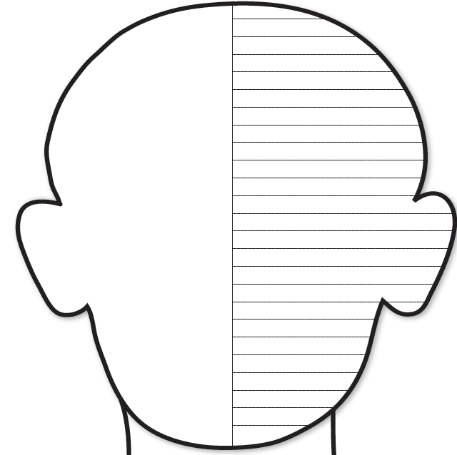

Adapted from ’25 Quick Formative Assessments for a Differentiated Classroom’ by Judith Dodge

