#KeepFamiliesTogether Social Media Toolkit
Consider sharing these tweets and images on social media until the July 9, 2019 comment deadline.
Sample Tweets:
- Speak the Truth, @SecretaryCarson! The “mixed-status” immigration rule is based on a lie! Let HUD know that we will not stand for the cruel proposal. Submit comments now www.Keep-Families-Together.org #KeepFamiliesTogether
- Let’s be clear. Federal subsidies DO NOT support undocumented immigrants! Then why is @SecretaryCarson proposing such a cruel rule? Let HUD know that a proposal like this will not stand. Send comments today www.Keep-Families-Together.org #KeepFamiliesTogether
- A proposal to evict over 100,000 people during a housing crisis is unconscionable. Let @SecretaryCarson know that children belong with their families. Send comments today www.Keep-Families-Together.org #KeepFamiliesTogether
- The HUD proposed rule to prohibit families of “mixed-status” from living in federally subsidized housing is cruel. Tell @SecretaryCarson to #KeepFamilesTogether & retract this rule #protectfamilies www.Keep-Families-Together.org
- HUD does NOT fund undocumented immigrants living in subsidized housing! The new proposed rule would break up families & do little to shorten waitlists. #KeepFamiliesTogether Tell @SecretaryCarson NO to this cruel rule! #protectfamilies www.Keep-Families-Together.org
- .@SecretaryCarson’s unconscionable proposal would evict over 100k people, incl. 55k deeply poor kids that are US citizens or legal residents, at the height of an #affordablehousing crisis. Let HUD know today that you oppose this rule www.Keep-Families-Together.org #KeepFamiliesTogether
- #FACTS: Undocumented immigrants do NOT receive housing subsidies–it’s not allowed in law. HUD’s rule isn’t for shortening housing waiting lists but for instilling fear in families. Tell @SecretaryCarson we will not stand for this! www.Keep-Families-Together.org #KeepFamiliesTogether
- Prohibiting “mixed-status” families from being able to live together is cruel & unnecessary. Tell @SecretaryCarson to #KeepFamiliesTogether www.Keep-Families-Together.org #protectfamilies
- HUD’s “mixed-status” families rule places thousands, incl. 55,000 children that are US citizens or legal residents, at risk of homelessness. #KeepFamiliesTogether. Tell @SecretaryCarson you stand against splitting up/evicting families www.Keep-Families-Together.org
- Hsg stability is crucial for getting families on a path to a better life. HUD’s proposed “mixed-status” rule threatens this path for some low-income immigrants. #KeepFamiliesTogether, support housing asst. for people w/ greatest needs www.Keep-Families-Together.org
- DUE JULY 9: Submit comments now & tell HUD to #KeepFamiliesTogether www.Keep-Families-Together.org
- The time is NOW to let HUD know that its proposed rule to force 25K “mixed-status” immigrant-families (incl. 55k children) to separate or face eviction is just cruel! Submit comments before the July 9 deadline #KeepFamiliesTogether www.Keep-Families-Together.org

Sample Images:
Download all sample images at: https://rebrand.ly/kt0sdi

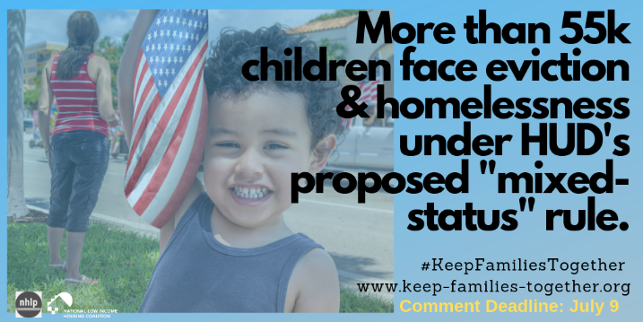
Download

Download

Download

Download

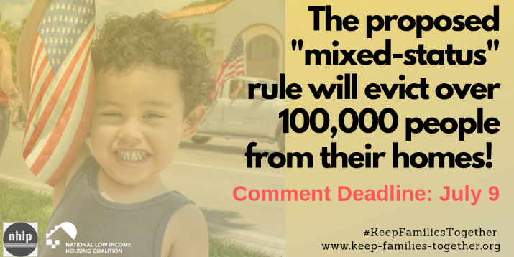
Download

