Solicitation for Applications

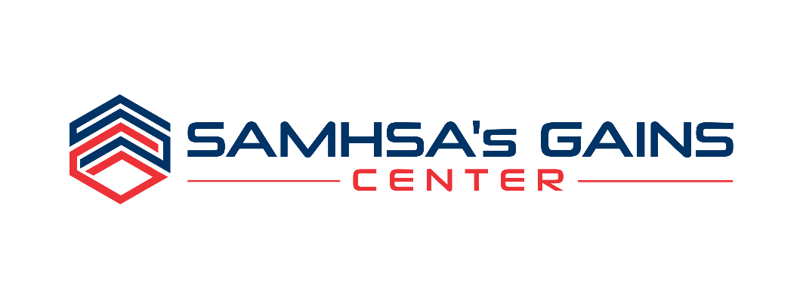
SAMHSA'S GAINS CENTER'S CRIMINAL JUSTICE LEARNING COLLABORATIVES

Data-Driven Equity & Inclusion

Please complete this application in its entirety to ensure that we have accurate background information on your community and that the appropriate level of commitment among Key Stakeholders is demonstrated.
Incomplete applications will not be considered.

PLEASE RETURN THIS APPLICATION VIA POSTAL MAIL OR E-MAIL BY FEBRUARY 20, 2019:

SAMHSA’s GAINS Center
Policy Research Associates, Inc.
345 Delaware Avenue
Delmar, NY 12054

Attn: Anthony Fortuna, Program Coordinator

Phone: 800.311.4246 or 518.439.7415 Ext. 5257
E-mail: afortuna@prainc.com

OvervieW
SAMHSA’s GAINS Center for Behavioral Health and Justice Transformation, operated by Policy Research Associates, Inc. (PRA), is known nationally for its work in regard to people with behavioral health needs who are involved in the criminal justice system. The GAINS Center is currently accepting applications from communities interested in collaborating with subject matter experts through Criminal Justice Learning Collaboratives designed to explore five topics:

- Risk-Need-Responsivity
- Family Treatment Courts
- Data-Driven Equity and Inclusion
- Competency to Stand Trial/Competency Restoration
- SAMHSA’s Eight Guiding Principles for Behavioral Health and Criminal Justice

The Learning Collaborative Model brings together local community teams in a blend of virtual and onsite events to create coordinated local strategic plans and implementation strategies for the topic of focus. Selected teams will work intensively to determine optimal ways to implement best practices and define success indicators for each topic area noted above. Each topic-specific Learning Collaborative will engage subject-matter experts to work with community teams during the implementation process and to facilitate peer-to-peer sharing within and across communities. The unique blend of virtual and onsite methods will offer selected teams an intimate and familiar environment in which to learn and complete their implementation work, while providing a virtual forum to share with other communities and receive an array of technical assistance from subject matter experts across the country.

The Data-Driven Equity and Inclusion Learning Collaborative will focus on creating and implementing strategies to reduce racial and ethnic disparities in local criminal justice and behavioral health systems. This collaborative is designed to support jurisdictions through a data-driven process that moves selected communities from recognizing disparities that exist to implementing practice changes around critical access, service-delivery, or decision-making points that are driving the disparities. This collaborative will challenge participating sites to go beyond training and conversations and to begin implementing inclusive and informed strategies that actively address and reduce disparities. Sites will be supported by expertise from both GAINS staff and consultants, as well as from the National Association of Drug Court Professionals (NADCP). Applicants seeking to participate in this opportunity must focus efforts of the Learning Collaborative work on one intercept of the Sequential Intercept Model, choosing from Intercepts 3-5 (see the Sequential Intercept Model figure on page 4).

Key Dates for the Data-Driven Equity and Inclusion Learning Collaborative

- March - May 2019 – onsite, face-to-face training and ongoing technical assistance on an equity and inclusion process developed by the National Drug Court Institute (NDCI) with each selected community

- June 13-14, 2019 – Data-Driven Equity and Inclusion Learning Collaborative virtual meeting

- July and August 2019 – monthly calls with the six selected communities and GAINS and/or NADCP subject matter experts

- August 2019 – each selected community submits report on outcomes measured to GAINS staff

Informational webinars were held on December 5 and December 6, 2018. To learn more about the solicitation, stream a webinar recording: December 5 Recording | December 6 Recording.
If you require an alternative format or captioning, please contact SAMHSA’s GAINS Center.

Please note: This opportunity has been updated following these webinars to shift the focus of this Learning Collaborative from Intercepts 0-3 to Intercepts 3-5.

Purpose & Background
The Learning Collaboratives are designed to achieve four key objectives:

- Enhance collective knowledge of key issues and familiarity with the topic
- Understand promising, best, and evidence-based practices to address the topic and related issues
- Develop strategic plans that focus on the issue, including defining assignments, deadlines, and measurable outcomes to be reported
- Increase knowledge about the challenges and lessons learned in implementing strategies through peer-to-peer sharing via a virtual convening and monthly collaborative calls

Prior to the virtual meeting, selected sites will receive onsite, face-to-face training on an equity and inclusion process developed by the National Drug Court Institute (NDCI). This data-driven, intensive program is designed to help jurisdictions identify and address disparities and bias, as well as enable equitable access, retention, and completion of criminal justice diversion programs. Each participating community will receive onsite training on the NDCI equity and inclusion program to focus on the specific key issues identified within their community. During this onsite training, selected teams will begin development of action plans designed to address disparities in their jurisdictions, within the selected intercepts. Trainings and ongoing support will be delivered by experts at NADCP and SAMHSA’s GAINS Center; and will take place between March and May 2019. Dates will be determined in collaboration with the selected communities.

After the onsite training and plan development, all teams will participate in a 1 ½-2 day Learning Collaborative virtual meeting on June 13-14, 2019 to begin peer-to-peer learning across the six selected communities. This virtual convening will create an opportunity for teams to share their plans with one another, facilitating cross-community learning. At this event, selected communities will also receive additional technical assistance from subject matter experts to continue strategic planning efforts and codify plans for implementation within the respective communities. The virtual meeting will include a blend of peer-to-peer collaboration and individualized technical assistance for the six participating communities.

Following the virtual event, ongoing technical assistance will be provided via monthly calls that include all six selected teams and subject matter experts to continue fostering the cross-community peer-to-peer learning. The virtual meeting and follow up will allow communities and subject matter experts ongoing opportunities to work toward achieving the implementation goals identified in the action plan developed and refined as part of the Learning Collaborative process.

Data-Driven Equity and Inclusion
Racial and ethnic disparities persist in many local and state criminal justice systems despite decades of reform efforts. These disparities exist across the criminal justice continuum, as the over-representation of people of color is documented in law enforcement contacts, jail populations, pretrial detention, and prisons. Studies also show that people of color in some areas are more likely to be sentenced to prison than referred to treatment courts; in other areas, they are more likely to be referred to treatment court than diverted to community-based treatment services without criminal justice oversight. People of color also face barriers to accessing community-based mental health and substance use treatment, as well as treatment services that resonate with their perspectives, cultures, and values. Communities implementing diversion programs often miss the opportunity to reduce disparities by failing to incorporate specific strategies and action steps that ensure equitable access and decision-making for people considered for diversion.

SAMHSA has placed a priority on addressing inequities, as evidenced by the work of the Office of Behavioral Health Equity, as well as the Disparity Impact Statement requirement for its grantees. This Learning Collaborative will advance SAMHSA’s work to address racial and ethnic disparities by supporting communities through a data-driven process to create the practice changes needed to reduce disparate outcomes within criminal justice and behavioral health systems. This opportunity may benefit communities that are working to address issues raised in their SAMHSA grant’s Disparity Impact Statement, seeking to be in compliance with industry standards (such as Drug Court Best Practice Standards), or repairing community relations between criminal justice, behavioral health, and community members.

Members will participate in a data-driven approach to better understand and create inclusive and transformational strategies for addressing identified disparities in their communities that stem from racial and ethnic inequities in criminal justice involvement and behavioral health. This Learning Collaborative will provide time, space, and facilitated support to communities ready to move from data analysis/contemplation into action and practice change to reduce or eliminate the identified disparities.

Applicants seeking to participate in this Learning Collaborative must select one intercept of the Sequential Intercept Model, choosing from Intercepts 3-5 as the focus of their work in the Learning Collaborative.

Sequential Intercept Model:
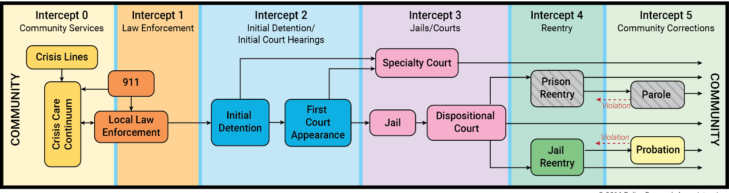

Site Selection
SAMHSA’s GAINS Center for Behavioral Health and Justice Transformation will host all activities related to the Learning Collaborative free of charge to selected communities. A Learning Collaborative virtual meeting, in which all Learning Collaborative participant teams must participate, will be held on June 13-14, 2019. Dates for the site visits and NDCI training will be established in coordination with the selected teams.

There are no fees for registration, tuition, or materials associated participation in the Learning Collaborative. The GAINS Center will pay all costs associated with pre and post-virtual meeting coordination, conference calls, and GAINS Center staff and/or subject matter expert time and travel.

Up to six sites will be selected through this solicitation. Communities selected for these events must be able to provide facilities and A/V resources to comfortably accommodate up to 15-25 event participants. Communities must be able to provide a scribe for notetaking and documenting the onsite visit. Further details will be provided to communities selected to participate.

[Please proceed to page 5]

To be considered, all applications must be received by February 20, 2019. Selected communities will be notified on or about February 27, 2019.

IDentified Team members/community partners
A community submitting an application should strive to include representation from a broad array of key stakeholders. The identification of 15-20 professional and community partners should include, but not be limited to:
- Community representatives/leaders of communities impacted
- Criminal justice agencies involved at the selected intercept, may include the following:
  - Law enforcement/Crisis Intervention Team representatives
  - Sheriff’s Office/jail personnel/jail mental health provider
  - Pretrial Services
  - Representative from indigent defense/public defenders’ office
  - Representative from prosecutor’s/district attorney’s office
  - Treatment court judges/treatment court administrators/staff
- Community behavioral health care providers involved at the selected intercept
  - Mobile crisis/co-response teams/mobile crisis outreach teams
  - Urgent care/crisis care or stabilization centers
  - Hospitals/emergency departments
- Social service coordinators
- Peer specialists/People with lived experience
- Local universities involved in criminal justice or behavioral health programs
- Data analysts involved in gathering, analyzing, and reporting at the selected intercept
- Local expert(s) working to reduce racial inequities in the community

Application Requirements
It is required that each applicant identify leaders within their community that support this project and are dedicated to allocating staff time to participate in the technical assistance activities. Support must be illustrated by a written letter of support or commitment from diverse community partners.

Please include letters of support from the following (* are required):

- Community representatives/leaders of communities impacted*
- Criminal justice agencies involved at the selected intercept*
- Organization submitting application (if not one of the above)*
- Community behavioral health care providers involved at the selected intercept
- Organization(s) that collect or house key data points at the selected intercept
- Peer specialist/Person with lived experience of mental or substance use disorder and justice-involvement

In addition, communities selected must agree to participate in the following:
- Pre-event planning conference call(s) with GAINS Center staff, including but not limited to kick-off calls, preparatory activities, and IT calls
- Local planning committee activities on an as needed basis to determine participants, recruit participants for virtual and on-site meetings, confirm logistical arrangements, etc.
- Provide space to host the Learning Collaborative virtual meeting and pre-meeting training visit – space must be able to comfortably accommodate up to a total of 25 people (up to 15-20 team participants, observers, and 2-3 GAINS Center representatives)
- Participate in Learning Collaborative virtual meeting and pre-meeting training visit by GAINS staff and/or consultants
- Engage in post-technical assistance activities, including but not limited to reporting and consultation calls

Following the technical assistance delivery, teams will be required to report on outcome measures determined during the Learning Collaborative virtual meeting. Reports must be submitted to the GAINS Center in August 2019, following the Learning Collaborative.

SAMHSA's GAINS CENTER'S CRIMINAL JUSTICE LEARNING COLLABORATIVES

data-driven Equity & Inclusion Learning Collaborative SITE Application

Please complete the application below.
Only complete applications will be considered for site selection.

APPLICANT JURISDICTION/COMMUNITY: _________________________________________________________________________________

NAME OF PERSON COMPLETING THIS FORM:
TITLE:
ORGANIZATION:
ADDRESS:
PHONE:
EMAIL:

PLEASE COMPLETE AND ATTACH A SEPARATE STATEMENT TO THIS APPLICATION THAT ADDRESSES THE APPLICANT EVALUATION CRITERIA BELOW. YOUR STATEMENT SHOULD BE A MAXIMUM OF FIVE SINGLE-SPACED PAGES IN LENGTH, AND SHOULD CLEARLY INDICATE WHY YOUR COMMUNITY SHOULD BE SELECTED TO participate in THE DATA-DRIVEN equity & Inclusion learning collaborative

Please address the following in your statement:

- Using the Sequential Intercept Model (page 4), identify which one of the following intercepts your jurisdiction will focus on to reduce disparities in the criminal justice and behavioral health systems in your community if selected to participate in the Equity & Inclusion Learning Collaborative:

- Intercept 3 – Jail Detention/Courts
- Intercept 4 – Reentry
- Intercept 5 – Community Corrections

- Provide a brief description of your jurisdiction/community (including population, demographics, available resources, and any other information that you think gives us a good “picture” of your community)

- Explain what measurable disproportionalities or disparities related to the selected intercept have been identified and are being considered for practice change through the Learning Collaborative
  - Include a brief description of the subpopulations in your community (e.g., by gender, race/ethnicity, age, socio-economic status, health condition, etc.) that are most impacted by the identified disproportionalities or disparities

- Discuss 2-3 specific goals that your community hopes to achieve at the selected intercept related to addressing racial and ethnic disparities across the criminal justice system and specifically with regard to identified or potential criminal justice and behavioral health inequities at the selected intercept

- Describe the current efforts that your jurisdiction already has underway to understand and address disparities at the selected intercept (e.g., data collection/analysis, MOUs in place, committee meetings, existing strategic plans, etc.)

- If already identified, describe any specific decision-points within the selected intercept that will or could be selected for strategies to reduce disparities (i.e., diversion from arrest to services, referrals to drug court programs, acceptance into diversion programs, etc.)
  - Please indicate if these decision-points are not yet determined

- Describe the data available, as well as access to data and information systems that are available within your jurisdiction, for measuring and assessing changes in disparities at the selected intercept

- Discuss any other policies, strategies, and programs/services that have already been implemented to better identify and respond to the needs of adults with mental and/or substance use disorders who are at risk of or are experiencing justice-involvement at the selected intercept

- Discuss any obstacles or hurdles you anticipate in regards to adhering to the schedule or expectations of this opportunity

- Briefly describe why it is important for your jurisdiction to be part of this learning collaborative right now

Please identify a primary contact for your jurisdiction, if it is someone different than the applicant. Please ensure the primary contact is someone who will be accessible to the participants and to GAINS Center staff throughout the entire duration of the Learning Collaborative.

PRIMARY CONTACT FOR THIS APPLICATION
Primary Contact Name: _________________________________________________________________________________________

Role/Position: ___________________________________________________________________________________________________

Agency: ___________________________________________________________________________________________________________

Address: __________________________________________________________________________________________________________

City/State/Zip: ___________________________________________________________________________________________________

Phone: __________________________________________________

Fax: _____________________________________________________

E-mail: __________________________________________________

Please identify the lead agencies/organizations that have agreed to participate in the DATA-DRIVEN EQUITY & INCLUSION LEARNING COLLABORATIVE.
Please complete the team selection grid below to indicate key stakeholders who have agreed to participate as part of your community team. AS INDICATED EARLIER, IT IS EXPECTED THAT ALL identified team members/stakeholders are available to participate in the learning collaborative VIRTuAL meetingS on thE SPECIFIED DATES.
Team Selection Grid
# | Required* | Role | Name | Affiliation | Letter of Commitment/Support Included? (Y/N)
1 | Community representatives/leaders of communities impacted*
2 | Criminal justice agencies involved at the selected intercept*
3 | Organization submitting application (if not one of the above)*
4
5
6
7
8
9
10
11
12
13
14
15

Please attach required letters of commitment/support (noted on page 5) to your application.

Thank you! SAMHSA’s GAINS Center sincerely appreciates your interest in this initiative.

PLEASE RETURN THIS APPLICATION VIA POSTAL MAIL OR E-MAIL BY FEBRUARY 20, 2019:

SAMHSA’s GAINS Center
Policy Research Associates, Inc.
345 Delaware Avenue
Delmar, NY 12054

Attn: Anthony Fortuna, Program Coordinator

Phone: 800.311.4246 or 518.439.7415 Ext. 5257
E-mail: afortuna@prainc.com

Questions should be directed to Anthony Fortuna at the phone number and email address listed above.

Late submissions will not be accepted or reviewed.
Incomplete applications will not be considered.
All applicants will receive notification regarding the status of their application on or about February 27, 2019. Notification will be distributed via email.

https://www.nadcp.org/magazine/AllRiseFall2018/index.html

