Solicitation for Applications

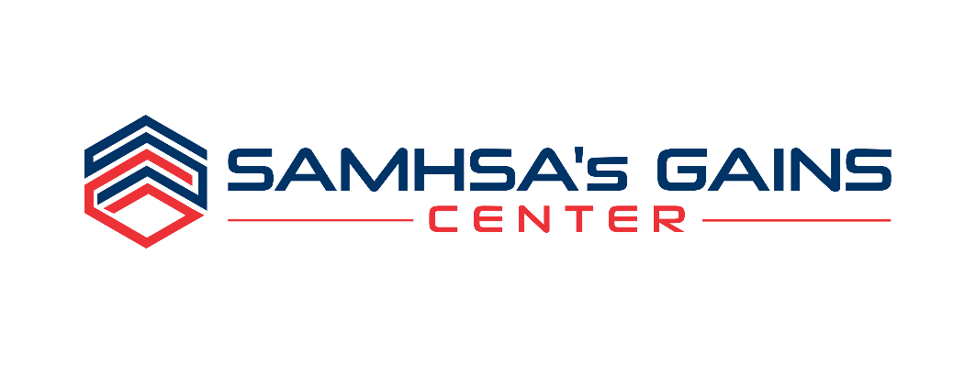
SAMHSA'S GAINS CENTER'S CRIMINAL JUSTICE LEARNING COLLABORATIVES
Improving Risk-Need-Responsivity Policies and Practice in Adult Drug Courts and Reentry Programs

Please complete this application in its entirety to ensure that we have accurate background information on your jurisdiction and that the appropriate level of commitment among Key Stakeholders is demonstrated.
Incomplete applications will not be considered.

PLEASE RETURN THIS APPLICATION VIA POSTAL MAIL OR E-MAIL BY FEBRUARY 20, 2019:

SAMHSA’s GAINS Center
Policy Research Associates, Inc.
345 Delaware Avenue
Delmar, NY 12054

Attn: Anthony Fortuna, Program Coordinator

Phone: 800.311.4246 or 518.439.7415 Ext. 5257
E-mail: afortuna@prainc.com

Overview
SAMHSA’s GAINS Center for Behavioral Health and Justice Transformation, operated by Policy Research Associates, Inc. (PRA), is known nationally for its work in regard to people with behavioral health needs who are involved in the criminal justice system. The GAINS Center is currently soliciting applications from jurisdictions interested in collaborating with subject matter experts through Criminal Justice Learning Collaboratives designed to explore five topics:

- Risk-Need-Responsivity
- Family Treatment Courts
- Data-Driven Equity and Inclusion
- Competency to Stand Trial/Competency Restoration
- SAMHSA’s Eight Guiding Principles for Behavioral Health and Criminal Justice

The Learning Collaborative Model brings together local jurisdiction teams in a blend of virtual and onsite events to create coordinated local strategic plans and implementation strategies for the topic of focus. Selected teams will work intensively to determine optimal ways to implement best practices and define success indicators for each topic area noted above. Each topic-specific Learning Collaborative will engage subject-matter experts to work with jurisdiction teams during the implementation process and to facilitate peer-to-peer sharing. The unique blend of virtual and onsite methods will offer selected teams an intimate and familiar environment in which to learn and complete their implementation work, while providing a virtual forum to share with other jurisdictions and receive an array of technical assistance from subject matter experts across the country.

The goal of the Improving Risk-Need-Responsivity Policies and Practice in Adult Drug Courts and Reentry Programs Learning Collaborative is to advance policies and practices around Risk-Need-Responsivity in adult drug courts and reentry programs. To be eligible for this opportunity, applicants must include a drug court or re-entry program as a primary partner, and indicate this partnership and application type on page 8. This Learning Collaborative will include expertise from both GAINS staff and consultants as well as George Mason University, supporting selected jurisdictions with using risk-need profiles to identify how to better work with individuals served by drug courts and re-entry programs.

The Learning Collaborative virtual meetings for this topic will take place on June 4-5, 2019.

Informational webinars were held on December 5 and December 6, 2018. To learn more about the solicitation, stream a webinar recording: December 5 Recording | December 6 Recording
Please note: If you require an alternative format or captioning, please contact SAMHSA’s GAINS Center.

Purpose & background

The Learning Collaboratives are designed to achieve four key objectives:

- Enhance collective knowledge of key issues and familiarity with the topic
- Understand promising, best, and evidence-based practices to address the topic and related issues
- Develop strategic plans that focus on the issue, including defining assignments, deadlines, and measurable outcomes to be reported
- Increase knowledge about the challenges and lessons learned in implementing strategies through peer-to-peer sharing via a virtual convening and monthly collaborative calls

Each Learning Collaborative virtual meeting will be a 1 ½ - 2-day event. Following the virtual event, each participating community will receive follow up technical assistance via monthly calls, including all selected teams; and a 1-day site visit by GAINS staff and/or appropriate subject matter experts to facilitate continued work toward achieving the implementation goals identified in the action plan developed during the topical, virtual event.

Improving Risk-Need-Responsivity Policies and Practice in
Adult Drug Courts and REentry Programs
The Risk-Need-Responsivity model of correctional assessment and treatment is an effective approach for guiding the identification and prioritization of individuals to receive appropriate services and supervision (Andrews & Bonta, 2003; Osher, D’Amora, Plotkin, Jarrett, & Eggleston, 2012). The model connects policies and practices of criminal justice programs to better match the intensity of treatment to an individual’s risk of reoffending. However, many jurisdictions struggle to implement the Risk-Need-Responsivity model in a comprehensive manner from both a systems perspective and within particular programs. This Learning Collaborative will focus on Adult Drug Courts and Reentry Programs serving behavioral health populations transitioning out of the jail to better understand and apply the Risk-Need-Responsivity model through development of appropriate procedures, assessment, and dosing of treatment and supervision resources.

Andrews & Bonta’s RNR Model:
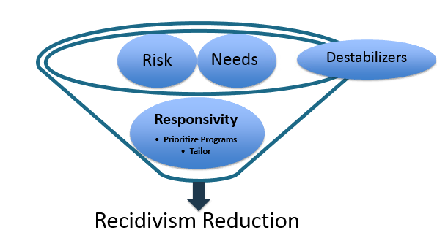

Source:
Andrews, D.A., & Bonta, J. (2003). The psychology of criminal conduct. (3rd ed.) Cincinnati, OH: Anderson.
Osher, F., D’Amora, D.A., Plotkin, M., Jarrett, N., & Eggleston, A. (2012). Adults with behavioral health needs under correctional supervision: A shared framework for reducing recidivism and promoting recovery. New York, NY: Council of State Governments Justice Center.

Site Selection
SAMHSA’s GAINS Center for Behavioral Health and Justice Transformation will host all activities related to the Learning Collaborative free of charge to selected jurisdictions. A Learning Collaborative virtual meeting, in which all LC participant teams must participate, will be held on June 4 and June 5, 2019.

There are no fees for registration, tuition, or materials associated participation in the Learning Collaborative. The GAINS Center will pay all costs associated with pre and post-virtual meeting coordination, conference calls, and GAINS Center staff and/or subject matter expert time and travel.

Up to six sites/jurisdictions will be selected through this solicitation. Jurisdictions selected for these events must be able to provide facilities and A/V resources to comfortably accommodate up to 15-25 event participants. Further details will be provided to jurisdictions selected to participate.

To be considered, all applications must be received by February 20, 2019. Selected jurisdictions will be notified on or about February 27, 2019.

target Team members/community partners
A jurisdiction submitting an application should strive include representation from a broad array of key stakeholders. The identification of 10-15 professionals and community partners should include, but not be limited to:

Adult Drug Court Applicants
- Presiding Judge
- Drug court director
- Prosecutor
- Public defender
- Substance use treatment provider director
- Community support program director
- Probation/community supervision director
- Research/evaluation partner

Reentry Program Applicants
- Probation/community supervision director
- Sheriff
- Substance use treatment provider director
- Mental health treatment provider director
- Community support program director
- Prosecutor
- Research/evaluation partner

Application Requirements
It is required that each applicant identify leaders within their jurisdiction that support this project and are dedicated to allocating staff time to participate in the technical assistance activities. Support must be illustrated by a written letter of support or commitment from diverse community partners.

Please include letters of support from the following (* are required):

Adult Drug Court Applicants
- Adult drug court presiding judge(s)*
- Chief prosecutor/District attorney*
- Substance use treatment provider director*
- Probation/community supervision director*
- Mental health treatment provider director
- Research/evaluation partner

Reentry Program Applicants
- Reentry program director*
- Probation/community supervision director*
- Sheriff*
- Substance use treatment provider director*
- Mental health treatment provider director
- Research/evaluation partner

Other eligibility criteria:
- Applicant jurisdictions must demonstrate they have received a at least one Federally-funded grant, operating a minimum of three years, within the past ten years for their program or similar initiatives
- Applicants must be engaged in formal collaborations/partnerships in regard to their Adult Drug Court or Reentry Program which can be demonstrated through Memoranda of Understanding or similar agreements
In addition, jurisdictions selected must agree to participate in the following:
- Pre-event planning conference call(s) with GAINS Center staff, including but not limited to kick-off calls, preparatory activities, and IT calls
- Local planning committee activities on an as needed basis to determine participants, recruit participants for virtual and on-site meetings, confirm logistical arrangements, etc.
- Provide space to host the Learning Collaborative virtual meeting and site visit – space must be able to comfortably accommodate up to a total of 25 people (up to 15-20 team participants, observers, and 2 GAINS Center representatives)
- Participate in Learning Collaborative virtual meeting and post-event site visit by GAINS staff and/or consultants
- Engage in post-technical assistance activities, including but not limited to reporting and consultation calls

Following the technical assistance delivery, teams will be required to report on outcome measures determined during the Learning Collaborative virtual meeting. Reports must be submitted to the GAINS Center in August 2019, following the Learning Collaborative

SAMHSA’s GAINS CENTER’S CRIMINAL JUSTICE LEARNING
COLLABORATIVES

Risk-Need-Responsivity SITE Application

Please complete the application below.
Only complete applications will be considered for site selection.

APPLICANT JURISDICTION/COMMUNITY: _________________________________________________________________________________

NAME OF PERSON COMPLETING THIS FORM:
TITLE:
ORGANIZATION:
ADDRESS:
PHONE:
EMAIL:

PLEASE COMPLETE AND ATTACH A SEPARATE STATEMENT TO THIS APPLICATION THAT ADDRESSES THE APPLICANT EVALUATION CRITERIA BELOW. YOUR STATEMENT SHOULD BE A MAXIMUM OF FIVE sINGLE-SPACED PAGES IN LENGTH, AND SHOULD CLEARLY INDICATE WHY YOUR JURISDICTION SHOULD BE SELECTED TO participate in THE RISK-NEED-RESPONSIVITY learning collaborative

Please address the following in your statement:

- Provide a brief description of your jurisdiction (including demographics, population, available resources, and any other information that you think gives us a good “picture” of your jurisdiction)

- Describe your Adult Drug Court or Reentry Program and discuss why it’s important for your jurisdiction to participate in this Learning Collaborative

- Applicant jurisdictions must demonstrate they have received at least one Federally-funded grant, operating a minimum of three years, within the past ten years for their program or similar initiatives. Provide descriptions and details regarding these grants.

Federal Grant Grid
Grant Program  (e.g., Offender Reentry Program) | Grant Source  (e.g., SAMHSA) | Award Period  (3 year minimum)  (e.g., 10/2015-09/2018) | Brief Description  (i.e., 2-3 sentence overview)

- Applicants must be engaged in formal collaborations/partnerships in regard to their Adult Drug Court or Reentry Program, which can be demonstrated through Memoranda of Understanding or similar agreements. Provide a description of these formal agreements. Attach copies of these agreements to your application.

- Describe efforts among your stakeholder agencies to share client-level data, including what data are shared and how the data are used by the program

- Describe policies and procedures in place to support the use of risk assessment tools in your program

- Describe 2-3 goals for your program around improving the application of the principles of Risk-Need-Responsivity

Please identify a primary contact for your jurisdiction, if it is someone different than the applicant. Please ensure the primary contact is someone who will be accessible to the participants and to GAINS Center staff throughout the entire duration of the Learning Collaborative.

PRIMARY CONTACT FOR THIS APPLICATION
Primary Contact Name: _________________________________________________________________________________________

Role/Position: ___________________________________________________________________________________________________

Agency: ___________________________________________________________________________________________________________

Address: __________________________________________________________________________________________________________

City/State/Zip: ___________________________________________________________________________________________________

Phone: __________________________________________________

Fax: _____________________________________________________

E-mail: __________________________________________________

APPLICATION TYPE
(Note: Only one application type can be selected.)

☐ Adult Drug Court ☐ Reentry Program

Please identify the lead agencies/organizations that have agreed to participate in the RISK-NEED-RESPONSIVITY
learning collaborative.
Please complete the team selection grid below to indicate key stakeholders who have agreed to participate as part of your jurisdiction team. AS INDICATED EARLIER, IT IS EXPECTED THAT ALL IDENTIFIED TEAM MEMBERS/STAKEHOLDERS ARE AVAILABLE TO PARTICIPATE IN THE Learning Collaborative Virtual MEETINGS ON THE SPECIFIED DATES.

Team Selection Grid
# | Required* | Role | Name | Affiliation | Letter of Commitment/Support Included? (Y/N)
1 | Adult drug court presiding judge(s; Drug court)*  OR  Reentry Program Director (Reentry)*
2 | Chief prosecutor/District attorney (Drug Courts)*  OR  Sherriff (Reentry)*
3 | Substance use treatment provider director*
4 | Probation/community supervision director*
5
6
7
8
9
10
11
12
13
14
15

Please attach required letters of commitment/support (noted on page 4) to your application.

Thank you! SAMHSA’s GAINS Center sincerely appreciates your interest in this initiative.

PLEASE RETURN THIS APPLICATION VIA POSTAL MAIL OR E-MAIL BY FEBRUARY 20, 2019:

SAMHSA’s GAINS Center
Policy Research Associates, Inc.
345 Delaware Avenue
Delmar, NY 12054

Attn: Anthony Fortuna, Program Coordinator

Phone: 800.311.4246 or 518.439.7415 Ext. 5257
E-mail: afortuna@prainc.com

Questions should be directed to Anthony Fortuna at the phone number and email address listed above.

Late submissions will not be accepted or reviewed.
Incomplete applications will not be considered.
All applicants will receive notification regarding the status of their application on or about February 27, 2019. Notification will be distributed via email.

