Welcome class of 2022!
Get ready for high school!

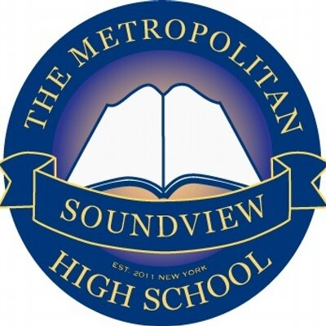
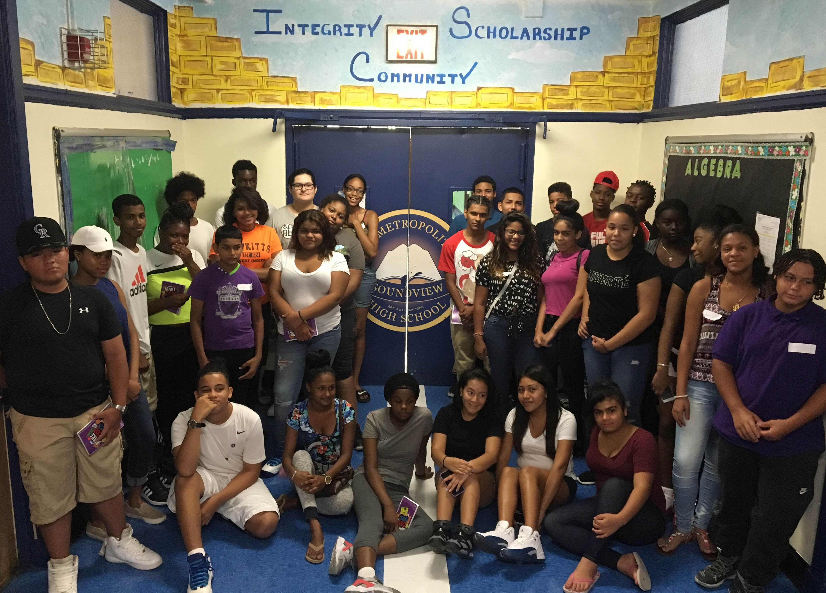
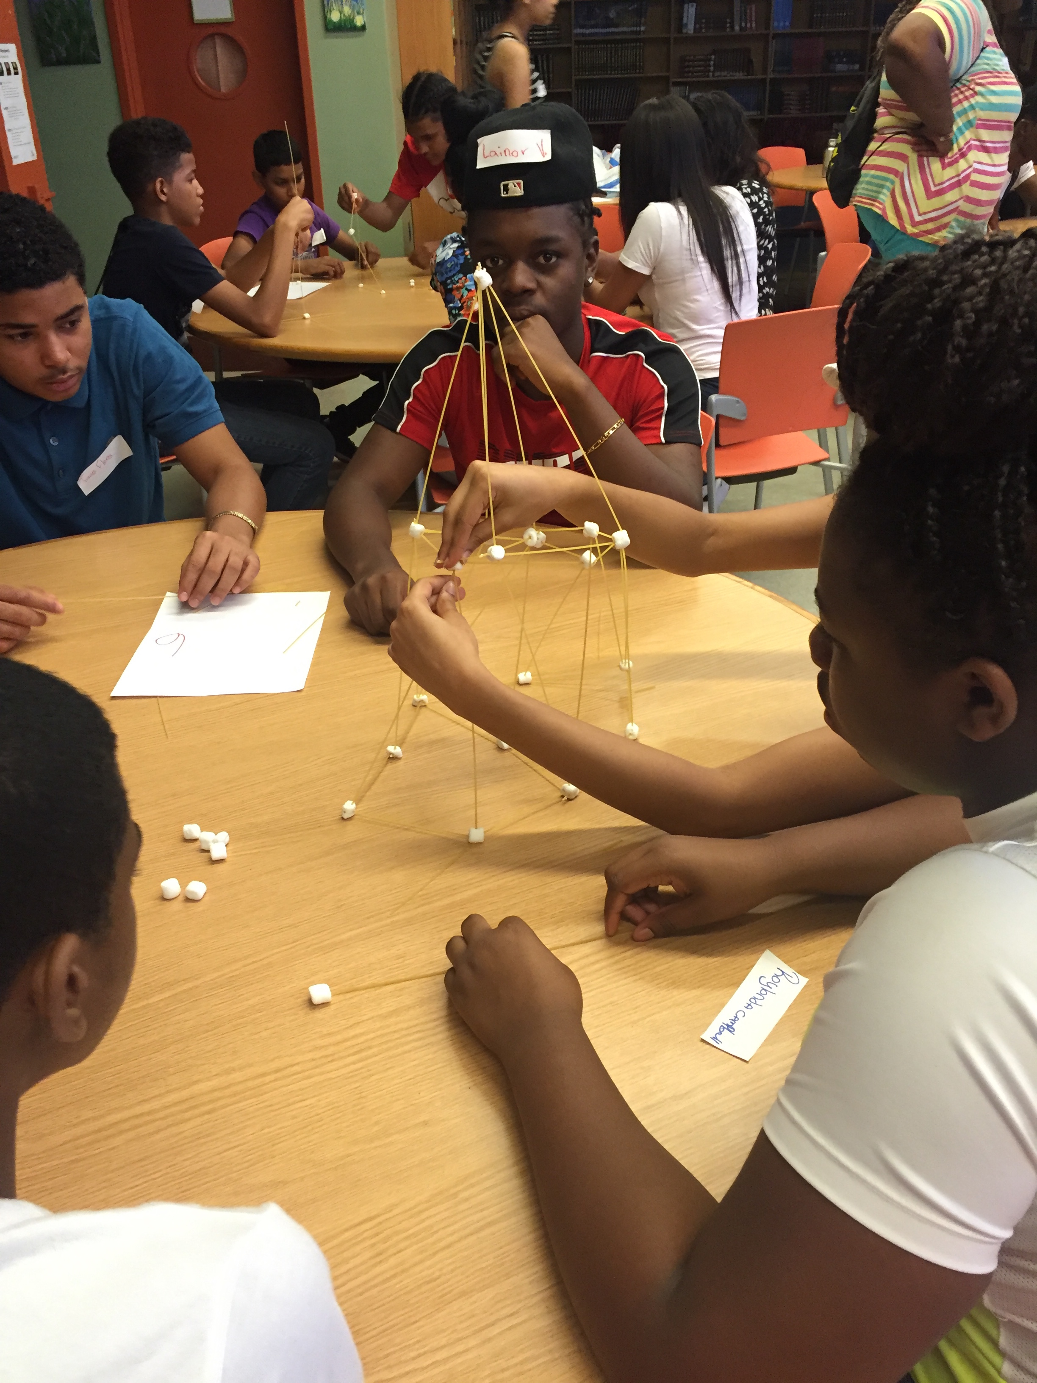

Join us on August 29th for our freshmen
Summer Bridge Program!

Who: All accepted freshmen AND their parent/guardian
Location: James Monroe High School Campus
1300 Boynton Ave. Bronx, NY 10472
Time: 9:00am – 1:00pm

You SHOULD attend Summer Bridge because you will:
- Meet the administration, staff, and teachers
- Get to know classmates
- Participate in fun team building activities
- Pick– up your uniform package

YOU’LL BE ENTERED IN TO A FREE RAFFLE FOR ATTENDING!

Have questions or need more information?
Contact us by:
- Calling Mon – Thurs: 8:00am- 2:00pm
(718) 860 – 8240
- Emailing Mr. Frias: mrfrias@metrosoundview.org
- Visiting our Facebook & Instagram pages:
  - The Metropolitan Soundview High School

NOTE TO PARENTS

- A parent session will take place at the same time as students are participating in their session.
Uniform Information

Uniform package is free and includes:
- 2 MSHS polo shirts
- 1 MSHS Phys Ed. t-shirt
- 1 MSHS navy blue cardigan

*Navy blue or black dress pants are required but NOT included.

Additional Uniform Contribution Prices:
- MSHS fleece - $20
- MSHS polo shirt - $10
- MSHS Phys Ed. t-shirt - $5

Uniform packages will be available at the end of both days of the Summer Bridge Program.
*Please bring cash for additional purchases.

