Andy Quinn (24/11/13)
The fine run of form continued for Sutton Swimming Club at the Hucknall leisure centre on Saturday 23rd November 2013. In the 6th and final round of the 2013 Sports Centre league Sutton Swimming Club secured their promotion to Division 2 from Division 3 with another fine team performance. On the night Sutton came from behind at the half way stage to run out winners by securing 18 wins from the 45 events. This meant that the Sutton club had won 5 out of the 6 rounds and amassed an impressive 35 points out of the 36 available.
In 2014 the Sutton Club will now compete in Division 2 against fresh opposition including Calverton and Bingham SC, Carlton Forum SC, Arnold SC, Nottingham Leander SC and Falcon SC.
The Sutton Club team photo is attached with their Sports Centre trophy. Swimmers from left to right are as follows:
Back Row - Giovanni Balanur (10yrs), Kiera Dobbs (8yrs), Owen Harding (9yrs), Chloe Peach (13yrs), Lara Prosser (16yrs), Nicole Lai (14yrs), Nell Polley (9yrs), Flora Lai (10yrs) and Lauren Dobbs (12yrs)
Middle Row - Jim Fergie (12yrs), Liam Marsh (13yrs), Jake Hudd (13yrs), Aaron Lee (15yrs), Ruslan Golubs (14yrs), Daniel Johnston (14yrs), Connor Marsh (11yrs), Spike Atkinson (9yrs) and Matthew Woodhall (9yrs)
Front Row - Adam Hudson (11yrs), Nicola Peach (11yrs), Mia Fergie (12yrs), Jason Lai (17yrs), Joshua Leeson (11yrs), Sam Creak (17yrs), Neve Fergie (13yrs), Chloe Quinn (10yrs), Sophie Bunker (13yrs) and Lauren Quinn (15yrs)

Peter Pink Trophy Gala
On Saturday evening 9th November 2013 Sutton Swimmers continued their fine run of form by winning the Peter Pink Trophy Gala. Sutton competed against 2 teams from Kimberley, 2 teams from Portland and 1 team from Newark swimming clubs.
This Trophy gala had a great mixture of both individual and relay events which meant that a team of 31 swimmers were able to participate from the Sutton Club. The swimmers were aged between 8/9yrs right through to the Open age group category. The individual events had cut off times so team selection had to be carefully selected as anyone going faster than the cut off times did not earn the team any points in that event.
The Sutton swimmers came first in 18 out of the 48 events. The gala again allowed Sutton to field some inexperienced younger swimmers and it is fair to say that they all performed superbly on the night.
Sutton ran out comfortable winners in the end securing some 231 team points with Kimberley's Blue team finishing second with 200 team points.
Sutton swimmers were delighted to collect the amazing Peter Pink trophy which will be retained for the next 12 months and were equally delighted to receive another impressive trophy which the club can permanently retain to mark this success.
The Chair of Sutton SC is delighted that once again the squad of competitive swimmers is growing in both talent and experience. The coaching staff and all volunteers are working hard together to ensure that Sutton SC continues to build on its successes in the pool. The Chair also praised the army of supporters that are vocally supporting the swimmers at each event explaining that the positive atmosphere throughout the club at present is providing a fantastic team environment for all swimmers to develop to their full potential.

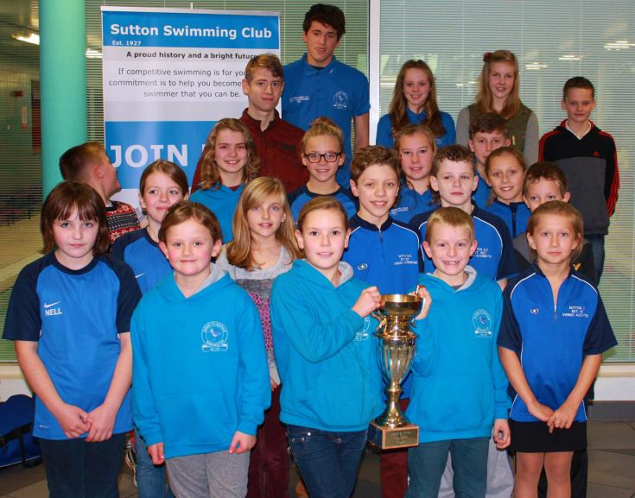

JC Dobbs 2/11/13 Results
Nottinghamshire ASA stage 2
Congratulations to Sutton Swimming Club who turned in a fantastic team performance on Saturday 26th October 2013 at Bramcote Leisure Centre to finish 3rd in the final of the Nottinghamshire ASA stage 2 gala.
Just to reach the final was a fantastic achievement but to finish 3rd was an excellent result with all swimmers making a tremendous contribution to the overall success. Even more impressive was that tonight we had two 9yr old boys making their competitive debut for Sutton SC. Both Jack Berta and Spike Atkinson did really well and their early nerves were turned into great swims as part of the 10/u relay teams.

Sutton and CABSC were neck and neck for 3rd and 4th spot most of the night with Sutton leading by just 1 point going into the final cannon relay event. In a tense final event Sutton managed to finish 3rd with CABSC finishing 5th which meant that Sutton clenched 3rd place on the night by just 3 points.

Winners on the night were Leander A with 227 gala points who beat Worksop by just 1 point, Sutton were 3rd with 176 points, CABSC finished a close 4th with 173, Carlton were 5th with 138 and Newark finished 6th with 81 points.

Once the nights final places were known the points from this gala were added to the overall league points from the previous 2 rounds. At the start of the night Sutton had been in 5th place overall out of the 18 teams competing. However, this 3rd place finish in the final round was enough to ensure that Sutton climbed the overall league table even higher to finish in an impressive 3rd place overall. Leander finished top overall club with Worksop finishing 2nd overall.

Most swimmers that competed in the final stage were around to collect the 3rd place trophy at the end of the night to a loud round of applause from the loyal Sutton SC supporters. Sutton Head Coach and both Boys and Girls Team Managers were delighted with the results which far exceeded their expectations on the night. Sutton SC continue to improve and if the current team spirit remains and the squad stays stable then even greater depth of talent in the squad will be produced which will enable the club to continue to compete at these high standards.
Final Table
Team Gala Points League Points Bonus Points Total
1 Leander A 238 + 196 + 227 6 + 6 + 12 5 + 10 39
2 Worksop Dolphins 254 + 246 + 226 6 + 6 + 10 5 + 10 37
3 Sutton in Ashfield 183 + 172 + 176 4 + 4 + 8 5 + 10 31
4 Carlton Forum 232 + 198 + 138 6 + 5 + 4 5 + 10 30
5 CABSC 166 + 178 + 173 2 + 5 + 6 5 + 10 28
6 Newark 197 + 162 + 81 5 + 4 + 2 5 + 10 26
Full Table

Sports Centre League 2013
The below shows the league table for Division 3.

It indicates that as long as we do not come last in the final gala, even if Kimberley win, then we should secure promotion to Division 2 next year. No doubt we will all want to go out on a high though and want to win the last round anyway, so lets hope we can field a strong team again.

The final round is at Hucknall on 23rd November 2013 with a 6pm warm up so put this in your diary now. If all goes well on the night there may well be a presentation of the trophy that night as well; so lets ensure we have club T-shirts and hats and we will ensure we take a team photo to mark the occasion.

Division 3
09/Feb 23/Feb 27/Apr 27/Sep 19/Oct 23/Nov League Points Total
1. Sutton 193 194 205 226 241 5 + 6 + 6 + 6 + 6 = 29
2. Kimberley 204 177 177 204 221 6 + 4 + 4 + 5 + 5 = 24
3. Portland 179 192 194 142 117 4 + 5 + 5 + 3 + 2 = 19
4. Sherwood B 156 175 173 179 169 3 + 3 + 3 + 4 + 4 = 17
5. Mansfield B 129 105 111 122 133 2 + 2 + 2 + 2 + 3 = 11
6. Hucknall & Linby 60 87 79 61 0 1 + 1 + 1 + 1 + 0 = 4

Notts ASA 14-Sept-2013
All,

The Head Coach and both Team Managers are delighted with the Team performance tonight. We were up against some of the top teams in the County and did extremely well to finish in a very credible 3rd place.

Leander won by a fair distance with 238 points, Sherwood finished 2nd with 195 points, Sutton SC finished in 3rd place with 183 points, Mansfield were 4th with 170 points, CABSC were 5th with 166 points and Ripley finished 6th with 70 points.

We had some super swims throughout the night. We continue to develop our younger swimmers with Keira Dobbs aged just 7yrs making her gala debut tonight and other young swimmers Matthew Woodhall, Owen Harding and Ben Mattin continuing to gain valuable gala experience. A number of our swimmers took first place in individual events including Chloe Quinn, Mia Fergie, Chloe Peach, Russ Golubs, Owen Harding and Neve Fergie.

The final event of the evening was the Cannon with 4 boys and 4 girls representing each age group competing in a 8 x 50m freestyle relay. Giovanni Balanur swam the first leg followed by Chloe Quinn, Jim Fergie, Mia Fergie, Russ Golubs, Neve Fergie, Sam Creak and finally Lara Prosser. What a race this turned out to be with the last few takeovers being simultaneous with Leander. Lara Prosser dug really deep and managed to just pip the Leander swimmer to ensure that the Sutton team took victory in this exciting final event.

Well done to all Sutton Swimmers. There is a real buzz at the Club at present and if we all stick together and start to build a bit of depth to our squad then in a couple of years I can see Sutton SC going on to even bigger and better results. We need to collectively work as a team, push each other on through the good and bad times, swimmers need to continue to work hard and the success will follow.

regards

Andy Quinn

Spring 2013 Sports Centre League Table
Position after 3 out of 6 rounds

Division 3
Place | Team | Gala Pts | League | Gala Pts | League | Gala Pts | League | Total
 |  | Round 1 | Points | Round 2 | Points | Round 3 | Points | Points
1 | Sutton | 193 | 5 | 197 | 6 | 205 | 6 | 17
2 | Portland | 179 | 4 | 194 | 5 | 195 | 5 | 14
3 | Kimberley | 204 | 6 | 176 | 4 | 177 | 4 | 14
4 | Sherwood (B) | 156 | 3 | 169 | 3 | 173 | 3 | 9
5 | Mansfield (B) | 129 | 2 | 107 | 2 | 112 | 2 | 6
6 | Hucknall & Linby | 60 | 1 | 87 | 1 | 79 | 1 | 3

