Boots Strapped – A Homeless Veterans Project
Presented By:

Chris Perry
Lam Ho
Ivan Salazar
Carina Carrasco

To Dallas Chamber of Commerce for Business Gives Back Competition 2017
TABLE OF CONTENTS
1. Introduction #
1.1 Objective of Proposal #
1.2 Why in Dallas? #
1.3 The Effect of The Proposal #
2. Demographics of homeless Veterans #
2.1 Background #
2.2 Unemployment #
2.3 Mental Health & Disabilities
2.4 Substance Abuse
3. Budget and Staff #
3.1 Budget #
3.2 Shelter Assistance #
3.3 Workshops #
3.4 Personal Assistance #
3.5 Staffing #
3.6 Workshop Staffing #
3.7 Financial Advisor #
3.8 Therapist #
3.9 Counselor #
4. Schedule #

- Introduction

  - Objective of Proposal
The purpose of this project is to reduce recurring homelessness of veterans by supplementing shelters with food and clothing in addition to the services they already provide. We will also be providing the shelter’s veterans with unique services such as IT workshops, counselors, therapists, interviewing practice workshops, resume workshops, and financial advisors. These services are key to reducing the recurring homelessness of veterans since at the roots of this problem lie unemployment and mental disorders such as Post-Traumatic Stress Disorder (PTSD).
  - Why in Dallas?
Dallas is part of the fourth-largest metropolitan population in the United States and is also the city in which Southwest Airlines is headquartered. Unfortunately, it is also a home to a serious problem; homeless veterans. According to The 2016 Annual Homeless Assessment Report to Congress, Texas’ homeless veteran population accounts for 5% (1,768) of the national homeless veteran population. For years, Southwest has been part of various efforts to support organizations within the communities they serve, donating money to qualified entities that meet their guidelines. The veteran community is no exception as Southwest has been and will continue to promote and assist in the easing of any troubles veterans may have. And although Texas observed a significant decrease in their homeless veteran population from 2009-2016, dropping 67.8%, one homeless veteran is one too many.
  - The Effect of the Proposal
While the aim of our proposal is noble and its scope narrow, we believe our proposal to have wide-reaching implications for its target audience. Without a doubt, these efforts to reduce the number of veterans experiencing recurring homelessness will bear fruit. Veterans will find it more possible than ever to get back on their feet and maintain that footing. The acquirement of basic Microsoft Office skills bundled with their sparkling resumes and interpersonal skills made possible through the workshops provided will put desirable job opportunities within their reach. Many of those who were suffering from mental disorders will find themselves with a healthier mentality and in a better position to return to the workforce. As a result of our endeavors, the amount of people in the workforce will grow and potentially stimulate the economy. At the very least, those returning to work will further saturate the labor force with the minimum, fundamental skills employers are looking for.

- Demographics Of Homeless Veterans

  - Background
According to National Coalition for Homeless Veterans, 11% of the total homeless population in the United States are veterans. Based on a 2015 report by Metro Dallas Homeless Alliance, there were a total of 291 homeless veterans in our local community. A chronically homeless individual is a person who has been homeless for longer than one year; or has experienced four or more occurrences with a combined length of at least twelve months in a span of 3 years. In 2015, Dallas was able to provide shelter for 241 veterans while 50 remained unsheltered. Lastly twenty-four individuals were considered chronically homeless for the year.
  - Unemployment
Outside of unforeseen and uncontrollable circumstances such as changes in the economy or slow economic growth, veteran unemployment can be addressed properly. Many of our veterans become and stay homeless for the mere fact that they cannot find employment. According to the Current Population Survey (CPS) and the American Community Survey (ACS), veterans aged 15-65 experience a higher unemployment rate compared to their non-veteran counterparts. Peculiarly, the gap between the two groups diminishes as both the age and time since separation for the veterans increases. Some of the top reasons commonly attributed to unemployed veterans are: mismatched skills, poor health, employer discrimination, and time taken in job searching.

One of the most challenging obstacle for veterans is transferring the experience and skills gained while in the military to civilian employers. Consequently, many of these special skills learned are not in high demand in the civilian sector--which can lead to long periods of job search. As of 2010, the average weeks taken for job searching has risen to 10, compared to about five weeks needed from 1994-2008 (Loughran). Furthermore, although federal law provides tax incentives to companies that hire previously unemployed veterans (VOW to Hire Heroes Act), many still judiciously discriminate against prior service members. Unlike the prohibited questions of sex, race, and religion; veteran status can and is used on job applications to identify those who have served in the military. Companies can then use this information to elevate or eliminate veteran applicants. Lastly, it is irrefutable that military service leads to many physical and mental injuries that impede from veterans to finding or keeping jobs.
  - Mental Health & Disabilities
One of the main reasons for the rapid increase of homeless veteran are disabilities and mental illness. Soldiers and war veterans face various physical and mental health problems due to the impact of diverse environmental hazards to which they are exposed (contaminated water, chemicals and infections); Moreover, in times of war, it is common for these veterans to suffer injuries, limb loss, trauma of all kinds, bringing them into depression and, consequently, becoming homeless veterans.

According to the National Coalition for Homeless Veterans, 51% of individual homeless veterans have disabilities. Although the Americans with Disabilities Act (ADA) prohibits discrimination and supports veterans, there are numerous corporations that tend to reject military personnel with disabilities. Unfortunately, there are many organizations that do not take into account the skills and a good curriculum of a veteran with disabilities, even if the dysfunction does not affect their productivity. The reason for this rejection is the amount of money spent by the employer for veteran accommodations.

Along with the National Coalition for Homeless Veterans, 50% of the total veteran homeless have serious mental illness. Mental illness predominates among all veterans, due to the situations that live during the war. They usually suffer from anxiety, depression, chemical addiction, and post-traumatic stress disorder (PTSD). The National Institute of Mental Health states that PTSD generates stress, fear, the feeling that the traumatic event is happening again, difficulty sleeping, nightmares, loneliness, worry, guilt or sadness; As well as angry outbursts. PTSD increases the risk of homelessness because it makes extremely difficult to build and maintain relationships, and to maintain a job. This stress is a like a vicious cycle and it is hard to get out.

In agreement with the National Security Research Division (RAND), innumerable of the soldiers do not seek treatment for psychological disorders "because they fear that this will hurt their careers," and among those who do apply for help, only half receive "adequate" treatment. Once these veterans get discharged for psychiatric reasons they became in homeless since they are unable to get back to life they had before joining the service. Some remain in the areas where they were placed; others settle in cities since rural areas are exceptionally difficult to survive.
  - Substance Abuse
According to the Human Rights Watch (HRW) report, the high consumption of opioid is strategically used to treat the trauma experienced in war. Unfortunately, opioids are drugs that relieve pain momentarily but in the long run, lead to addictions in coordination with the Foundation for the Drug-Free World. In other words, numerous veteran who served during war suffers from addictions to drugs. According to the National Coalition for Homeless Veterans, 70% of the homeless veterans have substance abuse problems. Unfortunately, for veterans, the stress of returning to civilian life, especially finding housing and work, increases the risk of substance abuse leading them to become homeless.

As stated by Drug rehab organization, “A large amount of our veterans become homeless. With military conflicts on the rise, there is also a high possibility that the number will continue to increase. One of the difficulties homeless veterans encounter is substance abuse. Around 70% of homeless veterans suffer from a substance abuse problem. A common primary substance which is abused among these veterans is alcohol (65.4 %), followed up by heroin (10.7%), and cocaine (6.2 %).”
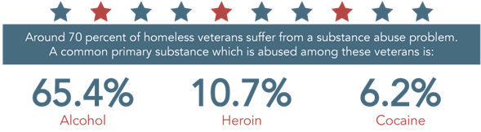
The Veterans Health Administration reports that 64% of Iraq and Afghanistan veterans who suffered stress received opiate prescriptions. Unfortunately, many veterans became addicted to this drugs in order to not remember what they lived in the combat.
In view of the alarming increase in the number of overdoses, The Veterans Health Administration distributes Naloxone to patients since the medication allows to revert an overdose and save the life of the intoxicated person in agreement with the Human Rights Watch.
In addition, doctors observed that many consumers of prescription opioids diverted their use to heroin use, since heroin costs less than medicine. Many doctors even refuse to prescribe opiates to their patients, considering that they "substitute one drug for another," laments HRW.
- Outline
Boots strapped is a yearlong plan of action to diminish recurring homelessness of veterans in the Dallas area. Our long-term goal is to bring awareness to the community about the ongoing misfortunes among our vets; perhaps motivating other organizations in the local area to follow suit.

Like any other project, money matters. The combined cost of our project totals $93,600, distributed across the shelter and personal assistance programs, various workshops, and their staff. We will focus working directly with The Bridge of North Texas homeless shelter located in Dallas, with all the services taking place on location.
  - Budget
The total cost of the proposal comes out to approximately $93,600. Half of which will be paid for by us at Southwest Airlines. This amount accounts for a year’s worth of a vast array of services and assistance that will be offered to our homeless veterans. These services will be made available to and take place at The Bridge North Texas. This homeless shelter was chosen as its noble purpose is aligned with our own.
  - Shelter Assistance
The current proposal calls for the donation of $750 per month to The Bridge North Texas homeless shelter to assist in the purchasing of food and clothing. Although the occupants of The Bridge North Texas homeless shelter consist of more than those of veteran status, these funds and those not yet mentioned, but part of the proposal budget, will be appropriated for veterans only. Of the $750, $500 will be utilized for food and the remaining $250 for clothing. The total yearly allowance for food and clothing is set at $9,000.
  - Workshops
In addition to food and clothing assistance, a variety of workshops will be held every two weeks on-site at the shelter (see schedule for exact dates). These workshops are designed to help veterans sharpen their existing skills and acquire new ones that we believe will prove useful in getting back on their feet. One of the biweekly workshops that will be offered is dedicated solely to navigating and utilizing Microsoft Office. Microsoft Office is a set of interrelated desktop applications and a person’s familiarity and ability to work within those applications are widely considered as the bare minimum requirement for most existing, attractive jobs. The workshops will focus mostly on Microsoft Word, PowerPoint, and Excel, however, the utilities of access will also be covered, although to a narrower extent. Two other workshops will be offered to our veterans. These will cover resume writing, and interview preparation and execution. The current cost associated with all three workshops is $2,250 per month, totaling $27,000 for the proposed life of the project.
  - Personal Assistance
Perhaps the most important services we will be offering to our homeless veterans comes in the form of financial advising, therapy, and counseling. These three areas of expertise provided by our staff will be critical to helping veterans get a grip and maintain that grasp in the critical areas of life. Financial advising is paramount to anyone who has experienced long periods of homelessness. Many of our veterans also still feel as if they were still at war, although a very different one, suffering from substance abuse and post-traumatic stress disorder. We will be offering therapy and counseling for any of our veterans in need of those services. These three services will be available every Monday and Friday of each week at The Bridge North Texas. The current cost associated with all three services will run at $4,800 per month, totaling $57,600 for the proposed life of the project. The cost may seem staggering, but it’s a small price to pay in comparison to that which we owe our veterans, especially in their time of need.

The aforementioned costs associated with the project’s endeavors can be found in the Proposal Budget table below.

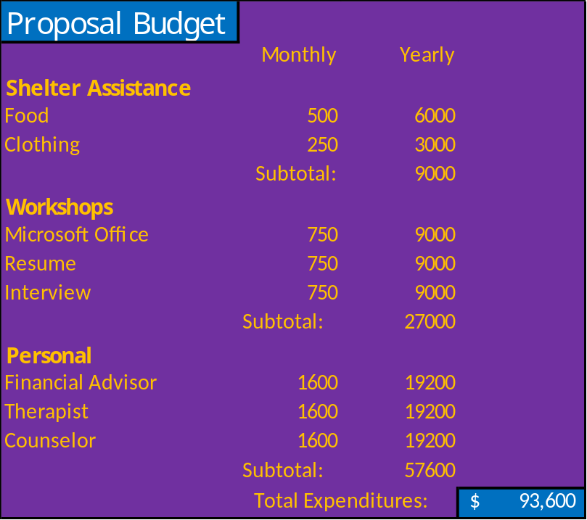
  - Staff
All staff will have been required to participate in a thorough background check prior to the start date of this proposal. We only wish to put our veterans in the hands of the dedicated and qualified.
  - Workshop Staffing
The workshops that are to be held on a biweekly basis will be instructed by our contracted staff. Each staff member can speak authoritatively on all the topics covered in any of the three services that will be provided by the means of workshops. However, we’ve assigned the staff member based on their strongest points to the appropriate workshop. All the workshop staff members are educated individuals, having graduated from various colleges or universities. These individuals also work full-time in a field that would require the daily use of the skills they will be instructing on during the workshops.

  - Financial Advisor
The financial advisor that will be contracted for this one-year proposal is a certified local advisor, advising individuals on their private investments and retirement options. This person is also a certified financial planner. This advisor will be giving hands on instruction to veterans on the creation and maintenance of a budget, allowing veterans to properly manage their money in the future. Financial advising will be made available on-site at The Bridge North Texas on the third Tuesday of every month. See Schedule for specific dates.
  - Therapist
We plan to have a therapist on duty to support our veterans with any mental health issues and concerns that may exist. The therapist that will be contracted as part of our proposal is a Licensed Clinical Mental Health Counselor (LCMHC). This therapist specializes in treating veterans with ‘veteran’ specific disorders (PTSD, substance abuse) and will prove to be a major asset to our cause. Homeless veterans can seek therapy sessions at The Bridge North Texas homeless shelter every Monday and Friday.
  - Counselor
Also, on-site every Monday and Friday at The Bridge North Texas will be a Licensed Counseling Professional. The counselor will offer guidance to our veterans and assist them in working through any issues that are affecting their mental health or well-being that are outside the realm of ‘veteran’ specific.
- Schedule
The proposed start date of our efforts to assist homeless veterans is slated for January 1, 2018. Once the proposal is approved, we will begin reaching out to our soon to be contracted personnel, making them aware that the project has been green-lighted. Below is a schedule highlighting the major events of our proposal along with the recurring services that will be offered to our veterans throughout the life of the project. A calendar view pamphlet will be provided online and on-site at The Bridge North Texas homeless shelter for the recurring events.
Boots Strapped – A Homeless Veterans Project
January 1, 2018 – Proposal Start Date and Contract initiation date for personnel
January 1, 2018 – Therapy and Counseling services begin (recurring every Monday and Friday)
January 2, 2018 – Financial Advising service begins (recurring every Tuesday and Thursday)
January 3, 2018 – Microsoft Office, Resume, and Interviewing workshops being (every other Wednesday)
December 31, 2018 – Proposal End Date and Contract expire date for personnel

- Targeted Question and Answer
What are the criteria for success?
Success can be defined when essential elements such as health, employment rate, goes up. It shows achievement when the veterans find themselves healthier mentally and ready to get back the workforce. It can also be measured by lowering the percentage of the homeless Veteran population. Together, analyzed these elements can be the main focus to help the community drive down the number of Veterans experiencing homelessness to as little as possible. However, we will continue to look at and evaluate the effectiveness of the program to really bring an end to the Veteran homelessness.
What do you think is the most important key to reducing the Veteran homelessness?
There are plenty of factors that help play an important role in achieving the goal. However, I think the most important one would be true passion and appreciation we have for our Veterans. If you think about, they really sacrificed and took risks for our country so that we don't have to. With this mind, we can overcome any obstacles along the way and take the program to its fullest potential. (why chosing this workshops, back to workforce and off the shelters)

Has there been any similar project within the DFW area?
I don't believe there has been an exact project within the DFW area. However, there has been and are very similar ones out there. There are plenty of programs for our Veterans regarding food and sheltering. Therefore, we came up with these unique services that can help really eliminate the problem.

Can the project really be done within 1 year?
The project can be done within 1 year but the goal won't be fully achieved. Like mentioned above, in order for the project to be extremely effective, it needs to be an on-going collaboration. We will always be going to have Veterans falling out and finding themselves in difficult places. Sadly, it's not going to be a 1-year thing.
How do you think we can improve the program?
One way we can improve the program is having more contribution from outside sources. We can partner up with volunteers from local community resources to help drive a food and clothing

