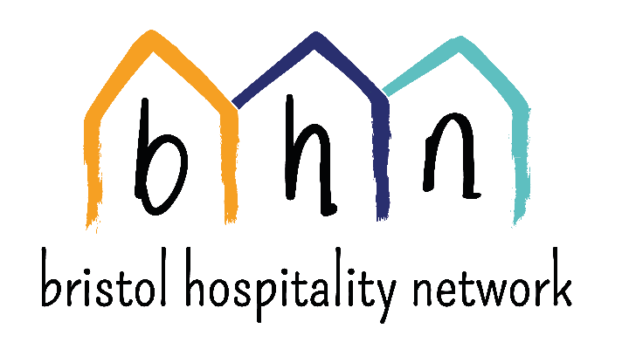
Volunteer Communications Officer (x2)
Hours: 4-6 hours per week
Commitment: 6 months – 1 year
What does Bristol Hospitality Network do?
BHN works alongside asylum seekers facing destitution by providing accommodation and opportunities for creative community engagement in Bristol.
Founded in 2009, BHN has supported over 150 destitute asylum seekers with accommodation in its network of host households and men's hostel and a weekly welcome centre attended by over 100 people. BHN campaigns to improve the inhumane UK asylum system by ending destitution, ending detention and improving initial Home Office decision making (among other asks).
BHN is always looking into creative ways in which our members can contribute to the network and have their stories heard. We are looking at involving our members in our public facing communications as much as possible in line with our values.
About the role
The purpose of this role is to support our members share their stories and help us in promoting and publicising BHN and the work we do. We are looking for self-motivated people to work alongside our members to identify, capture and share stories from the network, as well as informing people about the inhumane asylum system. The Communications Volunteers will support staff and trustees to create new content for the website, keep our social media channels updated, and attend events representing BHN (in a fundraising and campaigning role). You will work closely with the Trustees and BHN Manager.
This is a great opportunity for anyone looking to improve their communications skills in the charity sector and/or interested in working alongside people seeking safety and support them into telling their stories.
The role involves:
- Buddying up with members who are interested in supporting BHN communications
- Supporting members, as well as other volunteers and staff to create content for the website
- Representing BHN at local events to encourage people to donate, volunteer and/or host
- Encouraging more effective campaigning against the asylum system by volunteers and supporters of BHN
- Keeping our Facebook page updated
- Attending Communications Team meetings
The qualities and skills required for this role:
- Experience of marketing and social media: in a paid or unpaid capacity or while in education or training
- Good communications and writing skills
- Interest in working in solidarity with people seeking sanctuary in the UK
- IT literate
- Able to work on their own initiative
c

