Lemongrass Bath Salts
Labels

I have provided a page full of graduated sizes of labels, depending on the size of container you use.

Half of them have a lemongrass plant behind them for those who like photos; the other half are for you who prefer a more simple look.

These can be punched out with circle, square, or oval punches, or just sliced into a square. Scallop punches are fun too, for the main label or for the mat, mentioned next.

You can also put a larger mat behind your label for more color and an added effect.

I like to cover mine with tape, where possible, especially if it’s going to be used more than once.

As the fonts got smaller, they were less able to be seen clearly and fully, so I did half of those smaller ones in bold, and left the other half as-is.

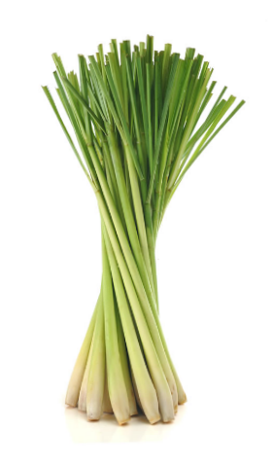

If you have any questions
or other ideas, please email me
at beshelton@aol.com
or message me on Facebook
under Barb Edtl Shelton.

Copyright Barb Shelton of Honeycomb Oasis
www.HoneycombOasis.com

Lemongrass
________________

Bath Salts

Lemongrass
_______________

Bath Salts

Lemongrass
______________

Bath Salts

Lemongrass
_____________

Bath Salts

Lemongrass
__________

Bath Salts

Lemongrass
_________________

Bath Salts

Lemongrass
__________________

Bath Salts

Lemongrass
_______________________

Bath Salts

Lemongrass
________________

Bath Salts

Lemongrass
_______________

Bath Salts

Lemongrass
______________

Bath Salts

Lemongrass
_____________

Bath Salts

Lemongrass
__________

Bath Salts

Lemongrass
____________________

Bath Salts

Lemongrass
___________________

Bath Salts

Lemongrass
______________________

Bath Salts

Lemongrass
________________

Bath Salts

Lemongrass
_______________

Bath Salts

Lemongrass
______________

Bath Salts

Lemongrass
_____________

Bath Salts

Lemongrass
__________

Bath Salts

Lemongrass
____________________

Bath Salts

Lemongrass
___________________

Bath Salts

Lemongrass
______________________

Bath Salts

Lemongrass
________________

Bath Salts

Lemongrass
_______________

Bath Salts

Lemongrass
______________

Bath Salts

Lemongrass
_____________

Bath Salts

Lemongrass
__________

Bath Salts

Lemongrass
____________________

Bath Salts

Lemongrass
___________________

Bath Salts

Lemongrass
_____________________

Bath Salts

