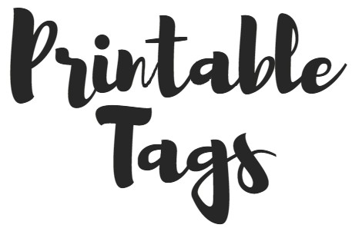

for

Gifts-in-a-Can

Created for you by

Barb Shelton
of
HoneycombOasis.com

- - - - - - - - - - - - - - - - - - - - - - - - - - - - - - - - - - - - - - - - - - - - - - - - - - - - - - - - - - - - - - - - - - - - - - - - -
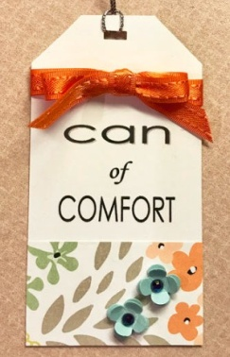
EMBELLISHING OPTIONS:
The tags themselves are not fancy, so their décor will come from what you add to them. In the tag to the right, I added a tiny piece of the same paper I used to cover the can, and then a couple of tiny punched flowers with tiny gems in the middle. I specifically didn’t make them colorful so that they would not clash with your can’s color scheme. Be sure to include enough at the top and bottom of the words to allow room for what you do to the top and space for adding on paper, washi tape, ribbon, gems, or whatever you decide to add!

PRINTING ONLY WHAT YOU WANT:
When printing out anything, be sure to select the specific page you want, otherwise you will print out everything. It may or may not work to select just the one tag you want to print; it may print the tag, but lose the formatting and print it in a different place than where it sits on the page, which is probably fine.
EDITING:
You can edit the tags only in Word. (The PDF format is basically a picture, so it is stable, but cannot be edited.) If you want to change anything, do it one word at a time. You will find that, when even a small change is made, the rest of the tags may completely rearrange. I apologize for this, but don’t know how to avoid it. (Let me know if you have a solution!) If you can’t get a format you like, you can always cut out the words and glue them onto a different colored tag, as I did in the teacher tag to the left.

Let me know if there are any other questions you need me to answer!

BIRTHDAY

GIFT
________

IN-A-CAN

BIRTHDAY
PARTY

~~~~~~~~~

IN-A-CAN

ANNIVERSARY

PARTY
________

IN-A-CAN
Valentine's

GIFT
________

IN-A-CAN

_ _ _ _ _

You’re

SEW

amazing!
_ _ _ _ _

BABY

GIFT
_______

IN-A-CAN
CHRISTMAS

GIFT

IN-A-CAN

FOR AN

AWESOME

TEACHER!

ORGAN-IZING

KIT

IN-A-CAN
GRADUATION

GIFT

IN-A-CAN

CHRISTMAS
SOCK
EXCHANGE
_ _ _ _ _

IN-A-CAN

HAPPY

FALL

Y’ALL!
_______

GIFT-IN-A-CAN

NEW JOB

KIT
________

IN-A-CAN

FITNESS
PROPS
________

IN-A-CAN

OFF-TO-
COLLEGE
KIT
______

IN-A-CAN

CAN OF

WED-DING

wonderfulness

GET

WELL

GIFT
IN-A-CAN

BON

VOYAGE

~~~~~

IN-A-CAN

TEACHER
APPRECIATION
_______

GIFT
IN-A-CAN

CAN

of

. . . . . . . .

RETIREMENT
FUN

CAN
of

GRATE-
FULL-
NESS

can

of

COMFORT

HAPPY
1ST DAY
OF SCHOOL
_______

IN-A-CAN

BRIDE

BLESS-
ING

______

IN-A-CAN
_______________

The note below, in vari-
ous widths and shapes,
goes on the back of the
tag you use.
_______________

There’s an intact, unopened pull-ring under all the ties, just waiting for you to pry it up, pull it back, rip off the lid, and find your gifts inside the can!

There’s an intact, unopened pull-ring under all the ties, just waiting for you to pry it up, pull it back, rip off the lid, and find your gifts in-side the can!

There’s an intact, unopened pull-ring under all the ties, just waiting for you to pry it up, pull it back, rip off the lid, and find your gifts inside the can!

There’s an intact, unopened pull-ring under all the ties, just waiting for you to pry it up, pull it back, rip off the lid, and find your gifts inside the can!

