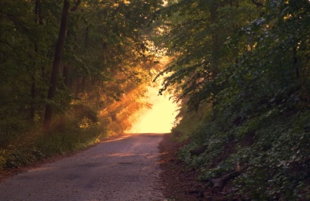
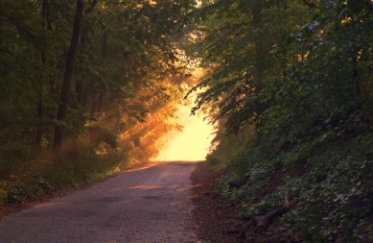
Verses for Life

“If you want to know what God wants you to do, ask Him, and He will gladly tell you, for He is always ready to give a bountiful supply of wisdom to all who ask Him; He will not resent it.” (James 1:5)

“The one thing I want from God, the thing I seek most of all, is the privilege of meditating in His Temple, living in His presence every day of my life, delighting in His incomparable perfections and glory. There I’ll be when troubles come.” (Psalm 94:19)

"[T]hose who are older are said to be wiser; but it is not mere age that makes men wise. Rather, it is the spirit in a man, the breath of the Almighty that makes him intelligent. (Job 32:9)

“Fear not, for I am with you. Do not be dismayed. I am your God. I will strengthen you; I will help you; I will uphold you with my victorious right hand.” (Isa. 41:10)

“God is our refuge and strength, a tested help in times of trouble. And so we need not fear even if the world blows up and the mountains crumble into the sea. Let the oceans roar and foam; let the mountains tremble! There is a river of joy flowing through the city of our God—the sacred home of the God above all gods. God himself is living in that city; therefore it stands unmoved despite the turmoil everywhere.” (Ps. 46:1-5a)

Verses for Life

“If you want to know what God wants you to do, ask Him, and He will gladly tell you, for He is always ready to give a bountiful supply of wisdom to all who ask Him; He will not resent it.” (James 1:5)

“The one thing I want from God, the thing I seek most of all, is the privilege of meditating in His Temple, living in His presence every day of my life, delighting in His incomparable perfections and glory. There I’ll be when troubles come.” (Psalm 94:19)

"[T]hose who are older are said to be wiser; but it is not mere age that makes men wise. Rather, it is the spirit in a man, the breath of the Almighty that makes him intelligent. (Job 32:9)

“Fear not, for I am with you. Do not be dismayed. I am your God. I will strengthen you; I will help you; I will uphold you with my victorious right hand.” (Isa. 41:10)

“God is our refuge and strength, a tested help in times of trouble. And so we need not fear even if the world blows up and the mountains crumble into the sea. Let the oceans roar and foam; let the mountains tremble! There is a river of joy flowing through the city of our God—the sacred home of the God above all gods. God himself is living in that city; therefore it stands unmoved despite the turmoil everywhere.” (Ps. 46:1-5a)

Verses for Life

“If you want to know what God wants you to do, ask Him, and He will gladly tell you, for He is always ready to give a bountiful supply of wisdom to all who ask Him; He will not resent it.” (James 1:5)

“The one thing I want from God, the thing I seek most of all, is the privilege of meditating in His Temple, living in His presence every day of my life, delighting in His incomparable perfections and glory. There I’ll be when troubles come.” (Psalm 94:19)

"[T]hose who are older are said to be wiser; but it is not mere age that makes men wise. Rather, it is the spirit in a man, the breath of the Almighty that makes him intelligent. (Job 32:9)

“Fear not, for I am with you. Do not be dismayed. I am your God. I will strengthen you; I will help you; I will uphold you with my victorious right hand.” (Isa. 41:10)

“God is our refuge and strength, a tested help in times of trouble. And so we need not fear even if the world blows up and the mountains crumble into the sea. Let the oceans roar and foam; let the mountains tremble! There is a river of joy flowing through the city of our God—the sacred home of the God above all gods. God himself is living in that city; therefore it stands unmoved despite the turmoil everywhere.” (Ps. 46:1-5a)

Verses for Life

“If you want to know what God wants you to do, ask Him, and He will gladly tell you, for He is always ready to give a bountiful supply of wisdom to all who ask Him; He will not resent it.” (James 1:5)

“The one thing I want from God, the thing I seek most of all, is the privilege of meditating in His Temple, living in His presence every day of my life, delighting in His incomparable perfections and glory. There I’ll be when troubles come.” (Psalm 94:19)

"[T]hose who are older are said to be wiser; but it is not mere age that makes men wise. Rather, it is the spirit in a man, the breath of the Almighty that makes him intelligent. (Job 32:9)

“Fear not, for I am with you. Do not be dismayed. I am your God. I will strengthen you; I will help you; I will uphold you with my victorious right hand.” (Isa. 41:10)

“God is our refuge and strength, a tested help in times of trouble. And so we need not fear even if the world blows up and the mountains crumble into the sea. Let the oceans roar and foam; let the mountains tremble! There is a river of joy flowing through the city of our God—the sacred home of the God above all gods. God himself is living in that city; therefore it stands unmoved despite the turmoil everywhere.” (Ps. 46:1-5a)

