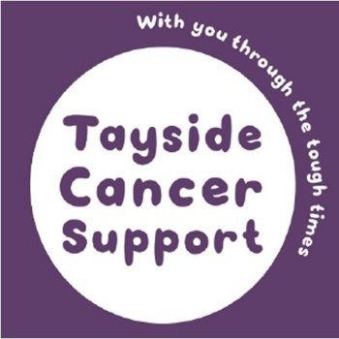
Tayside Cancer Support

Frequently Asked Questions

Why was the charity started? Can you tell me a bit about the history of the charity? When was it set up and by whom?
In 1990, Professor Charles Forbes, from the Department of Medicine at Ninewells Hospital in Dundee, set about forming a Cancer Support Group in the city. Professor Forbes was very aware of the lack of support for cancer patients, their families and friends, and also for professionals working in the field of cancer care in the area. So he did something about it.

This group was initially associated with Tak Tent Cancer Support Scotland (a much bigger organisation) but two years later the Dundee group decided to leave the national organisation and stand on its own. So in July 1994, Tayside Area Cancer Support (TACS) began and obtained its charitable status (SCO22798). Then in January 2003 the organisation changed its name to Tayside Cancer Support.

What are the main aims of the charity?
Tayside Cancer Support offers the opportunity for anyone affected by cancer in Tayside to receive emotional, social and practical support, either on an individual basis or in a group setting.

Our aim is to relieve suffering, distress and further the health of those people who either have suffered from or are suffering from cancer, their families and friends, and to promote the welfare of staff involved professionally in cancer care.

Basically if you, or your friend, or family member has cancer and you are scared or worried or don’t know what to do, we will try to help. You can talk to one of our befrienders, you can join one of our groups and talk to others who feel like you or you can come on one of our Mindfulness Courses which can help you think more clearly. Even if we can’t help you – we will try to help you find someone who can!

How many people volunteer?
Tayside Cancer Support is made up of an Executive Committee of voluntary Trustees. At the moment, there are five of them and they oversee the organisation, making the big decisions. Then we have about twenty volunteer befrienders who meet with clients (patients or their friends/family). We have two paid employees who work part time.

Do you have an office that you work from?
We have an office in St Aidan’s Centre in Broughty Ferry.

Do you have a website?
We have a new shiny website www.taysidecancersupport.org

