Long Ride – Starts at 9:00 from The Grandstand
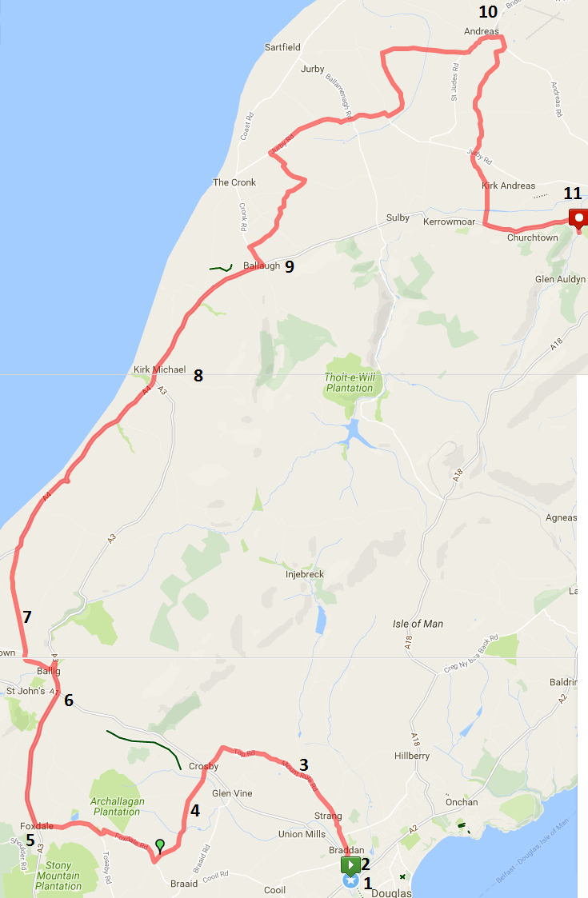
- Start at the Grandstand
- Quaterbridge
- Mount Rule
- School Hill
- Foxdale
- Ballacraine
- Switchback
- Kirk Micheal
- Ballaugh
- Andreas
- Finish at Milntown

