
INTRODUCTION TO ARCHERY LESSONS!

Would you like to learn how to be a great archer? Maybe like Hawkeye, or Katniss?
WE CAN HELP!

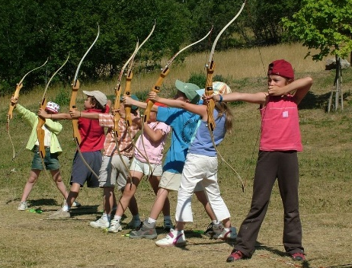
With J’z Archery Academy we can offer quality archery coaching at your school, with a professional and NZ recognised coach
- Archery is a sport anyone can enjoy, even if you are not “sporty!”
- Archery has noticeable health benefits, especially upper body strength and balance, and lots of walking!
- Builds Confidence, Discipline and Focus
- You can even represent your school in the Nationwide Archery in Schools programme

Cost $175 for 10 weekly lessons (during Term times)
Speak to your school’s sports co-ordinator if you wish to enrol
Intermediate and advanced lessons will be available in future terms when you want to continue.
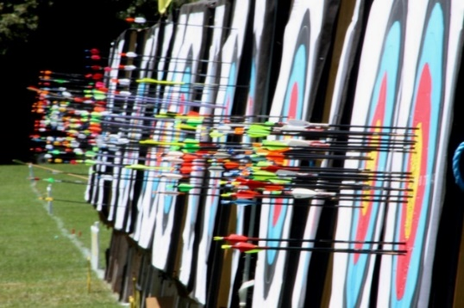
J’z Archery Academy will provide all the equipment needed for archers - target butts, target faces, beginner archery bows, arrows and safety equipment
Safety is of paramount importance and so there will be stringent guidelines on student conduct and obeying all safety rules.

