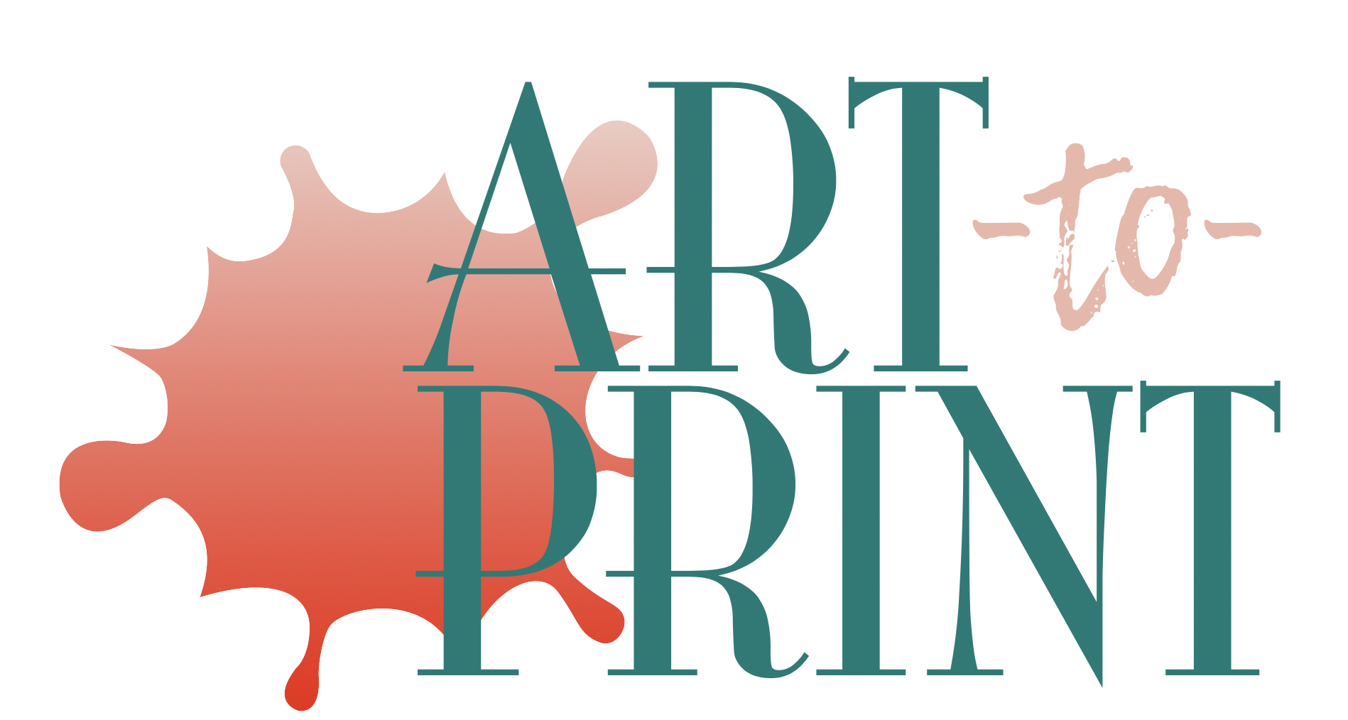 CALL FOR ART!
On behalf of one of our business members, The Kelly is seeking local artists to submit digital images of original art work in any two-dimensional medium or style, ranging from realism to abstraction. Selected prints of original art work will be framed and installed in the business members facility.

Round 1: Artists submit digital images of art work on a thumb drive for consideration. Label each image: First Name, Last Name, Title, Size, Medium.
Mail to: The Kelly, c/o Art-to-Print, PO Box 641, Wetumpka, AL 36092.
An unspecified number of works will be selected to advance to Round 2.

Round 2: Artists will be notified to bring original art works
(selected from Round 1) for professional photographing. Date & time TBA.

Round 3: Final selections will be made and artists will be notified.

- There is no charge for Kelly Member Artists
- If you are not a Kelly Member Artist, include a check for $35 payable to Kelly Fitzpatrick Memorial Gallery (which includes your membership.)
- Each work selected will be professionally printed.
- Each work selected will be awarded a $100 stipend.
- All works of art must be in a format that can be printed to 16” x 20”:

- 8 x 10
- 16 x 20
- 20 x 25
- 24 x 30
- 28 x 35
- 30 x 37.5
- 36 x 45
- 40 x 50
- 46 x 57.5
- 60 x 75

TIMELINE
Thumb drives (digital images) are due: Nov 10
Photographing original works of art: TBA (Nov)
Final acceptance notifications and announcements: TBA (Dec)
ENTRY FORM

Artist Name_____________________________________________________________________________
Address: _______________________________________________________________________________
City, State, Zip __________________________________________________________________________
Phone Number ( )___________-______________
E-mail _________________________________________________________________________________
# of Works Submitted ______________

