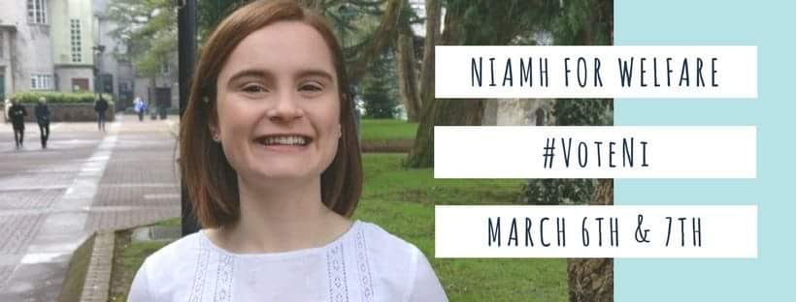
About Ni
Hi, my name is Niamh Connery and I hope to be elected as your Welfare Officer for 2018/19. I am graduating with a BSc in Social Science this year and believe I have gained invaluable knowledge during the course of my degree that will allow me to greatly improve student welfare here in UCC.
I have a very in-depth knowledge of the issues encountered by students and what is essential to reverse the existing inequalities and obstacles so that we can see social change on our campus. If elected as Welfare Officer, my aim is to tackle pressing issues such as drug harm reduction, consent and accommodation rights. I am passionate about making students college experience as fun, safe as smooth as possible.
Social Science was a great choice for me as it allowed me to focus on the topical issues in society which matter to me and allowed me to gain a greater insight into these issues. Not only have I gained knowledge in issues on a social level that we as students face, but I have also gained a layered understanding of problems on a psychological, economical and policy level.
I’ve always been a person that cares about the welfare of people in society. Thankfully, doing Social Science has given me the privilege of learning about the areas we need to improve on as a society, but most importantly, it has allowed me to relate these existing problems to the student population of UCC. Through theoretical, practical and experiential knowledge, I feel that I have a greater understanding of what areas we need to improve on in order to make UCC as educated, accessible, and safe as possible.
Accommodation
During the current housing and accommodation crisis, students face grave pressure each year as availability decreases and demand continues to rise as the intake of students to UCC expands. By looking at Maslow’s Hierarchy of needs, it is evident that physiological needs are often not met. Each student is capable and has the desire to move towards self-actualisation which is a combination of realising personal potential and growth and a sense of self-fulfilment, however unfortunately progress is disrupted when basic needs such as housing are not met. Basic needs such as housing must be met prior to higher needs.
I plan to combat issues where students find themselves couch surfing or sleeping in their cars or traveling prolonged periods of time to college due to the accommodation shortage. I plan to develop a landlord charter and checklist for accommodation. By encouraging landlords to sign up to a quality chart, this will significantly improve the quality and condition of student accommodation. I want to create a housing grading system that puts pressure on landlords to meet adequate housing conditions. The landlord will have to adhere to criteria and will be required to meet standards of what the accommodation should be.
As Welfare Officer, I would like to play an active role for incoming first years. I want to develop a workshop or seminar at the beginning of the college year during induction week based around educating students on tenant’s rights. By implementing a bottom up approach, this will educate first years on accommodation rights, having a knock-on effect for the years to follow. This will be delivered with issuing an information booklet to first year students. The booklet will cover key areas such as tenant rights, receiving rent books and how to issue a formal complaint with a landlord or Residential Tenancy Board. This would require working closely with societies who already work in this area such as the Free Legal Aid Clinic. As Welfare Officer, I think it would be a good idea to broaden this platform by collaborating with the Student Union.
Drugs Harm Reduction
There is a cultural acceptance of drug use in Ireland. Drug usage has become more normalised over time so rather than approaching this issue by discouraging drug use through abstinence strategies. I would like to confront this health issue in a different, more honest way. Implementing harm reduction strategies prevents or reduces negative health consequences associated with certain behaviours. Harm reduction focuses on minimising the personal and social harm associated with drug use.
As part of a final year project, I conducted research to investigate the level of awareness and knowledge of drugs and the results I observed were deeply concerning. As Welfare Officer, I plan to run information seminars during induction week to educate and communicate to students the health risks associated with drug use which will assist drug users and misusers to avoid or modify their drug-taking behaviour.
The seminar’s aim is to educate students around the chemical breakdown of drugs, both short-term and long-term effects and law bearing consequences. I plan to design an information card that would fit into a student’s purse or wallet encapsulating the information framed during the seminars. The cards would include a list of helpful services that would assist a person seeking support.
I would aim to work in conjunction with the Students for Sensible Drug Policy Society to make drug testing kits more accessible to students.
I would like to build a relationship between UCC and the local drugs task force in Cork City. The Community Outreach Drug/Alcohol Awareness Project would be able to conduct workshops and seminars in response to the emerging need to raise awareness and to ensure students stay safe, responsible and know what substance they are taking.
I would encourage the university to make greater investments on drug counselling services to assist students seeking help.
Consent
Consent affects all aspects of our lives. It essentially means respecting people’s boundaries and ensuring yours are protected. Our judicial system has made positive progress by including a statutory definition of consent in the Criminal Sexual Offences Act 2017. This will hopefully have a positive impact on the rape and sexual assault victims who may have previously been too afraid to prosecute due lack of clarity in the legislation. 2018, being the year of #MeToo, I think it is time that we, the students of UCC, men and women alike, learn what consent really means.
As Welfare Officer, I would like to focus on developing a workshop at the beginning of the year educating students on consent. Currently, only first year Law students have the opportunity to attend classes on this issue, I would aim to provide this class to all students in all courses. I plan to achieve this by working with all faculties to ensure that all students have access to this knowledge. I think it is important to portray a true, honest and balanced view of what consent means, that does not demonize either sex.
Disability Support
In relation to this topic, I feel that disability support is most definitely under-represented. In order to improve this support, there are facilities that I feel need to be implemented.
Working with the hub body is at the top of this agenda because accessibility in the new Student hub is very important as it is a social space for all students of UCC. Making sure every student can access all that the new Student Hub will have to offer is essential in order for the social area to thrive.
Funding for areas that are inaccessible for people that have disabilities needs to be increased for example older buildings like the Music building. The ramp entering the West Wing is of poor quality conveying a need to fund improvements. This is something I could to implement by communicating with the UCC Disability Support Service and finding the best way to meet the needs that students with disabilities have in relation to accessibility.
Casework
One of the most important roles of a Welfare Officer is casework. As a nation of tea drinkers and talkers, I would like students to feel comfortable coming to the office and I ensure I will always have an open-door system and a cup of tea at the ready. I am certain that the training received from various organisations such as Union of Students in Ireland, first aid, sexual health training, mental health training and many others will equip me to support and refer students in a caring, empathetic and confidential way.
Mental Health
I would like to broaden the platform for all the wonderful societies working towards raising an awareness of mental health along with breaking down the stigma, by highlighting events to all students.
I plan to organise workshops which would concentrate on helping students to cope with stresses and anxieties. Freshers are often bombarded with information or services available to them on induction week so I plan to highlight the services and societies that will offer support to students through social media. I would aim to utilise existing resources and expand with the demand.
If elected as Welfare, I would like to make UCC a place where students feel accepted. By working alongside the LGBT Society and the Equality officer, I aim to advertise specific counselling available to the LGBTQ* Community.
As Welfare Officer, I believe I have the passion and drive to ensure the welfare of students is addressed and improved.

