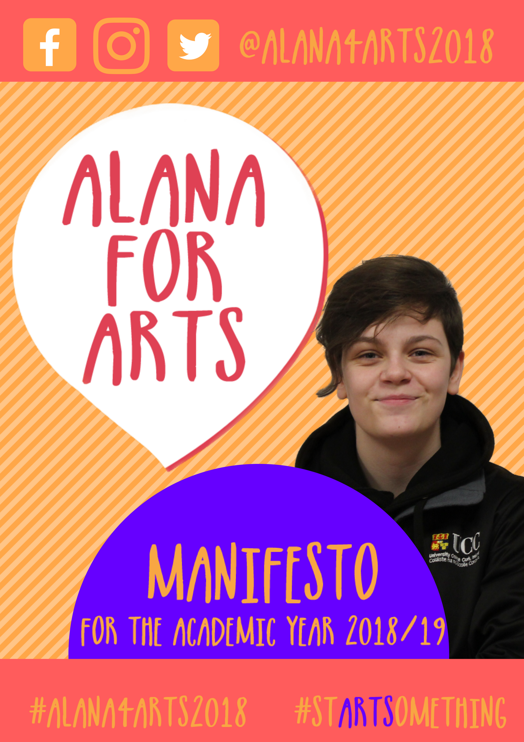

Name: Alana Daly Mulligan
Student Number: 117351893

Manifesto

For the position of Representative for the college of Arts Celtic Studies and Social Sciences for the academic year 2018/19

These views are my own and do not reflect the views of University College Cork, however if my views co-align with those of the University, that is purely coincidence.

All queries to 117351893@umail.ucc.ie

Or visit the social pages Facebook, Twitter and Instagram @alana4arts2018

Introduction

UCC is a campus that diverse but inclusive, big but with a community heart like no other, and supportive like a family. As a young person from outside of Cork, I felt very welcomed into the world of college by the wonderful students who came before me in the Students’ Union . After a very interesting year as Deputy Arts Representative, I feel I have an understanding of the workload as well as the commitment to taking on this position and being able to enforce real and actual change within my college community.
When it comes to leadership abilities, I am an experienced, competent, fair and just. For the last ten years, I have worked in a theatrical setting, having taken on several leadership roles both on and off the stage. I have spoken both in the European Parliaments in Strasbourg and Brussels respectively surrounding issues of active citizenship, cyber safety and LGBT* rights. At home, I have helped to coordinate two national homeless campaigns and was one of the founders of Ireland’s first youth literary festival. During my time in UCC, I have acted as class representative to all my four subjects of study (English, History, Greek and Roman Civilisation and Celtic Civilisation.) and during that time, have actively engaged with my classmates and gained a respect from the lecturers and tutors. I am also a proud member and Political Events Officer for UCC LGBT* Society, part of the Repeal the Eighth group on campus, and a member of the UCC Fencing Club. I enjoy working with people and more importantly, I enjoy helping people. At the core of the work I do is my passion for the arts, humanities and social sciences. I am an advocate for creativity and when embarking on any project, I am armed with my broad knowledge of the arts. Arts teaches students how to think for themselves, dares them to engage in debate, asks them to build, create and help paint a world that is better for all of us. From the work I have done and the work I continue to do, I strongly believe I would make a capable and worthy choice for this year’s CACSSS Representative.
I hope you will consider this manifesto and myself for the candidacy.
Alana Daly Mulligan

Mission:
For the academic year 2018/19, my hopes as Arts Representative are the following:

Use of Irish on Campus

I would strive for further incorporation of the student body’s involvement during Seachtain na Gaeilge.

This would be accomplished by working in hand with the Education Officer, Commercial & Communications Officer and the Irish Officer for this coming academic year.

Furthermore, a strategy would be put in place to ensure the long-lasting longevity of the use of the language on the campus.

This would be coordinated with the Education Officer, Irish Officer and Chairperson of Societies.

Monthly showcases of arts students ‘work in the Glucksman Gallery

It is my belief that art in all forms is a form of expression and allows people to connect on an emotional level.

As a campus that values the emotional wellbeing of our students and wants to encourage our students to produce the best work they can offer, it is my recommendation that monthly showings of artwork, poetry, literature and film would be displayed in the Glucksman Gallery.

There would also be the establishment of open mic nights and screenings on campus so that students who are not a part of a society can take part and immerse themselves in the vibrant arts community that University College Cork has to offer.

This initiative would spread across all parts of the department with anyone from within the University being allowed to submit works.

This will also be balanced with regards year group, with no group in preference over the other.

This would be coordinated with the assistance of the Campaigns Officer, the Entertainments Officer, the Commercial and Communications Officer and the Welfare Officer.

Work with Blackstone Launchpad

There is a stereotype among students and the general public that arts students and arts degrees are not valuable or useful.

It would be my intention to develop a closer partnership with Blackstone Launchpad in mentoring schemes for arts students; showing them how to better use their degrees and also teach them how to engage in entrepreneurial activities both within the college and in their personal lives.

This could be achieved via works with the Education Officer.

Peer Support Meetings with First Years

From my own experience as a first year, the initial jump from second level to third level is immense, intense and often very difficult for students.

Therefore I propose that by liaising with the Campaigns Officer and the Welfare Officer, alongside the Peer Support leaders, we could orchestrate a one-to-one meeting with first year arts students helping them adapt to the change.

We would also work in cooperation with the Class Representatives (second year and above) in order to fully care for the requirements and specific needs of each course in the College of Arts, Celtic Studies and Social Sciences.

Each class representative and Entertainments Representative in the College of Arts, Celtic Studies and Social Sciences would be assigned 10 students per week for five weeks. They would have 10 minute meetings with each student, discussing how the student was finding college life, what parts of their course they liked/did not like.

Arts Week

In coordination with this year’s outgoing Arts Officer, I worked to develop and Arts Week Programme which was successful.

I feel that this week could be organised on a far bigger scale for next year by getting full support from all members of the Student’s Union and the College itself.

Therefore, it is my hope should I be elected as the Arts Representative, that Arts Week will continue on a larger scale next year.

Opinions
At the heart of my campaigning for the last decade, representation and equality have been at the forefront of my work. I strongly believe that CACSSS is an underrepresented, undervalued and under-appreciated part of the college and as the Arts Representative, I would ensure that this opinion changed.
Furthermore, as CACSSS is the largest College within University College Cork, it is understandable that students, in particular, first years, feel bewildered, lost, confused and without guidance upon entering this hallowed third level institution. As aforementioned in Article IV, I would hope to enact a change in this area.
I am an advocate of working with the other colleges to improve life for students. I strongly believe that no student is one thing or should be defined by the college they come from. For example, a student studying biology should be entitled to experience the arts and social sciences were they to have an interest and vice versa. I think that by working alongside other college representatives we can help support these students who wish to engage with other colleges.
One of the key issues I observed this year was cyber-bulling and the use of offensive language within Class Representative group chats. I was appalled to come across homophobic, racist and sectarian comments. While this issue has been addressed in council, I feel that it should be more actively perused in the next academic year with electronic training provided to class representatives; showing them how to correctly and efficiently manage social media platforms relating to the college.
I am very passionate about Q+3 but would like if the history books were to be moved up from Q+2 because it’s a trek to go the whole way downstairs.

Vision
It is my hope that in the position of Arts representative I will be able to not only be a spokesperson for my college with pride and honour, but also bring together the other representatives. I see the tightening of the UCC student governmental community in the next few years and I would love to be a part of that change.
I would like to see more Arts students taking on a role as entrepreneurs with the guidance of Blackstone Launchpad. There is a world of opportunity for arts students, it is just a case of creating the opportunity for yourself.
I want to bring the College of Arts, Celtic Studies and Social Sciences closer together, uniting the satellite campuses, building a support network for students in every subject grouping and helping arts students realise the brilliance in their differences as well as what brings them together.
Finally and most importantly, I hope to learn from this very valuable experience. I strive to help and serve people in my community and it would be a great honour to give back to my University.

