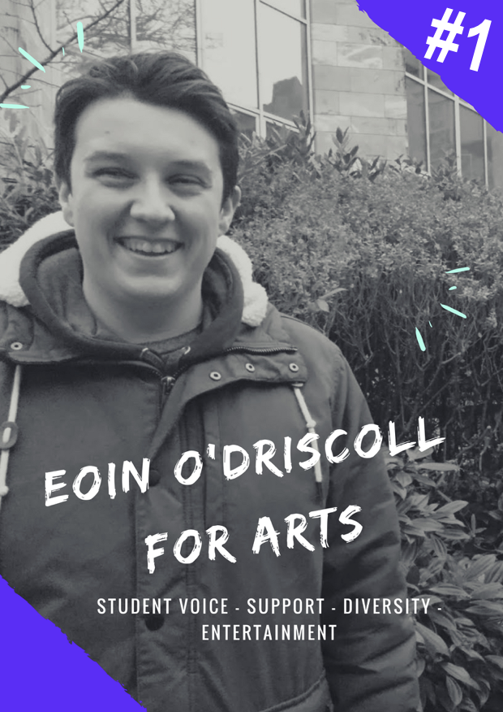

Manifesto

Who?
Eoin O’Driscoll (AKA Yours truly) is a second-year politics and geography student, class rep, laughter enthusiast.

Why?
The student experience is a very important issue for me. Ensuring that everyone has the best college experience possible, is an issue that needs to be addressed. I feel I am the best candidate to ensure a brilliant experience for all students. From experience as a class representative; fighting issues within my department, representing and helping my classmates, attending student union clinic and council, as well as working with different organisations and societies, makes me qualified for the position. From the issues laid out in my manifesto, I hope I get your number 1 vote on the 6th and 7th of March 2018.

The Issues.
- The Student Voice.
- Support.
- Diversity.
- Entertainment.

All students deserve a student voice in the college of Arts, Celtic Studies and Social Sciences. From the Arts Rep to Class Reps, I will ensure a strong cross community of diversity, that will have a strong presence in University College Cork. As YOUR college representative, I will:
- Ensure all students know about the position of the CACSSS (Arts) Rep. During the first week of semester one; I will visit the class groups of all incoming students. I will welcome them as well as inform them about the student union and hold class elections. Throughout the college year, I will send out emails to all CACSSS students. All students will be informed about the CASSS Representative; duties of the position and of the importance of class elections.
- Act as a strong student voice for all students. As outlined in Diversity points 2 and 3, I will act as the voice for all students. I will gain insights via Class Reps and students, painting a greater picture of the issues at hand, and act via the student union to address these problems.
- To ensure a strong voice for all students, I will endeavour to elect as many Class and Ent Reps as possible. I will do this via the traditional method of visiting of the various class groups. I plan to also use alternative methods of electing. For example, sending emails for the elections, creating a quick online voting system, and getting UCC peer support groups and societies of the subjects involved in the elections of Class Representatives. This will allow us to broaden and diversify the election and the methods used on campus, as well as ensure a class rep is elected for all students. Thus a strong student voice is on campus is ensured.

Support is essential for everyone. I guarantee a welcoming and supportive representative for all students. After the election of Class Reps, it is very important that all representatives know that I will be there. I will act as a point of contact, offering support and guidance. I will:
- I will ensure the proper training of all class representatives. On training days, I will ensure that Class Reps and Ent Reps get to know their fellow reps, especially the ones involved in the same subject. I will also ensure that the class representatives gain the vital knowledge needed for their position.
- I will have a Deputy Arts Rep elected at the first rep’s clinic. I will inform all class representatives at the training day of the availability of the position, the duties of the position, and encourage all to run for the position.
- I will support to the best of my ability any propositions brought forward by CACSSS reps or students. I will help bring forward the proposition and develop it with the individual to bring forward to the council.
- It is important to reach out to the elected representatives in other colleges and I will ensure contact with them, showing a unifying support for the work that takes place in the student union.
- It is vital that communication is kept up with between the CACSSS Rep, Class Reps, and Ents Reps. I plan via social media pages and email to ensure all class reps know they are part of a community. I also plan to meet with representatives in non-formal situations (for tea/coffee etc.) to see how they are, thus being a strong contact point for the class reps.

The college of Arts, Celtic, and Social Studies is an embodiment of the celebration of diversity. We need a representative who will embody this diversity. Celebrate the differences between our subjects, and be a unifying force that will bring together this diversity. As YOUR representative, I will do this do the best of my ability. I will:
- Encourage the cross communication of class representatives of the same or similar subjects. I will place students of the same or similar subjects together during rep training, and in clinics. This will ensure the best possible results for all students within the subject. Students will have an insight by class reps from different years, and it will also allow for students to see if there are any reoccurring issues within the department. It will help both the students and the various departments to resolve any reoccurring issue that may be taking place.
- The diversity of our subjects also needs a voice. A voice that will champion this diversity. I will act as an unbiased strong student voice for all students. I will introduce a monthly clinic, where students will be able to gain information on their rights as students as well as contact me should they wish to raise an issue; such as with class reps, their department and any issue that is felt the student union should champion.
- The diversity of the college also holds reaching out to various programmes at its heart. I will reach out to programmes such as HEAR, DARE, back to college programmes initiatives (UCC+ Students etc.), and will act as an ambassador for the college. Welcoming all students to our college of diversity.
- Our diversity within our college also needs entertainment that fits. From the cross communication (Diversity, 1) I will encourage representatives to help develop Arts Week. Events and activities based on our subjects in our college will help develop the presence of our college subjects and the diversity that exists.

Entertainment is a crucial aspect of the student experience. Working with the Class Reps and students, I plan to create a constant positive experience for all students.
- Working with the ent and class reps from various class groups to plan events will allow us to showcase the highlights of the subjects. For the planning of the Arts Week, I will bring together all the representatives, class and ents, to create a unique week of experiences. I will also work with the Ents Rep on the SU, ensuring the week is a success.
- I plan to work with the elected Deputy Arts Rep to form a more encompassing student experience. It will also give a second voice on the development of the student experience through the likes of the Arts Week, as well as the development of other activities throughout the course of the academic year.
- By working with the class ents and class reps and investigating preferable ideas for group events, it will allow us to create inclusive experiences for students in all classes. This will act as a point to showcase the diversity of the college.

Is that all folks?
No! it’s not all. This manifesto is just the start. Any ideas or suggestions ever thrown my way, they will never fall on silenced ears. I am always willing to listen to everyone, and as outlined try to create atmosphere, and create the best student experience. I hope I get YOUR number 1 vote.

