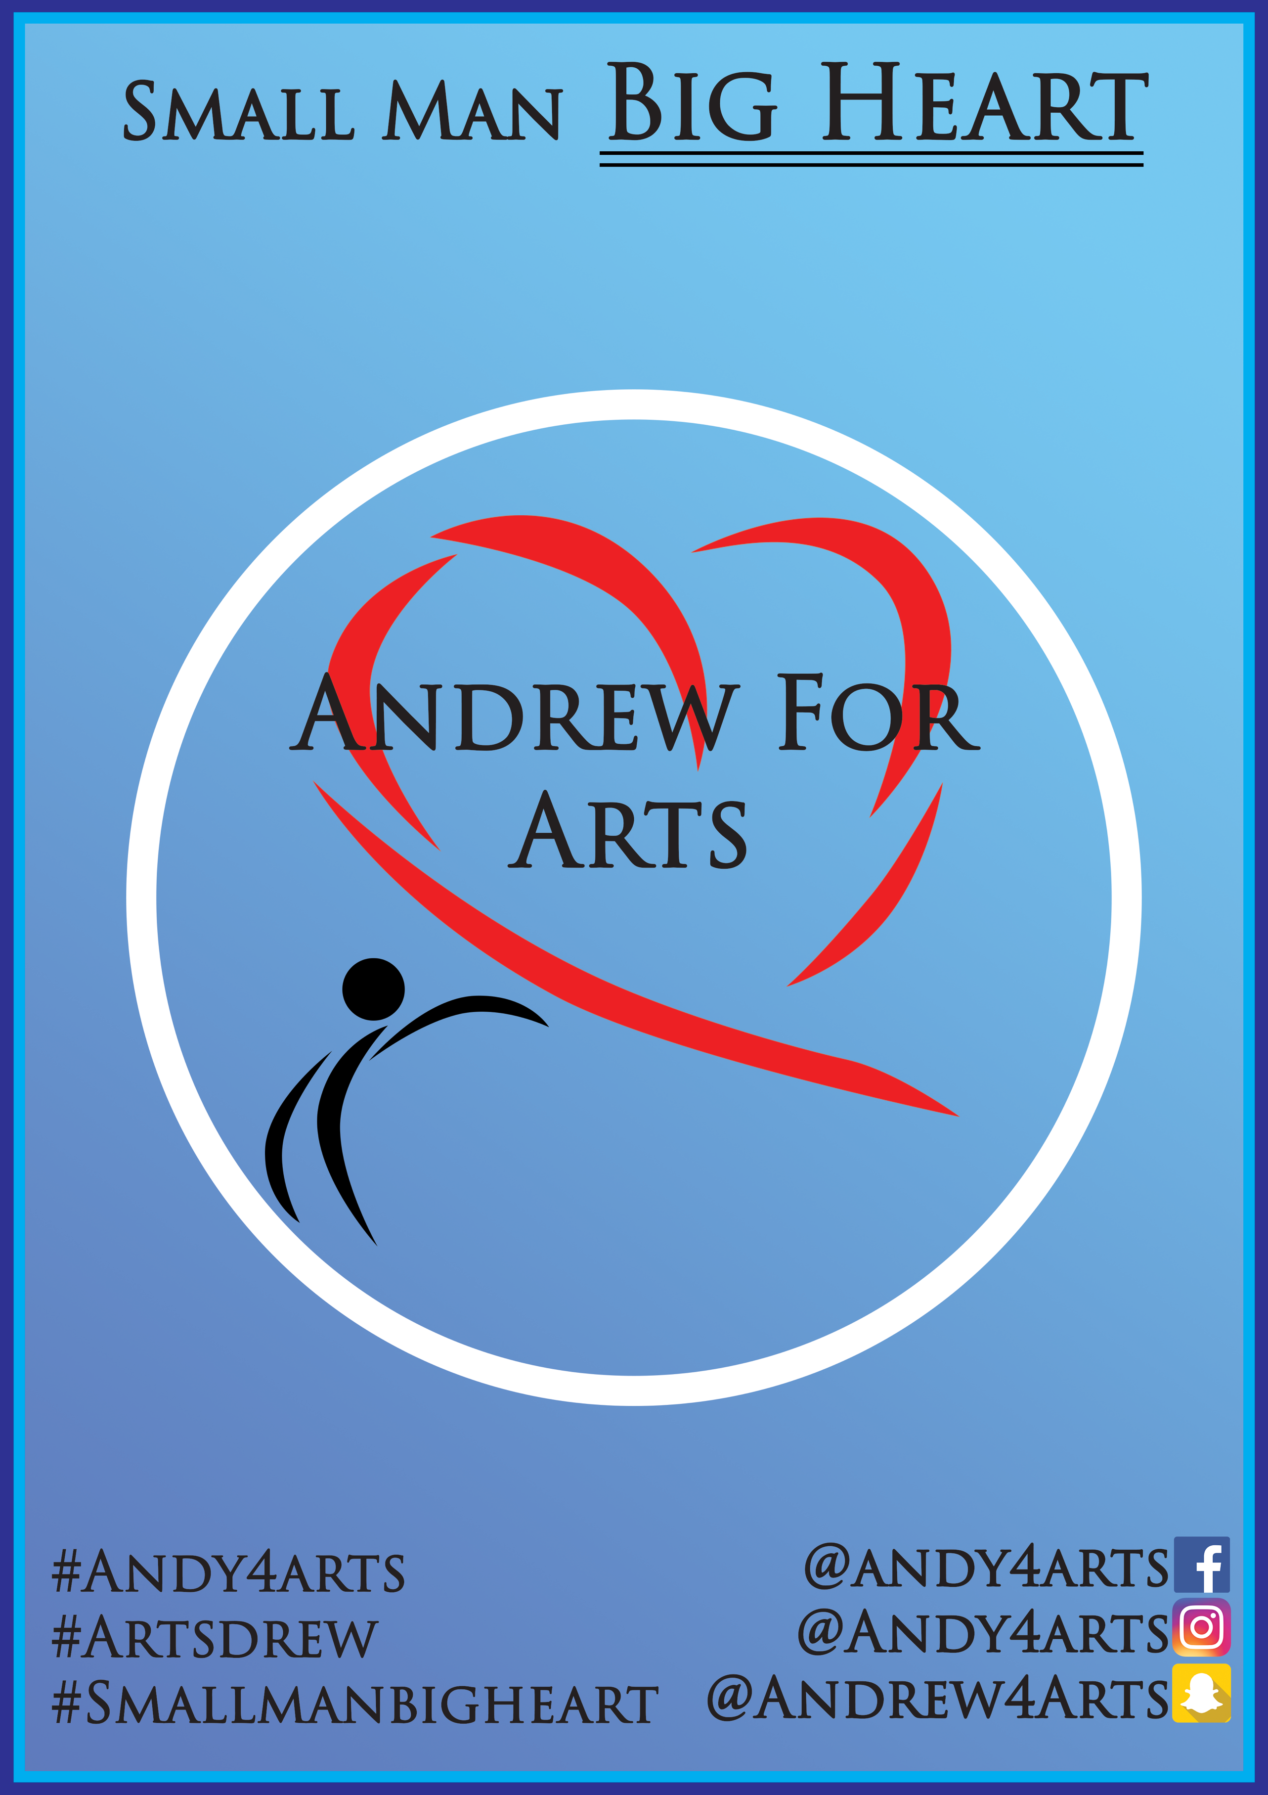
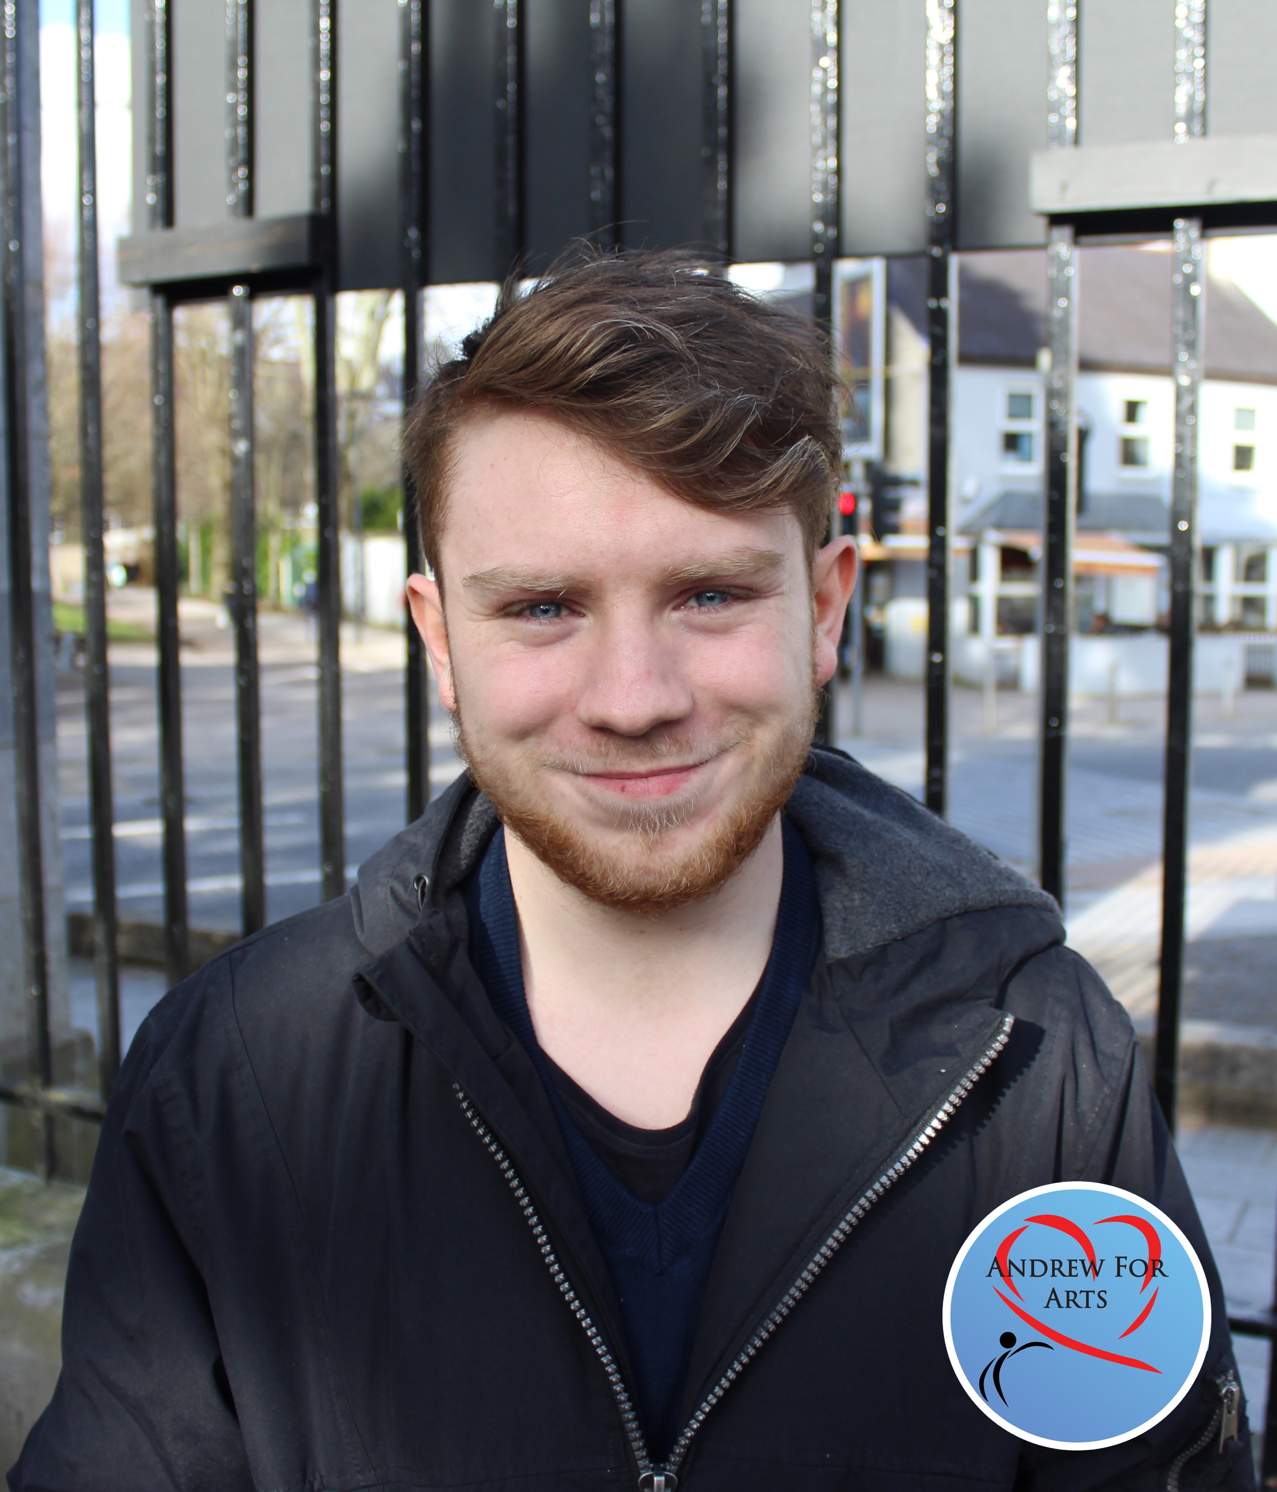

Andrew Burke for CACSS Representative UCC 2018/2019 Manifesto
Who am I?

My name is Andrew Burke and I am a First Year Arts student. I am also the First Year rep for Philosophy, and on the committee of the UCC Comedy Society! I like long walks on the beach, drinking Capri-suns and I am the same height as Michael D. Higgins.

Why vote for me?

I think I am the best candidate for CACSSS rep because I am a believer in advocacy; speaking out for those who cannot speak for themselves. I was the leader of my secondary school’s Meitheal team in 2016 and partook in the setting up of a local advocacy group in Cork. I was the first person to receive the Michael Sheedy Award for Drama and I have a grade 5 LAMDA. I have also proven to be one of the most active class reps this year by regularly emailing my peers and keeping them updated with the course, and ensuring notes were uploaded to Blackboard. In addition, I have logged on all my hours for the UCC Works Award! I would like to apply my skills on a larger scale as Arts Rep. I am a small man who wants to do big things for my fellow students.

My plans as CACSS Rep:

Communication:

I plan on improving communication between faculty and the student body (typical, I know). If you check the contact section of any subject on Blackboard, there are lecturers who have not put up their relevant information. This makes it difficult to get in touch with lecturers when problems with classes or assignments arise. As Arts rep, I will ensure that all lecturers and tutors can be contacted easily and that their visiting hours are clearly stated.
I will also improve communication between students and the Student Union. It is my belief that there should be an open line of communication between them because the Student Union represents the student body.
I plan on increasing the number of class reps per subject to improve student representation and communication. As a class rep of 300 students, it would have made my job a lot easier if I had someone to share the workload with. If a class exceeds 150 students, I want to make it mandatory to have two Class and Ents reps.

Transparency:

From my own experience with subjects, marking schemes are not transparent enough. As students, we should know how our marks at the end of the academic year will be calculated, what each part of the course is worth, and what is necessary to get a passing grade etc. Lecturers and tutors should also be more informative about the course and should be able to answer any questions that students have.
I believe that class reps should have further training in managing social media, first aid, and be given clear instructions on how to organise and order class memorabilia. Over the year, I have noticed fights starting in Facebook Messenger group chats. I’m aware that the UCC mobile app is being refreshed and a method of creating class wide groups with admin and moderation features should be included to minimise conflict.
As first years, we are privileged to have a faculty of qualified and experienced lecturers. I am appreciative of the hard work that goes into achieving such a high level of academic success. However, sometimes there can be a disconnect between experienced lecturers and inexperienced students, and because of this, communication can be difficult. There should be an option for students to provide feedback and suggestions to their lecturers in an efficient, stress-free way.
Notes and slides that lecturers made should be freely available to all students on Blackboard, regardless of reason for absence. It makes student life a lot more stressful to have notes be inaccessible, especially as a first-year student when time management is most important. This is equally true for recorded lectures. This service is only provided to certain students, but it is a utility that could be beneficial to all. Our education shouldn’t be drastically impacted by poor time management, as we adjust to a new education system.

Inclusivity:

I would like to push the Ents reps to have a minimum of one event per semester and I will regularly post possible locations and student deals for their future events. I would also like them to have at least one non-alcoholic event for students who don’t, or can’t drink.
Mature students often struggle to fit into student life and feel like they can be excluded by younger students. I want to find a way to bring mature and exchange students into the college community in UCC. I feel like Ents reps can play a huge part in this by setting up inclusive events.
Arts Week has been very successful this year, but next year I want to build on the good foundations that it has provided. I didn’t feel as though it was promoted enough on social media and I would like to rectify that. I want to hold more events, collaborate with societies and have a bigger Arts Week in 2019. I will also do my best to assist with Arts Ball, taking into account the opinions and suggestions of students.

In conclusion:

I promise that, if elected as Arts rep, I will endeavour to make the necessary changes in order to make academic and social life for Arts students easier, while continuing to implement the changes that previous Arts reps have made. I would like to thank everyone who invested interest in my campaign so far and I am thrilled to ensure that there is more to come in the next few weeks. Thank you very much, and I look forward to seeing you all on Tinder!

