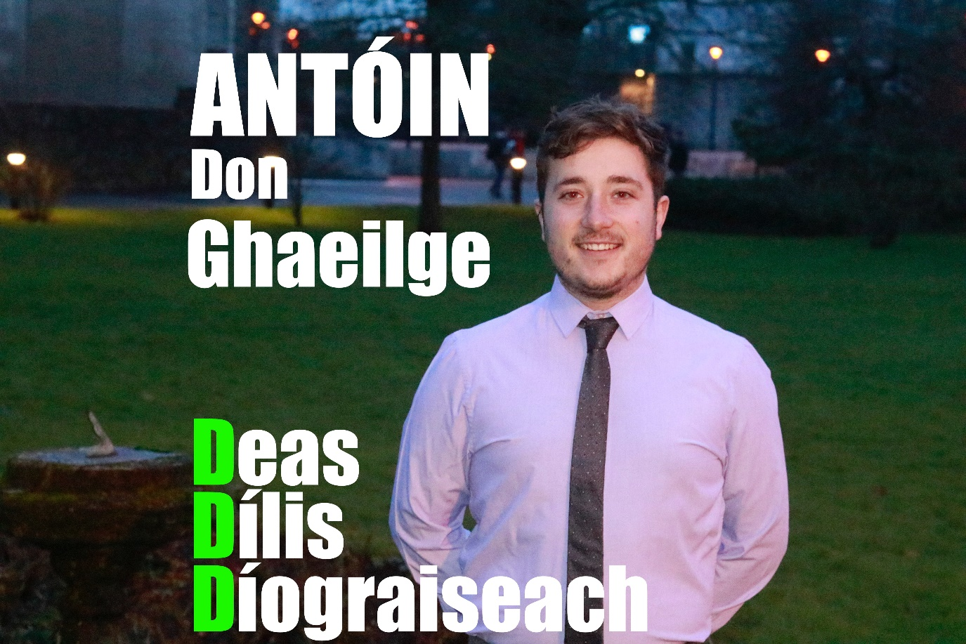

Antóin Ó Dúllaing

Forógra d’Oifigeach na Gaeilge ar Aontas na Mac Léinn, Coláiste na hOllscoile, Corcaigh
Manifesto for Irish Officer on University College Cork’s Students’ Union.

Réamhrá/Introduction:

Bail ó Dhia oraibh! Is mise Antóin Ó Dúllaing, Is as Gurrán na mBráthar i dtuaisceart na Cathrach mé agus tá mé i mbliain deireanach mo chéime Ealaíona. Tá bhur vóta uimhir a haon á lorg agam don phost mar Oifigeach na Gaeilge ar Aontas na Mac Léinn UCC 18/19. Tá ár dteanga dúchais fíor-thábhachtach domsa agus tá réimse leathan smaointí agam maidir le conas í a chothú, a chaomhnú agus a fheabhsú laistigh den choláiste. Beidh bhur dtacaíocht ag teastáil uaim, áfach. Le bhur dtoil, tóg cúpla nóiméad chun m’fhorógra a léamh agus blas a fháil ar mo smaointí don bhliain atá romhainn.

My name is Antóin Ó Dúllaing, I am a final year BA student from Gurranabraher, Cork City. I am looking for your Number One Vote as Irish Officer for UCC’s Students’ Union 18/19. The Irish Language is extremely important to me and I have a wide range of ideas on how to promote, secure and improve the future of our native Language within UCC. However, I will need your support in order to do so. Please take a few minutes to continue reading my manifesto and to get an understanding of the ideas that I have for the year ahead.

Taithí/Experience:

Is dóigh liom gur mise an duine is fear don phost seo de dheasca an taithí cuimsitheach atá agam leis an teanga chomh maith le mo scileanna ceannaireachta.
- Tá taithí ‘céad-lámh’ agam bheith ag suí i halla léachta ag foghlaim na Gaeilge mar bhíos á dhéanamh le 3 bliana anuas.
- Is ball den Chuallacht mé ón gcéad bhliain agus an bhliain seo táim ar an gcoiste freisin. Bhíos páirteach le gach uile imeacht/ócáid a d’eagraigh an Chuallacht chun an Ghaeilge a chur chun cinn i mbliana. I gcaitheamh m’aimsire ar an gcoiste, d’éirigh linn réimse leathan imeachtaí a eagrú agus a chur ar fáil ar nós: Bál na Gaeilge, turas go hOireachtas na Samhna, aoi-chainteoirí, seachtain na Gaeilge, Seachtain Chultúir na hÉireann, clubanna chomhrá, Pop-up Gaeltacht, srl.
- Is mise an t-ionadaí ranga don bhliain deireanach.
- Is láithreoir mé ar an gclár raidió ‘Lár an Lae’ atá trí mheán na Gaeilge, uair amháin gach seachtain ar UCC 98.3FM.
I think that I am the best candidate for the job as I have an abundance of experience with the Irish Language as well as holding positions of authority.
- I have first-hand experience as to what it is like sitting in a lecture theatre learning about the Irish Language, as I have been doing so for the past 3 years.
- I have been a member of An Chuallacht since first year and this year I am currently on the committee. I have played a part in organising every event that An Chuallacht has put together to promote the Irish Language. During my time on the committee we managed to put together a wide range of successful events such as: Bál na Gaeilge, annual trips to Oireachtas na Samhna, guest speakers, Seachtain na Gaeilge, Seachtain Chultúir na hÉireann, weekly Club Comhrá and so on.
- I am the class rep for final year Irish this year.
- I host a radio show ‘Lár an Lae’ which is completely through Irish, once a week on UCC 98.3FM.

I rith bliain na hardteiste, roghnaíodh mise mar chaptaen na foirne ar an bhfoireann díospóireachta sa mheánscoil, is é sin a thug scileanna ceannaireachta a mhúin dom conas foireann a stiúradh sa treo ceart agus bua a bhreith. Chomh maith leis sin, bhíos mar chathaoirleach ar Chomhairle na nDaltaí, taithí luachmhar ceannaireachta eile atá agam a chabródh go mór liom is mé mar Oifigeach na Gaeilge.
During my Leaving Cert year I was appointed Captain of my school’s debate team (completely as Gaeilge), that gave me the leadership skills on how to steer a team to victory. As well as that I was elected as Chairperson for the Students’ Council, another invaluable leadership experience which I believe will help me in my role as Irish Officer on the SU.

Mo Chuid Smaointí/ My Ideas:

- Teasatíonn uaim seomra a chur ar fáil d’fhoghlaimeoirí agus ghaeilgeoirí uilig chun Gaeilge a labhairt pé am gur mhaith leo. Tá a fhios agam go bhfuil a leithéad de rud ann ‘Pop up Gaeltacht’, ‘Tae & plé’, ‘ciorcal chomhrá’, srl, ach tá sé seo difriúil. Ba mhaith liom sórt common room a bhunú a bheadh ar oscailt ar feadh an lae go bhféadfadh mic léinn crocadh timpeall laistigh ann, staidéar, bualadh le daoine nua nó fíu a scíth a ligint go léir trí mheán na Gaeilge.

I would like to have a room available for all learners or Irish speakers to go to and speak Irish whenever they want. I know there are such things out there as ‘Pop up Gaeltacht’, ‘Tae & plé’, ‘ciorcal chomhrá’, etc, but this is different. I want to set up a common room completely as Gaeilge that would be open all day for students to hang around, study and meet fellow Gaeilgeoirí.

- Le cúpla mí anuas, táim ag cur ranganna ar fáil do shean-daoine i dtuaisceart na cathrach san ionad pobail áitiúil saor in aisce. Ranganna ag múineadh na Gaeilge, agus is iontach an rud é an suim a fheiceáil beo i sean-daoine nár labhair Gaeilge le 40+ bliain anuas. Dá roghnófaí mé mar Oifigeach na Gaeilge, bheadh sé de dhíth orm leanúint ar aghaidh leis na ranganna seo agus níos mó a chur ar fáil. Agus b’fhéidir ceangail a dhéanamh idir UCC agus an t-ionad pobail go mbronnfadh teastas de shaghas éigin ar mhic léinn a dhéanann na ranganna seo. Teastaíonn uaim go mbeadh mic léinn eile sásta tuillteanach cúnamh a thabhairt leis na ranganna seo. Bheinn ag iarraidh go n-aithneofaí an obair seo trí scéim ar nós UCC Works.

For the past few months, I have been teaching classes to elderly people in the north side of the city in the local community centre free of charge. Classes teaching Irish, and it is surreal to see how interested the elderly people are in the language even though they haven’t spoken a word of it in over 40 years. If I was chosen as Oifigeach na Gaeilge, I would continue with my classes and also I would make more available. I would like for fellow students to join with me in this initiative and to have their efforts recognised through some sort of scheme like UCC Works.

- Bhí seachtain na ngiobail an-rathúil i mbliana arís, áfach, mar a bhí ann le cúpla bliain anuas, ní raibh móran imeachtaí ag baint leis an nGaeilge ann. Ba bhreá liom an Ghaeilge a thabhairt isteach sa scéal agus imeacht iomlán trí ghaeilge a thosnú. Pop-up Gaeltacht nó rud éigin mar sin.

Again this year, R&G week was very successful, but, just like the last few years, the Irish language has nothing to do with the events that were on. I plan to incorporate Irish into R&G and have an event completely through Irish. Something like a Pop-up Gaeltacht.

- Tá na mílte mac léinn timpeall na tíre le Gaeilge acu. Dá mbeinn mar Oifigeach na Gaeilge, bheinn in ann dul i dteangmháil leis na hoifigigh eile sna coláistí eile agus ócáid a eagrú eadrainn féin. Fiú na coláistí timpeall na tíre NACH bhfuil cumann Gaelach acu (CIT, Coláiste Stiofán Naofa, srl) go bhféadfainn dul i dteangmháil leo agus fáilte a chur rompu chuig an ócáid. Bheadh turas go dtí an Ghaeltacht oiriúnach.

There are thousands of students around the country that can speak Irish. If I was Irish Officer, I could get in touch with all the other Irish Officers from other colleges and organise an event between ourselves. Even the colleges that don’t have an Irish society (CIT, Coláiste Stiofán Naofa, etc), I could get in contact with them and invite their Gaeilgeoirí to come along to the event. A trip to the Gaeltacht would be suitable.

Mar fhocail scoir, dá dtóghfaí mé mar Oifigeach na Gaeilge ar Aontas na Mac Léinn, déanfaidh mé mo sheacht ndícheall an Ghaeilge a chur chun cinn timpeall an choláiste. Tá post do-chreidte déanta ag Faye Murphy i mbliana agus bheinn an-sásta liom féin dá bhféadfainn cur leis an méid atá déanta aici cheana féin. Creidim go láidir gurb é mise an t-iarrthóir is fear don phost seo agus táim ag tnúth le bheith ag obair ar bhur son agus ar son ár dteanga ar Aontas na Mac Léinn.
To come to a close, if elected as Irish Officer to the SU, I would do my upmost to promote the Irish Language within the college. Faye Murphy has done an incredible job this year and I would be very happy with myself If I could add to all the things that she has done this year and come up with even more ideas myself. I strongly believe I am the best candidate for this job and I look forward to being able to work on your behalf and on behalf of the Irish Language on UCC’s Student Union.

Ar scáth a chéile a mhaireann na daoine.

