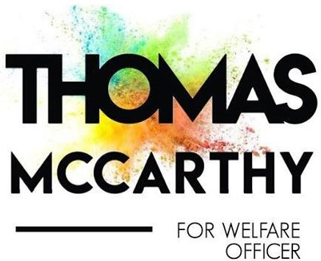

Introduction
My name is Thomas McCarthy, I am a final year Commerce student in UCC and I’m running to be your Welfare Officer for the coming academic year of 2018/2019. A Welfare Officer needs to be kind, caring, considerate, and above all must be there for any student in times of difficulty. The perfect person for the role must be hardworking, experienced and ambitious to ensure that the health and safety of every student in UCC is in good hands. Throughout my four years in college I’ve been involved in many clubs and societies, such as SÁMH (Suicide Awareness and Mental Health) and Enactus where I was an ordinary committee member on both societies. I have also been involved in the UCC Commerce Society, where I took up the role of Public Relations Officer last year, and Auditor this year. I’ve organised events of a broad variety, but those that are closest to my heart are those that both benefits the students and give back to worthy causes. ‘Minding Our Mental Health’ was an event I established in 2016 alongside my fellow society members. The event is now in its second year. It involves a panel discussion surrounding mental health. Last year, we hosted speakers such as Fionbarr Walsh (father of the late Donal Walsh), and Cailin Tobin (Current Miss Universe Ireland and positive mental health advocate). I’ve also helped raise awareness and funds for charities such as the Irish Cancer Society, raising €600 in 2016 and €800 in 2017 through another original event named ‘Turn UCC Pink’. We encouraged students to wear pink on campus to support the cause.

Mental Health
Mental health is something that is very close to my heart and in recent times has become such an important topic in every student’s life. Mental health, in essence, is something that I have battled with just like many others. Some of my main points surrounding mental health deal with increasing counselling services for students, and making them more readily available. I would also run campus-wide events throughout the year where speakers who have a variety of experiences and knowledge on mental health come to the college to discuss their experiences, such as Blind Boy (from the Rubber Bandits), Niall Breslin and Miss Universe Ireland winner, Cailin Tobin.
If elected as your Welfare Officer, I promise to ensure the promotion of the vital and underused service we have here in UCC, Niteline. Niteline is a listening service for students provided by students. I feel it is underutilised and should be promoted more so that every student knows about this service. If elected, I would invest my time into creating an online and on campus awareness campaign so every student is made aware what exactly the service does and other essential information.
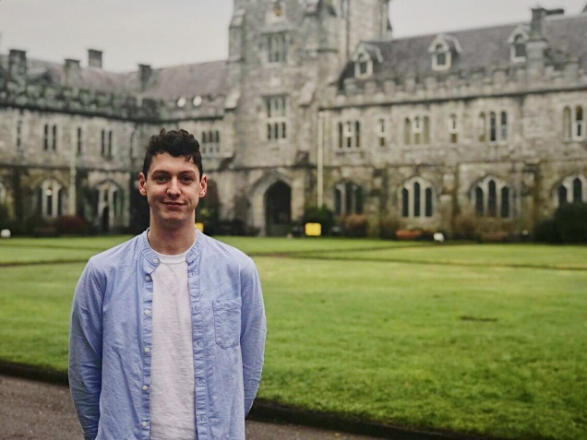
Throughout the college year I also intend to run workshops and classes in the following areas
- Mindfulness
- Wellbeing
- Exam Stress Relief
- Meditation

These are extremely important to student’s mental wellbeing, especially around stressful times like exams. I think these classes, if run properly and run on a regular basis, will help strengthen mental health resources and support structures for students.
I hope to work alongside the Deputy and Campaigns Officer and run events towards breaking down the stigma around mental health. Raising awareness around the services available to anyone who is suffering from mental health problems is a major priority of mine. I want to ensure students know that there are people and services out there to help, such as Pieta House, ULink Peer Support and Niteline.
If elected Welfare Officer, I plan to maintain and expand the Welfare Crew. The Welfare Crew is a group of students who volunteer their time throughout the week to assist with the wellbeing of the student body. My main initiative for the Welfare Crew would be to promote events and services, through social media in order to reach every student. Extensive training would be provided to the team to deal with situations where students can confide in them in times of need. Also the Welfare Crew will be involved in organising events and workshops on a regular basis that will cover a wide range of topics, such as how to deal with a friend that comes to you with a problem, or dealing with your own mental health difficulties.

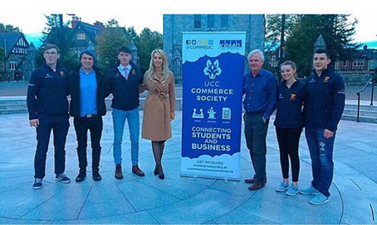
(Myself, Adam Finn and Fionbarr Walsh at ‘Minding Your Mental Health’, event on World Mental Health Day 2016.)
Physical Health
Caring for the body is as crucial, as caring for the mind. In fact, one cannot be healthy without the other. Our physical health is just as important as our mental health. I would love to see more friendly, less competitively driven sports tournaments and events happening in and around campus. These can be great fun, increase mood and moral and help keep students fit, socially engaged and connected.

I would also like to promote the classes that the Mardyke offers free of charge to students. I would do this by hosting a “Mardyke Classes Fair” at the beginning of the academic year which would provide students with information on all classes available to students.

There is a wide range of classes available to students no matter what you’re interested in from aqua aerobics to hot yoga. I would lobby the Mardyke to add classes throughout the day, and even add new classes such as TRX suspension training. I would like to ensure that every student is aware of these classes that we can sometimes take for granted. I also aspire to promote classes for self-defence and hold body confidence workshops throughout the year.

‘’Something I am very passionate about is introducing a ‘gym buddy’ system, we all know how intimidating the Mardyke can be for newcomers’’

I like the idea of involving charities in these events, more colour runs and fun runs or even UCC’s first marathon, as these can help physically and mentally while supporting a great cause. If elected, I will also run more campaigns to emphasise the benefits of walking instead of using public transport, where applicable.

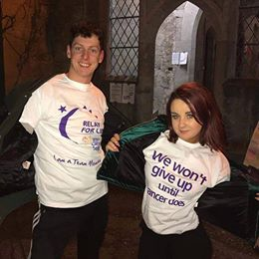
(My friend Sophie and I at the Relay For Life UCC)

Sexual Health
Sexual health is extremely important. Just like physical and mental health, you must take care of it!
I would continue the work of previous Welfare Officers by maintaining SHAG week at the beginning of semester one. I would also continue to make this a more LGBTQ* friendly week and I will incorporate and promote various sexual health services. I intend to bring rapid HIV tests to campus. If held on a regular basis, students can avail of these for free and feel safe with the fact that their results will be back that day. I would work closely with the Deputy and Campaigns Officer to raise awareness around the symptoms of different STDs.
I want to make a point of educating the student body about the drug PrEP. Pre-exposure prophylaxis (PrEP) is a HIV prevention strategy where HIV-negative individuals take anti-HIV medications before coming into contact with HIV to reduce their risk of becoming infected. The medications work to prevent HIV from establishing infection inside the body. PrEP has been shown to reduce risk of HIV infection through sex for gay and bisexual men, transgender women, and heterosexual men and women, as well as among people who inject drugs.
If elected Welfare Officer, I would also like to hold consent classes and workshops, similar to the nationwide Gardaí initiative ‘Ask for Angela’ campaign. I would also like to run a ‘Me Too Movement’ campaign for those who have experienced sexual assault or sexual harassment. This would encourage those affected to speak out about their experiences, so the people responsible can be held accountable. I want to make UCC a safe space for students to be able to come out and say they were abused or sexually assaulted without having to worry about any ridicule they might face.
Finally, if elected I promise to campaign to repeal the 8th amendment. The SU are already mandated to campaign on this due to a previous referendum and I can guarantee I will do my best to see this through.
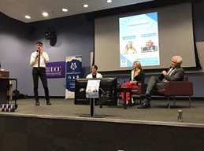
(Introducing our speakers at ‘Minding our mental health’ 2017 in Boole 4 UCC)
Accommodation
It’s no secret that currently we are facing a housing crisis. There are not enough rooms available to cater for the amount of students coming into college. What will I do if elected as your Welfare Officer? I hope to work towards having all rent options advertised through the UCC Accommodation website to avoid us students falling victim to scams. This way it can be monitored and hopefully prevented.
I would like to run a ‘Rent and Your Rights’ campaign throughout campus as to make every student aware of their rights to protect themselves from fraud or unsuitable living conditions.
For those students who drive to college I would like to start a campaign where students rent their spare parking spaces for a small fee for the week, thus benefitting both parties.

Finance
Being a student isn’t cheap. Fees, accommodation, food and socialising, it can all add up very fast. As Welfare Officer I promise to hold educational classes on:
- How to balance college life with a part time job
- Budget classes so students know how to save and spend efficiently.
Also, I will run campaigns making students aware of what discounts and deals they can avail of throughout campus and throughout the city.
Having a good Curriculum Vitae is one of the biggest stepping stones when it comes to getting that dream job. Do you ever sit there and think, ‘How the hell am I going to write this?’ Well you’re in luck, I would like to set up a workshop on ‘How to Write a CV and Cover Letter’ and provide guidance and tips on interviewing which would help students who need part time work. I plan to ensure that student health services and student counselling services receive the correct amount of funding. I also hope to tackle the issue with Student Fees with the Union of Students in Ireland to ensure a college education remains affordable for everyone. I would do the very best in my power to ensure that the student grant remains untouched.
If elected, I would organise a part time jobs fair to advertise all part time jobs that may be available for the college year, I will also do the same for summer jobs available after the summer exams.

All The Other Important Bits:
Satellite Campuses/Inclusion
I would like to see more inclusion for those students on satellite campuses, holding regular events not just on main campus but in Brookfield, North Mall Campus, Copley Street and Western Gateway etc. Just like the ‘Clubs And Socs On Tour’ ran by Clubs and Societies, I would also like to see events run by Clubs and Societies. For example, I would like every society to host an Erasmus Night, inviting all foreign students to a social evening and giving them information about their club or society.
First Aid/Defibrillators
As Welfare Officer, I would ensure that first aid classes and basic first aid training would be made available to every student in UCC for free. I would like to run a campaign which highlights where all the defibrillators are on campus. As a UCC student, I have no idea where any of them are. In times of difficulty, this is essential information to be aware of.
Getting Involved
I have been involved in Clubs and Societies since day one in UCC. I have met individuals from all walks of life and have met some of my best friends in these clubs and societies. I have been amazed at the opportunities that have come my way as a result of joining them. This would not have been possible if it wasn’t for these clubs and societies. Something I feel very strongly about is getting involved, for friends, for fun and for experience. I intend to run campaigns to promote these clubs and societies in UCC and make sure every student has the choice, if they want to join any club or society. It has transformed my college experience and I don’t want any student to be deprived of these experiences. On a separate note, as your Welfare Officer, I would do my very best to ensure every student gets registered to vote. This is essential – ‘’We, are the future and every student should use their voice.’’

Drug Awareness
Instead of pretending that students aren’t taking drugs, let’s make sure they know what they are taking. The Student’s Union need to bring their campaign on safe and controllable drug use up to date. The idea of drug testing kits on campus has already been brought into the SU and I plan on working alongside the ‘Students for Sensible Drug Policy Society’ (SSDP) to ensure that this is successfully implemented. One of my main goals would be to make kits readily available for students for free on campus. As a Students Union, we cannot stop students from taking drugs but we can certainly do everything possible to ensure that the students of UCC:
- Stay safe,
- Are responsible
- Know what they’re taking
Collaboration
My close friend, Lorcan O’Donnell is currently running for Welfare Officer in University of Limerick. We have both agreed if we are successful in getting the role of Welfare Officer, that we would run events throughout the two colleges and collaborate on various things that I have mentioned in my manifesto, mainly mental health and sexual health. This would be a lot of fun and it would be very exciting to unite the two colleges.
Food Education
Something I feel is very important is food education. Students need to know what they are eating. I intend to run healthy cooking seminars and demos; either through videos on Facebook, or the UCC Student’s Union Snapchat account. I love food, it’s something I am very passionate about. I have worked in the food industry since the age of 14, and I have worked in some of the best restaurants in Cork. If elected I would run a healthy food campaign, highlighting how essential it is to have a healthy diet for our bodies and for our minds.

Environmental Issues
There are a few things I would like to see done differently around UCC campus. For example, the introduction of compostable coffee cups. 2 million coffee cups go to Irish landfills every day - this is simply unacceptable, especially as we are actively trying to reduce our carbon footprint. As a green campus, we should be doing more to battle this problem.
I would also like to see more bins on campus so that rubbish doesn’t end up on the ground, not only outdoors but in the library as well. Too many times, bins are left overflowing. This is a sanitary issue that must be dealt with.

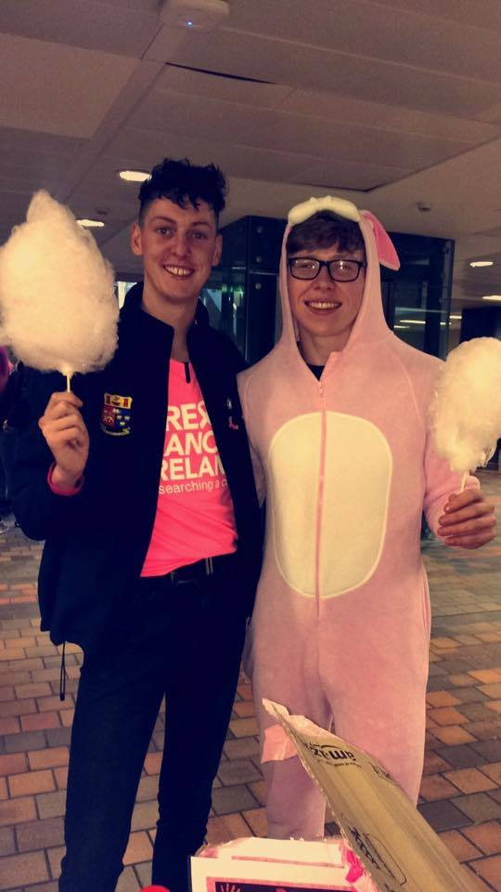

(My friend Padraig and I, at ‘Turn UCC Pink’ which raised €850 for the Irish Cancer Society)

Final Statement
Finally, I believe that students deserved to be listened to and to be taken seriously. We are the future of this country and the welfare of each and every student in UCC is so important. I will represent you, I will be a friend to you, I will fight for you. I will ensure that no student is forgotten about, and that no voice goes unheard. I will do my very best to make sure every aspect of your welfare is improved by the Student’s Union, and that is a promise.
So please vote for Thomas McCarthy on March 6th and 7th and don’t forget,
#ThomasMacHasGotYourBack

