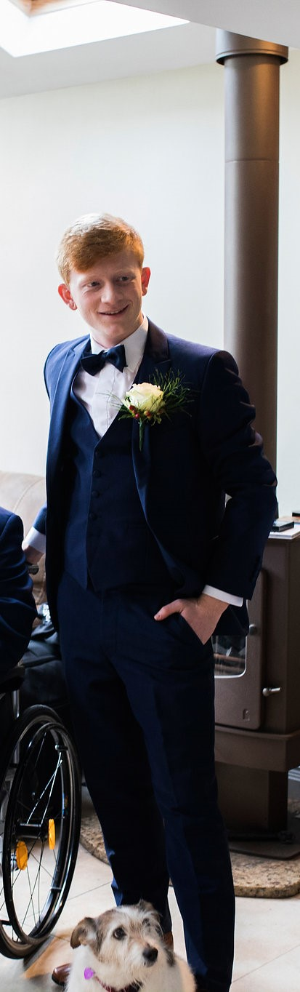
Seamusbreathnach4pres@gmail.com
@MakeWayForSe
Makewayforse

For SU President
Vote #1 Séamus
Makeway4se
/Seamus-For-President-UCCSU-1819
Séamus Breathnach
UCCSU President

About Me

My name is Séamus Breathnach, and I want to be your Student Union’s President for the coming year. I’m twenty years old, and I’m from Ballincollig, only 20 minutes down the road. I’m currently studying Irish and English, and have served as a class academic rep, an OCM for An Chuallacht, and as a member of the UCC ENTS crew.

I’ve had a phenomenal time during my years in UCC and I think a very large part of that can be accredited to the Student’s Union. I have the skills, knowledge, and experience necessary to lead this team in ensuring that all students have as great an experience as I did as a student of this outstanding university.

So, have a look through my manifesto (put it to the testo) - there’s a lot in it, I know, but it covers much of what I’d like to do as SU President.

Le meas,

Séamus

Vote #1 Séamus

For SU President

Engaging with the Sabbatical Officers

As President, I have my own ideas on how I want to have an impact on UCC for the coming year and beyond. However, I want to give the specialized sabbatical officers as much freedom as possible to do what they promise in their own election campaigns. While the President must be a sort of Jack-of-all-trades, the other five officers of the SU are the experts in each field. With that in mind, as President I would try to allow the sabbatical officers to achieve what they believe to be the most important things in each of their fields, serving more as a directorial aide then as a tyrant who’s plans must be followed.

For SU President
Vote #1 Séamus

Education

Education is the core of University life, it’s the reason all of us are here at UCC. But there exist a lot of barriers to accessing higher education. I’d like to try and deal with a lot of these issues, and I’ve outlined some of my plans to do this.

- After the abortion referendum in May this year, the government are going to be feeling the power of the student vote like never before. As 2019 is a local election year, we’re going to be heading into an election where there will have been recent evidence of the power of the student vote. I plan to use this momentum to lobby politicians and have them pledge to:
- Increase the SUSI grant across the board.
- Lower the restrictions preventing people from receiving the full grant.
- Increase the provision of student accommodation.

- Ensure the Student Assistance Fund continues to assist at its current rate.

- Maintain no Saturday exams for the coming year.

- Maintain extended opening hours of the Boole library and work towards extending Brookfield library hours past 21:45.

- Push for the recording of lectures to be mandatory, as this is an invaluable resource for students
Vote #1 Séamus

For SU President

Ents

- Push for greater SU-Society/Club collaboration throughout the year (not jut R&G week), to maximise and diversify the events happening on campus, such as comedians, bands, and sports days.
- Ensure that Ents for the coming year aren’t solely focused on main campus, I want to push for events to be held in the WGB, in Brookfield, and further afield in the Cooperage and the architecture building.
- I want to bring back big names to UCC – I’m not saying I can get Ed Sheeran, but in 2015/16 we had Pat Short and Hermitage Green on campus, 2016/17 we had Hudson Taylor, twice. It’s time to get bigger Irish acts back into UCC.
- I’d like to focus on raising money for R&G throughout the year, instead of limiting it to one week, so that we can raise a substantial amount of money and really make a difference.
- Hold a Mental Health week with plenty of events, as in the past they’ve often been disappointing – I’d like to see a Mental Health week full of events both fun and educational, so that we can really have a chance of tackling this issue.
Vote #1 Séamus
For SU President
- Further explore non-alcoholic options for class parties etc.

Welfare

- Ensure regular “Safe Talk” training sessions are held throughout the year, to better equip people to talk to their peers about Mental Health issues.

- Set up a “drop-in” counselling service for situations where students don’t feel like they can wait for an appointment.

- I want to place further emphasis on services such as Nightline and the UCC Peer Support service, to make sure students are aware that there exists an ongoing support system within UCC that are capable of supporting people who are under stress, suffering from mental health issues, or just need somebody to talk to.

- Organise for the free STI checks in the campus clinic to test for more than just chlamydia and gonorrhoea (as is the current system), and attempt to reduce the negative view many people have surrounding STI checks.

- Organise for pregnancy tests to be available at a reduced rate from the Welfare office.

- I want to work to increase the ability of campus counsellors to deal with addiction counselling, for people addicted either to drugs or alcohol.
For SU President
Vote #1 Séamus

Accountability
Accountability means a lot to me – the sabbatical officers are paid for their work, and there are standards of professionalism associated with that. If the President, and indeed, the wider Student’s Union, are supposed to be the voice of the students, students should be able to hear what that voice is saying.

- So, to ensure that everyone knows what I’m up to and how I’m representing students, I’m going to hang a calendar visible to all in the ground floor of the Student’s Union offices, with each officer’s schedule for the week, so that you can see exactly in what ways we’re representing the student body, and see when we’ll be back in our offices if you have any queries.

- Along with this, I believe that all SU officer reports should be made directly available to all students, not just through their class reps. I would like to organise this on an opt-in basis, because many students have expressed to me their distaste in the volume of all-student emails sent by the SU.

- I wish to publish student council attendance, so that students can know whether or not they are being represented in SU discourse.
For SU President
Vote #1 Séamus

Student Amenities

Throughout my time in UCC, I’ve noticed quite a few improvements that could be made to improve student life around campus.

- Address the lack of water fountains on campus, particularly in the Kane Building.

- Work towards getting the common room to stay open later, allowing not only students a place to wind down, but providing a venue for clubs and societies to meet.

- Promote the Cycle to Campus scheme and increase the amount of bike parking racks as we are already far over capacity.
For SU President
Vote #1 Séamus

Séamus Breathnach
for
UCCSU President

Thanks so much for reading my manifesot. I look forward to meeting with everyone in the year ahead to make the 2018/2019 academic year the best UCC has seen yet.

Beir bua agus beannacht,

Séamus Breathnach
Vote #1 Séamus
For SU President

