Support Energy Now: Fossil Free Fryslân 2016 - 2019
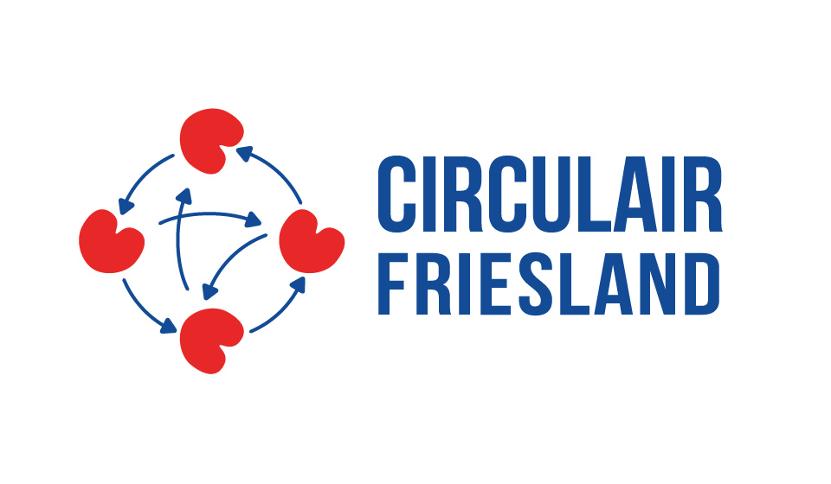
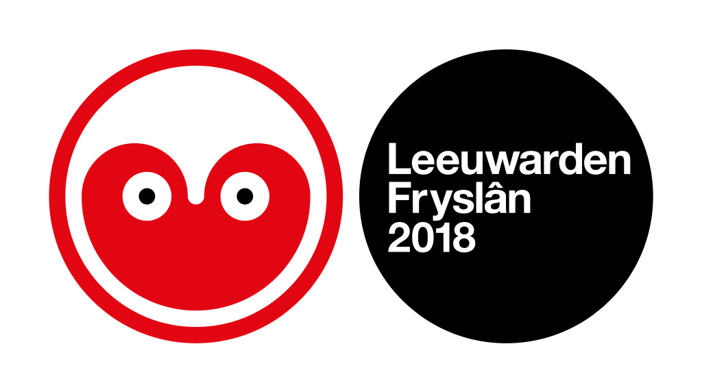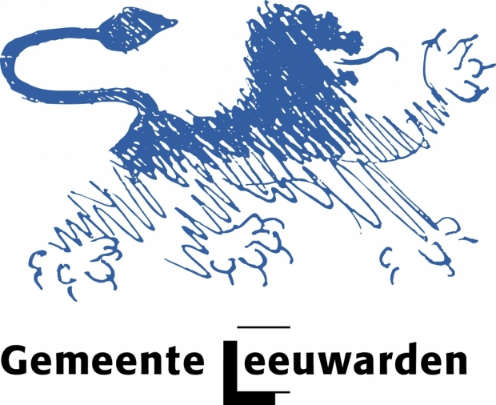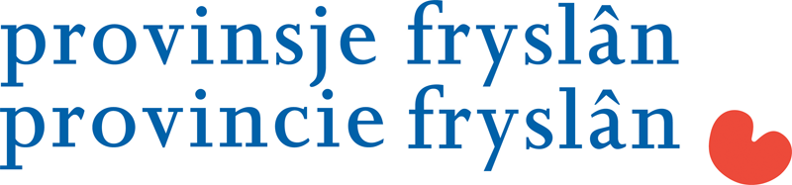
Letter of support – Fossil Free Fryslân

In my capacity of CEO of our Company I support the Energy Now! program of the Cultural Capital 2018 foundation, the Municipality of Leeuwarden and Circular Fryslân.
Part of the Energy Now! program is the Fossil Free Fryslân (FFF) project proposal, being developed by the Municipality of Leeuwarden and Friends for submission under the first call for applications of 2016 of the Urban Innovative Actions Initiative.
I support by:
- participating in the following FFF projects*:
________________________________________________________________________
- contributing 500 / 1000 EUR/jr, my company has … employees (less than 6: 500/more: 1000)
- bringing in at least 1 other company during the lifespan of the project (2016-2020) for participation in FFF activities.
- Supporting and participating in the 2 Fossil Free weeks in 2018.
The proposed project activities and results are relevant for our organization. We will support the project through our participation in project activities like workshops and visits and we are prepared to review the project throughout the project execution.

Yours sincerely,
Signature: Place: Leeuwarden
Date: … / march / 2016

Name:
Position:
Company name:

*The different projects are:
- Fossil free festivals;
- Energy Expo;
- 2000 energy neutral houses;
- 100 fossil free schools;
- 100 energy corporations;
- 100 fossil free companies;
- Solar boat race;
- Another project: _________________________
- I want to organize something else. My idea is to organize:
___________________________________________________________________________

