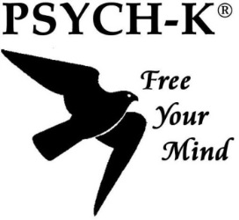
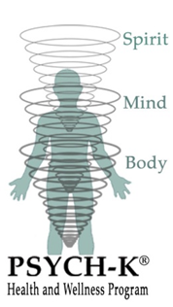
Change Reflection Sheet Name: Date:
Believe that change is possible and look forward to a simple, effective and powerful session. This is a quick and simple change modality that does not require much talking. PSYCH-K accesses the sub-conscious mind and has the ability to re-write limiting beliefs that prevent the life that you want. To help with any curiosity go to the Resources page of the website.
Reflect on the following two questions as preparation for a focused session.
How are things in your life right now?
(work, relationships, health, spirituality, prosperity, grief, confidence).
What patterns keep re-occurring that are limiting your life?

What do you want instead? (rather than what you don’t want)
(write in present tense and use positive language-think BIG!)

