Last Updated 2/19/19 – New Items Being Added All the Time!

Family Travel and Dining
B01 |  | Whitetail Resort | Learn to Ski or Snowboard Package (Top 2 Bids Win)  www.skiwhitetail.com  If you have never tried skiing or snowboarding, this package from Whitetail Resort is for you. This package includes:  ● Lift ticket that is valid on the Northern Lights, Velvet, Almost Home and the Launching Pad lifts.  ● Rental skis, boots, helmet and poles or snowboard and boot rentals.  ● A first-timer ski or snowboard group lesson  Located in Mercersburg, PA  Valid through the 2019-20 winter season. Age 8 and up Excludes holidays: Xmas-New Year’s; MLK Day Weekend, President’s Day Weekend | $113  Fair Market Value  $30  Opening Bid  $10  Increments
B02 |  | Liberty Mountain Resort | Learn to Ski and Snowboard Packages for Two  www.libertymountainresort.com  The Package includes  - An open to close lift ticket good on the beginner ski area!  - Ski or snowboard rental equipment and helmet  - A 90 min class lesson that guarantees you'll learn to turn, stop, and ride a lift!  Located in Fairfield, PA  Valid Sun through Fri during the 2019-2020 winter season. Age 8 and up. Excludes Saturdays and Holidays: Xmas-New Year’s; MLK Day Weekend, President’s Day Weekend | $220  Fair Market Value  $60  Opening Bid  $20  Increments
D04 | 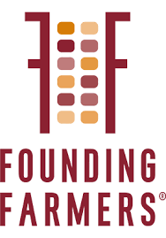 | Founding Farmers | $50 Gift Card to Founding Farmers  (Top 4 bids win!)  Owned by the more than 47,000 family farmers of NDFU and supplied by hundreds of family farms everywhere. | $50  Fair Market Value  $20  Opening Bid  $5  Increments
 |  | Jenny Cakes | 1 Dozen Cupcakes of Your Choice  www.jennycakesbakery.net  Our baked goods are made from scratch, in small batches, with fresh ingredients. Stop in our cheerful bakery tucked in Old Town Kensington on Armory Avenue just off Antique Row. Huge variety of flavors to choose from. | $30  Fair Market Value  $10  Opening Bid  $2  Increment
D03 | 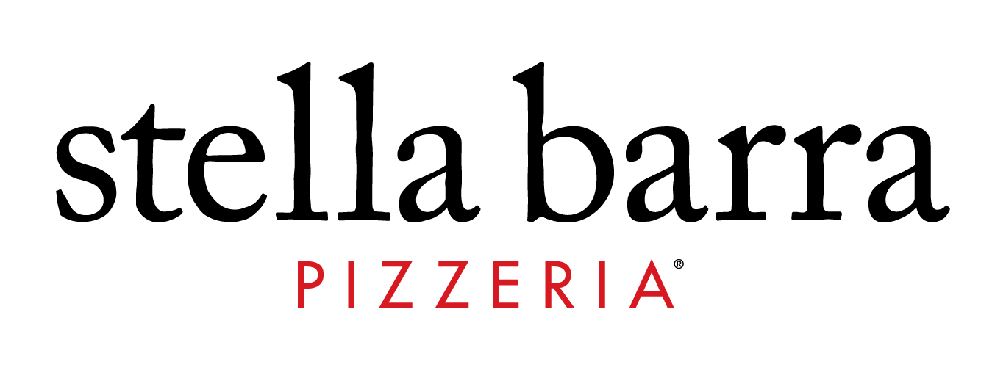 | Stella Barra  Pike and Rose | $50 Gift Card to Stella Barra  http://stellabarra.com/  This installment marks the fourth iteration of Stella Barra Pizzeria (other locations include Hollywood, CA, Santa Monica, CA, Chicago, IL), serving Chef Mahin’s classic pies atop his signature crust, plus a range of dishes created for the DC market. The wine list is comprised of more than 40 bottles, many derived from Southern Italy. | $50  Fair Market Value  $15  Opening Bid  $5  Increments
D02 |  | Summer House Pike and Rose | $50 Gift Card to Summer House  (Top 2 Bidders win)  http://summerhousesm.com/  Summer House Santa Monica presents an escape to the warmth and laid-back vibes of the West Coast, complete with beach house décor and hanging string lights. At the heart of the open kitchen lies a wood fire grill that is the workhorse of many of Summer House’s menu items. The menu, created by Chef/Partner Jeff Mahin, is California inspired and focuses on market driven ingredients, local and sustainable farming, and seasonal specialties, all complemented by a carefully curated list of California and Pacific North Coast wines. | $50  Fair Market Value  $15  Opening Bid  $5  Increments
D06 | 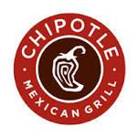 | Chipolte | Dinner for 4 (top 2 win)  Includes 4 entrees, 2 sides and chips and 4 regular non-alcoholic fountain drinks  Expires 12/31/2019 | $50  Fair Market Value  $20  Opening Bid  $5  Increment
D08 |  | Baked Bear | $25 Gift Card to Baked Bear  Pike & Rose  Custom Ice Cream Sandwiches  1. You pick the top and bottom  2. Pick ice cream  3. Enjoy! | $25  Fair Market Value  $5  Opening Bid  $5  Increment
D07 |  | Cava | $25 Gift Card to Cava  Cava celebrates the flavors of Greek and Mediterranean cooking in a casual modern setting. | $25  Fair Market Value  $5  Opening Bid  $5  Increment
D05 | 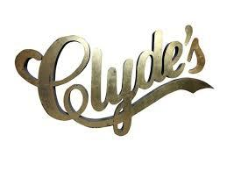 | Clyde | $75 Gift Card to Clyde  Whether you are visiting or live in Washington, DC, Virginia or Maryland, Clyde's restaurants are where you'll find a home away from home. We were one of the first in Washington to feature "locally-raised" and "sustainable" foods. In addition to our local and farm-grown produce, our legendary burgers are made using hormone-free, farm-raised beef sourced in the area and our chicken is antibiotic-free and hormone-free. Visit us and taste to believe. | $75  Fair Market Value  $25  Opening Bid  $5  Increment

Childcare, Summer Camp, and Birthdays
 | 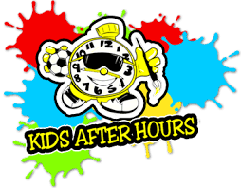 | Kids After Hours | Full Year of Before and After Care at GPES  www.kidsafterhours.com  Kids After Hours offers Before School programs beginning at 7am and After School programs from the end of classes until 6:30 p.m. | $5600  Fair Market Value  $1,800  Opening Bid  $200  Increments
 | 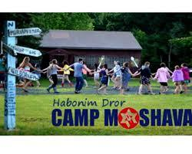 | Camp Mosh | $2,400 credit towards 2 Week Sleep Away Camp at Habonim Dror Camp Moshava  www.campmosh.org  Habonim Dror Camp Moshava, aka “Mosh” is full of camp fun – arts & crafts, sports, drama, swimming, camping, and bonfires, but we also infuse Jewish values into the camp experience. We are famous for our informal educational programming, our focus on Israel, Zionism, community, and Tikun Olam (community service).  Offering a variety of session lengths for campers ages 8- 17, we are a leader in progressive Jewish camping. If you are looking for a sleep-away camp that will entertain and educate your child, please consider Mosh! www.campmosh.org  Valid for the weeks 06/23/19 -07/07/19 or 07/22/19 – 08/04/19.  Valid for new campers only.  July 1- July 8, 2018  New campers only. Valid only for rising 3  rd  graders. May not be applied to registered campers.  Must be redeemed by 4/15/2018.  Contact abby@campmosh.org for more information. | $2,400  Fair Market Value  $600  Opening Bid  $100  Increments
 |  | Kids After Hours | One Week of Summer Camp at GPES  (3 single weeks available)  www.kidsafterhours.com  Camp KAH offers NINE weeks of summer fun for school-age children (entering Kindergarten and up). Our program is packed with a wide variety of activities including Giant Water Slides, Arts & Crafts, Sports, Field Trips, Swimming, Rockwall, Shaving Cream Battles and Jell-O Wars and much more. Check out our schedule to see all the fun! Includes extended care from 7 am - 6:30 p.m. | $315  Fair Market Value  $80  Opening Bid  $20  Increments
 |  | KOA Sports | One Week of Multi-Sports Camp  www.koasports.org  KOA offers multi-sport camps for girls and boys. Located in Bethesda at Woods Academy. Camp hours are 9-3, Monday-Friday.  Must register by 5/1/2018 | $349  Fair Market Value  $85  Opening Bid  $20  Increments
 |  | ESF | $425 Credit towards Summer Camp  ESF’s award-winning traditional, sports and specialty camps for boys and girls, ages 4-15, combine Education, Sports & Fun and offer 60+ activities for every interest. A world-class campus at Georgetown Prep School provides the perfect setting for learning and growing. For more details visit us at www.esfcamps.com/GeorgetownPrep. | $425  Fair Market Value  $100  Opening Bid  $20  Increments
 | 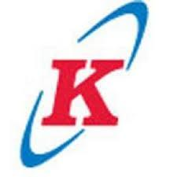 | Kicks Karate | Karate Birthday Party for up to 30 Guests  http://kickskarate.com/  75 Minute fun-filled karate party for your child and up to 30 guests. Special invitations and goody bags filled with a variety of gifts. One hour of exciting karate games. Birthday child is a Black Belt for the day and receives a special gift.  All parties are held on Saturday afternoons between 1-3 pm at all locations. Expires March 2018 | $299  Fair Market Value  $75  Opening Bid  $20  Increments
 | 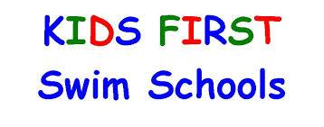 | Kids First Swim School | Splash Birthday Party  http://kidsfirstswimschools.com/  * Enjoy 1 hour in a private swimming pool and 1 hour in the party room | $250  Fair Market Value  $60  Opening Bid  $20  Increments
 |  | Kang’s Black Belt Academy | Karate Birthday Party for up to 20 children  Includes 45 minutes of high-energy karate instruction plus games, demonstrations & more.  For children 3 and up  Must be redeemed by 07/31/19 | $299  Fair Market Value  $75  Opening Bid  $20  Increments
 |  | Dynamite Gymnastics Center | $100 Gift Card towards Birthday Party  at one of four locations (Dynamite Gymnastics Center, The Agility Center, Bolt or Dynamite 2)  Expires 12/31/2019 | $100  Fair Market Value  $25  Opening Bid  $10  Increments

Family Entertainment
C12 |  | Blue Mercury | Party for Six  You and five friends will enjoy a private master class with an artist from one of their premier makeup brands.  Includes Regional Makeup artist, refreshments and free gifts  Bluemercury at Pike and Rose | $1,000  Fair Market Value  $150  Opening Bid  $25  Increments
C11 | 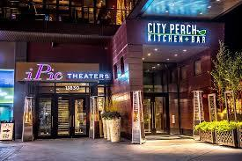 | City Perch  &  iPic Theater | $50 Gift Card to City Perch and 2 Movie Tickets  Enjoy the dinner at City Perch and head over to iPic theater – perfect for a date night! | $82  Fair Market Value  $20  Opening Bid  $5  Increments
C01 | 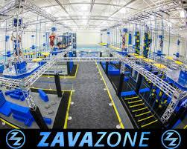 | Zava Zone | 4 x One Hour General Admission to Zava Zone  www.zavazone.com  ZAVAZONE is a multi-attraction indoor adventure park which includes trampolines, rope & zip lines, ninja warrior course & much more. | $78  Fair Market Value  $20  Opening Bid  $5  Increments
C13 |  | Badlands | Admission to Nerf Night  This package includes two adult admissions and four child admissions for any Nerf Night by Badland event.  Expires 06/30/2019 | $100  Fair Market Value  $25  Opening Bid  $5  Increments

C07 |  | Paint Muse | $70 Gift Card  https://www.musepaintbar.com/  Muse Paintbar combines a restaurant & bar with painting instruction sessions. We'll guide you step-by-step through a painting, offering eats, wine, & beer to keep your inner artist inspired (you do have one, we promise). When we're done, your masterpiece is yours to keep!  Conveniently located at the Rio Washingtonian Center.  For use with public sessions only (no private parties). | $70  Fair Market Value  $15  Opening Bid  $5 Increments
C04 |  | Strathmore | 2 Tickets for performances presented by Strathmore  www.strathmore.org  High quality arts programming, designed for audiences of many tastes, served with the hospitality and warmth of a family enterprise, are the hallmarks of Strathmore. Artistic offerings presented by Strathmore in the Music Center include world-class performances by major international artists of folk, rock, blues, pop, R&B, jazz, world music, show tunes, dance, and classical music.  Expires 2/23/2020  Strathmore Presents performances only. | $100  Fair Market Value  $25  Opening Bid  $5  Increments
C06 |  | Round House Theatre | 2 Tickets to Oslo  www.roundhousetheatre.org  Valid for any Tuesday – Friday evening or Saturday matinee performance of Oslo at Round House Theatre in Bethesda.  04/24/19 – 05/19/19 | $110  Fair Market Value  $30  Opening Bid  $5  Increments
C10 |  | Earth Treks | 2 Climbing Passes to Earth Treks  https://www.earthtreksclimbing.com  Earth Treks Climbing Centers, indoor climbing gyms in Maryland, DC, Virginia and Colorado, offer the best-designed climbing terrain for all ability levels & activities for kids & adults. Join our community of lifelong adventurers today!  Two (2) climbing passes, which are redeemable at any of their locations. Each pass may be used for either two Open Climbs or two Day Passes (experience required) | $120  Fair Market Value  $30  Opening Bid  $5  Increments
C14 |  | Anytime Fitness | 30 - day Membership & 1 Personal Training  Our encouraging personal fitness coaches & group classes will help you along your fitness journey - from any starting point. Membership includes a free, no-pressure fitness consultation, global access to more than 4,000 gyms, & 24/7/365 convenience. | $209  Fair Market Value  $55  Opening Bid  $10  Increments
C09 |  | Jazzercise | One Month Unlimited Jazzercise Classes at Jazzercise Bethesda (Top 2 bidders win!)  Jazzercise is the original dance party workout. Blending dance with Pilates, yoga, kickboxing and strength training, one 55-minute session can burn up to 800 calories. The results? Long, lean muscles and an undeniable mood boost! | $59  Fair Market Value  $15  Opening Bid  $5  Increment
C08 | 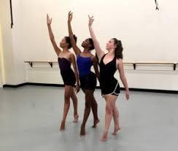 | Maryland Youth Ballet | 10 Drop in Classes for Adult  The MYB adult program, spanning levels from basic beginner through advanced, enjoys the same faculty as the children’s program, offering our adults the finest teachers of ballet, stretch, and classical core conditioning in the region. | $185  Fair Market Value  $50  Opening Bid  $10  Increments
C05 |  | Spicy Seed Art Studio | 5 x $ 20 Coupons for Henna Artwork  - Up to 5 henna design pattern on same or different individuals  - Each coupon entitles the person to get free henna artwork done by me  - Size of design will vary to the size of the hand/palm  - Allergy caution: Not to be used by individuals with any allergies  - Total value of the 5 coupons at maximum rate of $20.00 = $100.00 | $100  Fair Market Value  $25  Opening Bid  $5  Increments
C02 |  | Thrive Yoga | 10 Class Pass to Thrive Yoga  Thrive Yoga offers classes, trainings, everyday practices and once in a lifetime retreats. Our varied menu of physical classes, paradigm-shifting events and inspired community of students, teachers and leaders is designed for you to grow and feel fit and alive. Thrive is experienced in offering high-quality programs with experienced teachers in a tranquil environment. | $175  Fair Market Value  $60  Opening Bid  $20  Increments

Classes for Kids
E08 | 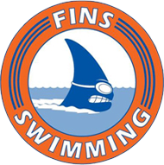 | Fins Swimming | 2 Private Swim Lessons from Fins  http://www.finsswimming.com/  Lessons from September to May take place at the Georgetown Prep Pool on Saturdays from 12:30pm to 4:30pm.  Lessons during the summer months take place at Old Farm pool on weekdays and weekends at most anytime!  Valid through 08/31/2019 | $90  Fair Market Value  $30  Opening Bid  $5  Increments
E02 | 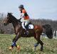 | Reddemeade Equestrian Center | One month of group riding lessons  www.reddemeade.com  You don’t have to own a horse to experience the fun, outdoor adventure and healthful exercise of horseback riding. Year-round lessons for all ages. Well-trained, safe horses. Low staff/student ratio. Located in Silver Spring/Ashton, MD  1 group lesson per week for 4 weeks. Each lesson is 1 hour long. | $295  Fair Market Value  $65  Opening Bid  $20  Increments
E05 |  | Mathnasium | One Month (8 Classes) at Mathnasium  http://www.mathnasium.com/northbethesda  When math makes sense, kids leap way ahead – whether they started out far behind or already ahead in math. Our formula for teaching kids math, the Mathnasium Method™ has transformed the way kids learn math for over a decade across 700+ centers in the US and Canada.  We pinpoint your child’s learning needs, meet them where they are, and take them where they need to go. Mathnasium instructors use our unique assessment process to determine (with great accuracy) exactly what each child knows and what they need to learn. Next, we design a customized learning plan for teaching the concepts the student needs to master. It doesn’t stop there – our encouraging instructors continually check progress along the way to make sure kids truly understand and retain the concepts we’ve taught. The results are transformative – kids will see measurable changes in attitude, confidence, and school progress. | $489  Fair Market Value  $150  Opening Bid  $20  Increments
E01 |  | Tollefson Swimming | 1 Session of Swimming Lessons  http://tollefsonswimming.com/  One 10-week session of swim classes for 1 swimmer during our Spring 2019, Fall 2019 or Winter 2019-20 session at Georgetown Prep. | $510  Fair Market Value  $125  Opening Bid  $20  Increments
E07 |  | FLEX Academy | $250 Gift Certificate  www.gpespta.org/before after school  Enjoy a class of your choice right here at GPES before or after school from FLEX Academy.  Must be used during the 2019-20 school year. Spring session will be available. | $250  Fair Market Value  $60  Opening Bid  $20  Increments
E11 |  | ArtWorks Fine Art Studio | One Month of Art Classes  https://artworksclasses.com/  Artworks Fine Art Studio is dedicated to teaching  drawing and painting to all ages.  Located at 7740 Old Georgetown Road, Bethesda, MD, 20814. Valid for one month of art classes for 4 consecutive weeks for one new student ages 5 to adult. Classes meet once per week and focus on drawing and pastels. | $147  Fair Market Value  $30  Opening Bid  $10  Increments
E06 |  | Lessons in Your Home | $100 Credit towards Home Music Lessons  At Lessons In Your Home, we know your time is valuable so we strive to help you fit music lessons into your busy lifestyle. Since we come to you, in the relaxed atmosphere of your home or school, you focus on your lesson and learning music and we’ll take care of everything else!  No matter if it is piano, guitar, violin, drums, voice or any other instrument from our wide offering, we will get you started right, keep you motivated to learn and celebrate your musical accomplishments with you. | $100  Fair Market Value  $25  Opening Bid  $10  Increments
E03  E04 |  | Montgomery Sports Association | One Full Soccer Clinic ($125)  One Full Basketball Clinic ($125)  MSA is a non-profit organization that runs sports clinics, fine art enrichments, camps and leagues throughout Maryland, Virginia and the Washington D.C. Metropolitan area.  MSA is known for improving each athletes skills and tremendously enhancing their ability to perform newly acquired skills while having FUN! | $125 Each  Fair Market Value  $30  Opening Bid  $10  Increments
E10 |  | Ballet Petite | $50 Gift Card towards Any Classes  Illustrated Book “My Magical Morning” included  Put on your tiara and be a part of this fun, fantasy filled class for your little princess. | $50  Fair Market Value  $15  Opening Bid  $5  Increments

Special Services
A08 | 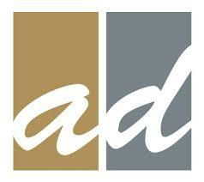 | Anderson Davis Photography | Family Portrait Session with Digital Image  We founded this company based on a need in the portrait photography industry. In today's world, photographs are staged, cold, and unrealistic. We wanted to build a company that would join you on your events, be it the pumpkin patch or ice skating, to capture the moments of your real life.  We aspire to become your trusted photographer throughout your life's experiences | $300  Fair Market Value  $75  Opening Bid  $10  Increments
A06 | 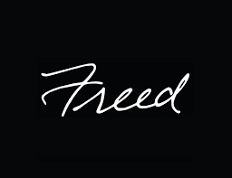 | Freed Photography | Family Portrait Session with 8 x 10  (Top 2 Bidders win)  Our award winning photographers are supported by a skilled staff who can assist you with portfolio review, photographer selection, scheduling, album selection, and the myriad other details that accompany special events. | $375  Fair Market Value  $75  Opening Bid  $10  Increments
A05 |  | iKona Photography | Photo Session and 8x10 (top 2 bids win)  www.ikonaphotography.com/  Ikona Photography is a boutique photography studio located in Olney, MD. We focus on baby, children, family photography, seniors and model photography, wedding and Bar/Bat Mitzvah photography. | $290  Fair Market Value  $75  Opening Bid  $10  Increments
A01 | 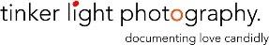 | Tinker Light Photography | 20 Minute Photo Session  Any location within 15 miles of Bethesda, MD  Includes curated high resolution digital photos. | $300  Fair Market Value  $75  Opening Bid  $10 Increments
A02 |  | PR Partners  Pike and Rose | One Haircut Party | $350  Fair Market Value  $85  Opening Bid  $20 Increments
A03 |  | PR Partners  Pike and Rose | One Color Service | $85  Fair Market Value  $20  Opening Bid  $5 Increments
A04 |  | Nanno | $100 Gift Certificate for Babysitting Service (2 top bidders win!)  We pride ourselves on connecting you with only the best sitters — and we stand by that. That’s why we created the Nanno Guarantee.  Happy sitters who feel valued and respected are essential for making sure kids are well cared for. Our core values reflect that (and more). | $100  Fair Market Value  $25  Opening Bid  $5  Increments
A07 | 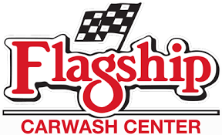 | Flagship Carwash | Flagship Full Service Ultimate Wash (top 2 bidders win)  Includes Brushless Wash, Underwash, Poly Gloss, Wheel Brightener, Tire Protectant, Interior Vacuum, Windows Cleaned and Complete Towel Wipe Down | $22.50  Fair Market Value  $10  Opening Bid  $2  Increments
Special Goods
A15 |  | Regal Cinema | $50 Gift Card | $50  Fair Market Value  $15  Opening Bid  $5 Increments
A20 | 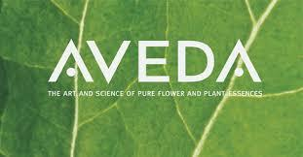 | Aveda | $100 Gift Card | $100  Fair Market Value  $25 Opening Bid  $5 Increments
A11 |  | Washington Redskins | Limited Edition 2019 Team Signed Laser Football  http://www.redskins.com/ | $100  Fair Market Value  $25 Opening Bid  $5 Increments
A12 |  | Washington Nationals | Autographed Dave Martinez Baseball  http://washington.nationals.mlb.com/ | $150  Fair Market Value  $25  Opening Bid  $10  Increments
A10 |  | Washington Wizards | Autographed Markieff Morris Photograph  www.nba.com/wizards/ | $25  Fair Market Value  $5 Opening Bid  $2 Increments
A13 |  | Trader Joe’s | Trader Joe’s Basket | $36  Fair Market Value  $10 Opening Bid  $5 Increments
A17 | 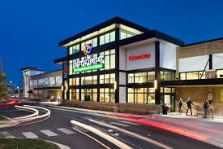 | Harris Teeter | $30 Gift Card | $30  Fair Market Value  $15 Opening Bid  $2 Increments
A19 |  | Baltimore Orioles | Baltimore Orioles Autographed Photo of Dylan Bundy | $15  Fair Market Value  $5  Opening Bid  $2  Increments

Teacher Treasures – All teacher treasurer items start at $10 with an increment of $5

Grade | Teacher | Item Name | Item Description
Media | Mrs. Marsden and Moyer | Box of Books | box of books
Counselors | Mrs. Kemp | Pizza Lunch “Out” with the Counselors | Winner plus 1 friend is invited to enjoy a lunch with the Counselors
Counselors | Mrs. Karbeling | Pizza Lunch “Out” with the Counselors | Winner plus 1 friend is invited to enjoy a lunch with the Counselors
4th Grade | Mrs. Ahearn | Pizza Lunch with Teacher | Pizza lunch and popsicles for the winner and 1 friend.
4th Grade | Mrs. Leon | Pizza Lunch with Teacher | Pizza lunch and popsicles for the winner and 1 friend.
4th Grade | Mrs. Russ | Pizza Lunch with Teacher | Pizza lunch and popsicles for the winner and 1 friend.
4th Grade | Mrs. Trubic | Pizza Lunch with Teacher | Pizza lunch and popsicles for the winner and 1 friend.
4th Grade | Mrs. Ziegler | Pizza Lunch with Teacher | Pizza lunch and popsicles for the winner and 1 friend.
Healthroom | Ms. White | Lunch with Mrs. White | Lunch with Mrs. White
Reading | Mrs. Nguyen | Pizza and Ice Cream Lunch with Teacher | Pizza and Ice cream lunch for student plus 1 friend.
ESOL | Mrs. Herstein | Pizza and Ice Cream Lunch with Teacher | Pizza and Ice cream lunch for student plus 1 friend.
Kindergarten | Ms. Bley | Pizza and Ice Cream Lunch with Teacher | Kindergarten student winner plus 1 friend is invited to enjoy a pizza lunch and ice cream dessert during lunch and recess with teacher.
Kindergarten | Mrs. Hardwick | Pizza and Ice Cream Lunch with Teacher | Kindergarten student winner plus 1 friend is invited to enjoy a pizza lunch and ice cream dessert during lunch and recess with teacher.
Kindergarten | Mrs. Switzer | Pizza and Ice Cream Lunch with Teacher | Kindergarten student winner plus 1 friend is invited to enjoy a pizza lunch and ice cream dessert during lunch and recess with teacher.
3rd Grade | Mrs. Fanning | Ice Cream Sundae Party | 1 Student plus 1 friend will enjoy a ice cream with yummy sundae toppings after lunch with teacher.
3rd Grade | Ms. Frank | Ice Cream Sundae Party | 2 Student plus 1 friend will enjoy a ice cream with yummy sundae toppings after lunch with teacher.
3rd Grade | Mrs. Cruz | Ice Cream Sundae Party | 3 Student plus 1 friend will enjoy a ice cream with yummy sundae toppings after lunch with teacher.
3rd Grade | Ms. Morici | Ice Cream Sundae Party | 4 Student plus 1 friend will enjoy a ice cream with yummy sundae toppings after lunch with teacher.
3rd Grade | Ms. Yoon | Ice Cream Sundae Party | 5 Student plus 1 friend will enjoy a ice cream with yummy sundae toppings after lunch with teacher.
3rd Grade | Ms. Mongia | After School Movie with Teacher and Friends | 1 Student plus 5 lucky friends will watch movie in Ms. Mongia's room after school. Includes popcorn, pizza and drinks.
5th Grade | Mr. Vogel | Trip to Barnes and Noble With Teacher + Book and Ice Cream | 1 winner, plus 1 friend will take a trip to Barnes and Noble with 5th grade teacher and select a book (value of $10 or less). Then, the winner and a friend will travel to SweetFrog, where they will enjoy frozen yogurt together.
5th Grade | Ms. Gallagher | Trip to Barnes and Noble With Teacher + Book and Ice Cream | 2 winner, plus 1 friend will take a trip to Barnes and Noble with 5th grade teacher and select a book (value of $10 or less). Then, the winner and a friend will travel to SweetFrog, where they will enjoy frozen yogurt together.
5th Grade | Mr. Frazier | Trip to Barnes and Noble With Teacher + Book and Ice Cream | 3 winner, plus 1 friend will take a trip to Barnes and Noble with 5th grade teacher and select a book (value of $10 or less). Then, the winner and a friend will travel to SweetFrog, where they will enjoy frozen yogurt together.
5th Grade | Ms. Goncalves | Trip to Barnes and Noble With Teacher + Book and Ice Cream | 4 winner, plus 1 friend will take a trip to Barnes and Noble with 5th grade teacher and select a book (value of $10 or less). Then, the winner and a friend will travel to SweetFrog, where they will enjoy frozen yogurt together.
5th Grade | Ms. Mueller | Trip to Barnes and Noble With Teacher + Book and Ice Cream | 5 winner, plus 1 friend will take a trip to Barnes and Noble with 5th grade teacher and select a book (value of $10 or less). Then, the winner and a friend will travel to SweetFrog, where they will enjoy frozen yogurt together.
2nd Grade | Mrs. Krieger | Pizza and Ice Cream Lunch Bunch | Winner plus 1 friend is invited to enjoy a pizza lunch with the 2nd grade teachers and ice cream for dessert!! Must be redeemed by June 1, 2019.
2nd Grade | Mrs. Fanning | Pizza and Ice Cream Lunch Bunch | Winner plus 1 friend is invited to enjoy a pizza lunch with the 2nd grade teachers and ice cream for dessert!! Must be redeemed by June 1, 2019.
2nd Grade | Mrs. Kolb | Pizza and Ice Cream Lunch Bunch | Winner plus 1 friend is invited to enjoy a pizza lunch with the 2nd grade teachers and ice cream for dessert!! Must be redeemed by June 1, 2019.
2nd Grade | Mrs. Reese | Pizza and Ice Cream Lunch Bunch | Winner plus 1 friend is invited to enjoy a pizza lunch with the 2nd grade teachers and ice cream for dessert!! Must be redeemed by June 1, 2019.
2nd Grade | Mrs. Lucas | Pizza and Ice Cream Lunch Bunch | Winner plus 1 friend is invited to enjoy a pizza lunch with the 2nd grade teachers and ice cream for dessert!! Must be redeemed by June 1, 2019.
2nd Grade | Mrs. Martin | Pizza and Ice Cream Lunch Bunch | Winner plus 1 friend is invited to enjoy a pizza lunch with the 2nd grade teachers and ice cream for dessert!! Must be redeemed by June 1, 2019.
2nd Grade | Mrs. George | Pizza and Ice Cream Lunch Bunch | Winner plus 1 friend is invited to enjoy a pizza lunch with the 2nd grade teachers and ice cream for dessert!! Must be redeemed by June 1, 2019.

