Name: ______________________________ Grade: ________________
A SECRET EMOJI CODE
Find out your teacher’s message for you by using the secret code below. Write the letter on the top of each emoji.
A | B | C | D | E | F | G | H | I | J | K | L | M
 |  |  |  |  |  |  |  |  |  |  |  | 

N | O | P | Q | R | S | T | U | V | W | X | Y | Z
 |  |  |  |  |  |  |  |  |  |  |  | 

___ | ___ | ___ | ___ | ___ | ___ | ___ |  | ___ | ___ | ___ | ___ |  | ___ | ___ |  | ___ | ___
 |  |  |  |  |  |  |  |  |  |  |  | ! | ’

___ | ___ | ___ | ___ | ___ |  | ___ | ___ |  | ___ | ___ | ___ | ___ |  | ___ | ___ | ___

___ | ___ |  | ___ | ___ |  | ___ | ___ | ___ | ___ | ___ |  | ___ |  | ___ | ___ | ___ | ___
 |  |  |  |  |  |  |  |  |  |  | .

___ | ___ | ___ | ___ | ___ | ___ | ___ |  | ___ | ___ |  | ___ | ___ | ___ |  | ___ | ___ | ___
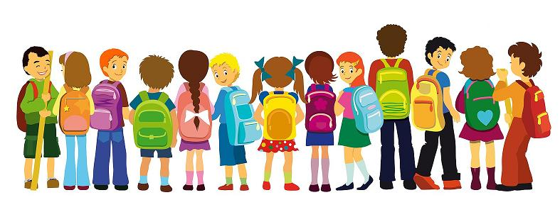
___ | ___ | ___ |  | ___ | ___ |  | ___ | ___ | ___ | ___ |  | ___ | ___ | ___ | ___
 |  |  |  |  |  |  |  |  |  |  |  |  |  |  |  | .

Name: ______________________________ Grade: ________________
A SECRET EMOJI CODE
Find out your teacher’s message for you by using the secret code below. Write the letter on the top of each emoji.

___ | ___ | ___ | ___ | ___ | ___ | ___ |  | ___ | ___ | ___ | ___ |  | ___ | ___ |  | ___ | ___
 |  |  |  |  |  |  |  |  |  |  |  | ! | ’

___ | ___ | ___ | ___ | ___ |  | ___ | ___ |  | ___ | ___ | ___ | ___ |  | ___ | ___ | ___

___ | ___ |  | ___ | ___ |  | ___ | ___ | ___ | ___ | ___ |  | ___ |  | ___ | ___ | ___ | ___
 |  |  |  |  |  |  |  |  |  |  | .

___ | ___ | ___ | ___ | ___ | ___ | ___ |  | ___ | ___ |  | ___ | ___ | ___ |  | ___ | ___ | ___
___ | ___ | ___ |  | ___ | ___ |  | ___ | ___ | ___ | ___ |  | ___ | ___ | ___ | ___
 |  |  |  |  |  |  |  |  |  |  |  |  |  |  |  | .

Name: ______________________________ Grade: ________________
A SECRET EMOJI CODE
Find out your teacher’s message for you by using the secret code below. Write the letter on the top of each emoji.
A | B | C | D | E | F | G | H | I | J | K | L | M

N | O | P | Q | R | S | T | U | V | W | X | Y | Z

W | E | L | C | O | M | E |  | B | A | C | K! |  | I’ | M |  | S | O
 |  |  |  |  |  |  |  |  |  |  | ! |  | ’

H | A | P | P | Y |  | T | O |  | H | A | V | E |  | Y | O | U

I | N |  | M | Y |  | C | L | A | S | S. |  | I |  | L | O | O | K
 |  |  |  |  |  |  |  |  |  | .

F | O | R | W | A | R | D |  | T | O |  | A | L | L |  | T | H | E

F | U | N |  | W | E |  | W | I | L | L |  | H | A | V | E.
 |  |  |  |  |  |  |  |  |  |  |  |  |  |  | .

Welcome back! I’m so happy to have you in my class. I look forward to all the fun we will have.

Name: ______________________________ Grade: ________________
A SECRET EMOJI CODE
Find out your teacher’s message for you by using the secret code below. Write the letter on the top of each emoji.

___ | ___ | ___ | ___ | ___ | ___ | ___ |  | ___ | ___ | ___ | ___ |  | ___ | ___ |  | ___ | ___
 |  |  |  |  |  |  |  |  |  |  |  | ! | ’

___ | ___ | ___ | ___ | ___ |  | ___ | ___ |  | ___ | ___ | ___ | ___ |  | ___ | ___ | ___

___ | ___ |  | ___ | ___ |  | ___ | ___ | ___ | ___ | ___ |  | ___ |  | ___ | ___ | ___ | ___
 |  |  |  |  |  |  |  |  |  |  | .

___ | ___ | ___ | ___ | ___ | ___ | ___ |  | ___ | ___ |  | ___ | ___ | ___ |  | ___ | ___ | ___
___ | ___ | ___ |  | ___ | ___ |  | ___ | ___ | ___ | ___ |  | ___ | ___ | ___ | ___
 |  |  |  |  |  |  |  |  |  |  |  |  |  |  |  | .

Name: ______________________________ Grade: ________________
A SECRET EMOJI CODE
Find out your teacher’s message for you by using the secret code below. Write the letter on the top of each emoji.

___ | ___ | ___ | ___ | ___ | ___ | ___ |  | ___ | ___ | ___ | ___ |  | ___ | ___ |  | ___ | ___
 |  |  |  |  |  |  |  |  |  |  |  | ! | ’

___ | ___ | ___ | ___ | ___ |  | ___ | ___ |  | ___ | ___ | ___ | ___ |  | ___ | ___ | ___

___ | ___ |  | ___ | ___ |  | ___ | ___ | ___ | ___ | ___ |  | ___ |  | ___ | ___ | ___ | ___
 |  |  |  |  |  |  |  |  |  |  | .

___ | ___ | ___ | ___ | ___ | ___ | ___ |  | ___ | ___ |  | ___ | ___ | ___ |  | ___ | ___ | ___
___ | ___ | ___ |  | ___ | ___ |  | ___ | ___ | ___ | ___ |  | ___ | ___ | ___ | ___
 |  |  |  |  |  |  |  |  |  |  |  |  |  |  |  | .

