Name _____________________ Surname ______________ Class 7a

1. The place where the hotel is located.
Romania, Transylvania, Pennsylvania

2. Write sentences using the table and verbs.
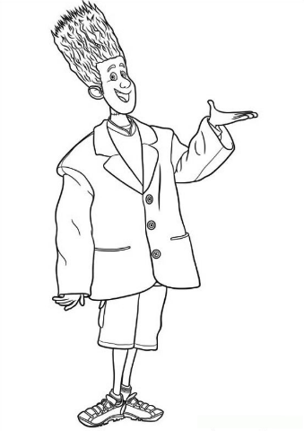
forgive , fly, afraid, walk, have
 | people | night | offense | day | smartphone
Often |  | X
Sometimes | X
Rarely |  |  |  | X
Never |  |  | X
Always |  |  |  |  | X

Example: Zombies always have a smartphone
1. I _______________________________________________________________
2. Mavis___________________________________________________________
3. Monster__________________________________________________________
4. Monsters_________________________________________________________

3. Write the translation:
Монстр не боится темноты.
Лучшее место отдыха – это детский лагерь.
Мы едем в Калифорнию сейчас.
Свет луны лучше чем свет солнца.
Лучный друг Денниса это Винни.
В отеле «Трансильвания» 1250 комнат.

4. Who is who?
Mummy, Jonny, Wolf, Dracula, Frankenstein, The invisible Man
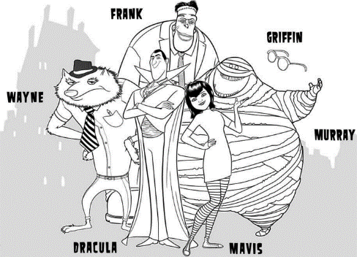
He is strong, charismatic, and able to bend the will of anyone. ________________
He is confident, cheerful, curious, friendly traveler with a backpack ________________
He's not like all of the other monster is a giant with a huge heart ________________
He is wrapped in a huge bandage smiley ________________

