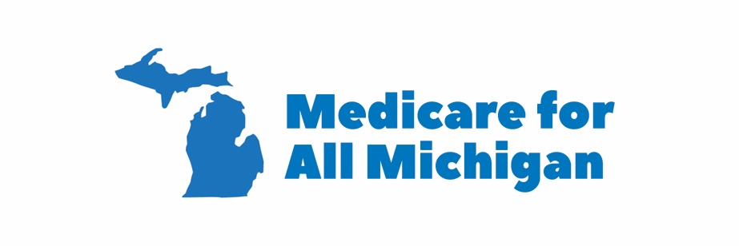
WHO ARE WE?
Medicare for All Michigan is a coalition of grassroots groups, concerned citizens, unions and others throughout the state who are organizing to fight for Improved Medicare for All, both at the state and the federal level.

WHAT GROUPS DO WE REPRESENT?
- Michigan United is coordinating the coalition. Other groups include:
- MICHUHCAN
- Indivisible
- Michigan for Revolution
- Our Revolution Michigan
- Michigan Nurses Association
- Progressive Democrats of America
- Physicians for a National Health Plan
- Democratic Socialists of America
- Michigan Democratic Party Disability Caucus
- Women’s March Michigan
- A number of smaller unaffiliated groups, individuals, and politicians/political candidates

WHERE ARE WE LOCATED?
We have groups active in: Washtenaw County, Detroit, Downriver, Oakland County, Lansing, Mt. Pleasant/Midland, Traverse City, Muskegon, Grand Rapids, Kalamazoo/Battle Creek, and Jackson.

WHAT DO WE WANT?
To have Improved Medicare for All passed at the national level, and if not, then at the state level. To that end, we want every candidate for state and federal office to support and champion Improved Medicare for All.

WHAT DO WE DO?
Medicare for All Michigan organizes education and public awareness on the benefits of Medicare for All through town halls, canvassing, film screenings, letters to the editor, and other means. Medicare for All Michigan also is developing a base of citizen activists who can be mobilized to make their voice heard when and where necessary to influence decision makers.

Visit us on the web:
www.medicareforallmichigan.org
Facebook: https://www.facebook.com/Medicare4AllMI/
Twitter: @Medicare4AllMI
Email: Medicare4AllMichigan@gmail.com

