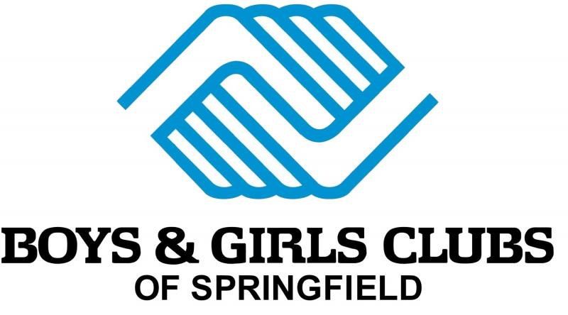
Sertoma Unit Parent Club Council Handbook
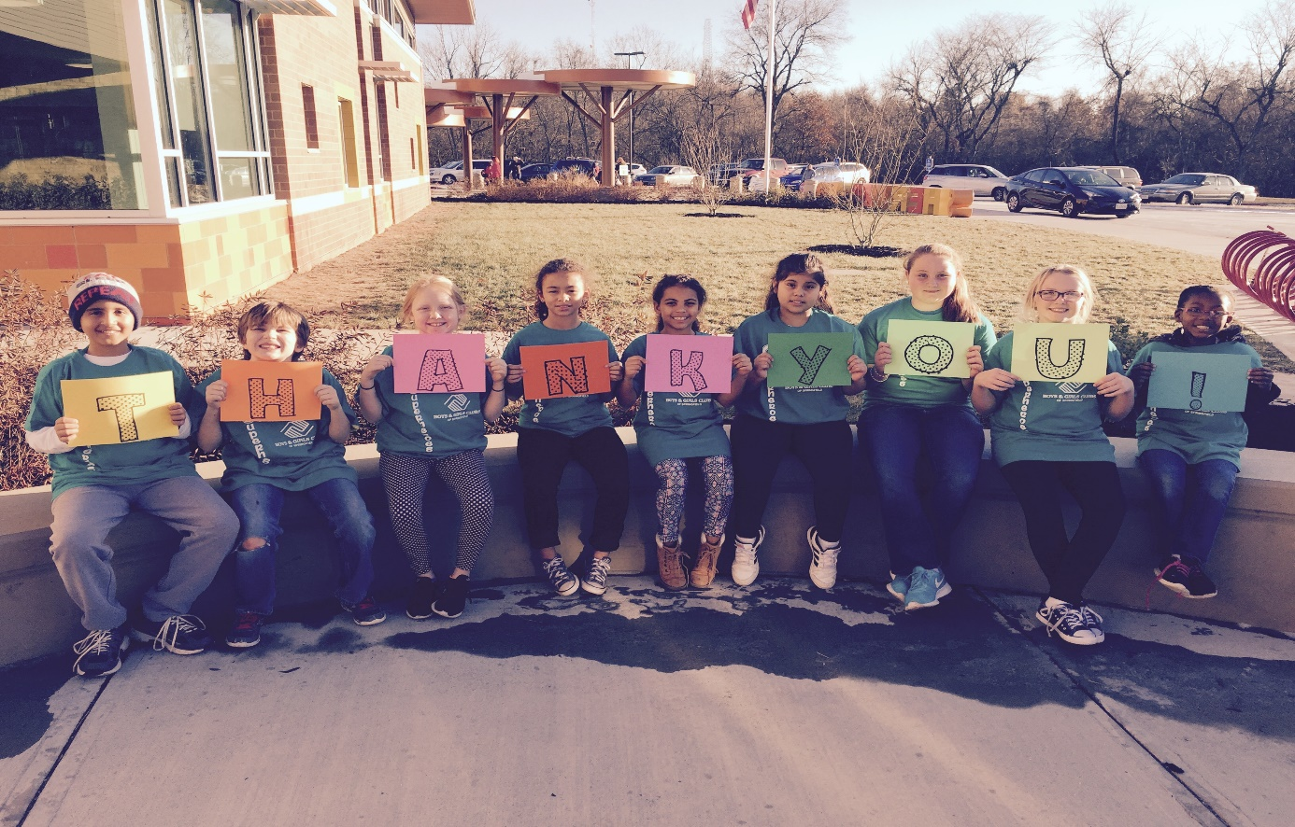
Boys & Girls Clubs of Springfield-Sertoma Unit Parent Club Council By-Laws
Section I. Purpose
The purpose or purposes of the Boys & Girls Clubs-Sertoma Unit of Springfield Parent Club Council is:
- To promote the welfare of members of the Boys & Girls Clubs of Springfield-Sertoma Unit,
- To serve as an advocate for members in need,
- To advocate for laws that further the academic success, good character & citizenship, and healthy lifestyles of our members,
- To ensure the physical and emotional safety of all members,
- To promote the collaboration and engagement of families and Club staff,
- To engage the public in united efforts to secure the physical, mental, emotional, spiritual, and social well-being of all members and,
- To advocate for fiscal responsibility regarding public tax dollars in public education and after-school funding.
Section II. Membership
- Membership in Boys & Girls Clubs-Sertoma Unit of Springfield Parent Club Council at all levels shall be open, without discrimination, to anyone who believes in and supports the mission, purposes outlined above,
- Membership in Boys & Girls Clubs-Sertoma Unit of Springfield Parent Club Council is free, however members are expected and encouraged to help provide resources, donations, monetary assistance, time, etc. as needed and when available.
- It is the expectation that all Parent Club Council members attend the meetings outlined and determined by the Club Director. These meetings will occur four times during the school year and additional communication via email, text, or phone may occur as needed.
Section III. Officers and Elections
- The officer of the Boys & Girls Clubs-Sertoma Unit of Springfield Parent Club Council shall be President.
- The President will be appointed by a general election and the candidate with the majority of votes will be named President.
- In the event of a vacancy or removal of position because duties are not being upheld, a new election will take place.
- Each term will last one Club school year (August-May) with elections occurring in August.
- The President shall serve as the point person for the Council. He or she will be responsible for relaying information from Club Directors to the Council, helping lead meetings, promoting events, and other duties as outlined by Club Directors.
Section IV. Amendments
- If anything needs to be added, deleted, or changed in the by-laws above, Club Directors and the Parent Council President will submit those edits to the Council. Said changes will occur with a majority vote. The Club Director also has a right to make changes, without a vote, based on the assurance Club members are being served effectively.

Boys & Girls Clubs of Springfield -Sertoma Unit Parent Council Member Information Sheet
Name:
Email Address:
Cell Phone Number:
Address:
Member Name(s):
Birthday:
Favorite Color:
Favorite Animal:
Favorite Snack:
Favorite Drink:
Favorite Restaurant in Springfield:
Favorite TV Show:
Favorite Movie:
Favorite Thing about Sertoma:
Favorite Book:
Favorite Sports Team:
Favorite Band/Singer:
Hobbies:
Things you collect:
Anything you’d like to add:
*Please download the GroupMe app for our messaging services! It is free, convenient, and easy!
Boys & Girls Clubs of Springfield-Sertoma Unit Parent Council Member Big Event Sheet
September 2017 | 8- Back to School Bash at Sertoma  11-Patriot’s Day Events  16-Day for Kids/ Partners in Education Walk  30-Oktoberfest Ride for Kids
October 2017 | 13-Triple Play National Fitness Competition  20-Corn Maze Field Trip  26-Lights on After School  27- Halloween Parties
November 2017 | 8-National STEM Day  10-Veteran’s Day Activities & National Heritage Day (4:00)  17-Thanksgiving Dinners (Clubs Closed After-School)  17-Fine Arts Exhibit at Clubs  20-24-National Family Week  Non-Celebrity Waiter  Wingapalooza
December 2017 | 5- Christmas to Remember  7-Fine Arts Finalists Due  11-15-Fall Basketball Tournament  22-Christmas Dinners (Clubs Closed)
January 2018 | 15-MLK Day of Service
February 2018 | 1-Summer Registration Begins  19-Fashion Show Shopping  19-23-Engineering Week  23-24-Sertoma Chili Cook-Off  Black History Month Celebrations
March  2018 | 2-Dr. Seuss Day Activities  9-FashionLEADstas Fashion Show  12-16 Spring Break: Club Open 7:30am-5:30pm  16-Games Room Festival  31-Winter Basketball Season Ends  NYOI Surveys Begin  Women’s History Month Celebrations
April  2018 | 9-13-BGC Week  15-World Arts Day  20-Child Abuse Awareness Event  28-Triple Play National Fitness Competition  Fashion Forward Fashion Show  TouchDown Dinner  Steak & Steak Dinner  Cajun Cook Off
May  2018 | 11-Banquet of Champions @ Sertoma  11- Sertoma Closed After-School  Play FORE! The Kids Golf Tournament  Last Day of School Year Program  Cashew Craze
*Bolded is highest need
Boys & Girls Clubs of Springfield-Sertoma Unit Parent Council Member Recurring Needs List

Markers | Paper Towels
Crayons | Windex
Binders | Dodgeballs
Disinfecting Wipes | Sharpies
Bottled Water | Cardstock
New Movies (rated G/PG) | Kleenex
New Books (for ages 5-12) | Hand Sanitizer
Copy Paper | Cash for as needed items such as shorts, first aid replenishments, allowing members to go on field trips, basic needs, laminating sheets, school supply replenishments, etc.

Boys & Girls Clubs of Springfield-Sertoma Unit Parent Council Meeting Dates

- Orientation and Q & A: Friday, September 8th
- Meeting: Thursday, September 28th at 6:00pm
- Meeting: Thursday, November 9th at 6:00pm
- Meeting: Thursday, February 8th at 6:00pm
- Meeting: Thursday, April 5th at 6:00pm
Upcoming Help Needed

- Saturday, September 16th is Day for Kids at the Stalnaker Unit (10:00am-1410 N. Fremont)
- Saturday, September 30th is Oktoberfest Ride for Kids (Expo Center)
  - 8:00am Registration if riding-IT IS FREE FOR YOUR KIDDO! $35 for other riders.
  - Small group of leader members will be helping (invite only)
- Recurring gifts (bgclubspringfield.org)

