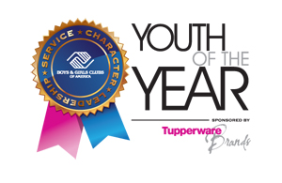

CALLING ALL PRE-TEENS
Junior Youth of the Year Program
What: Youth of the Year is the Boys & Girls Club premier recognition program for Club members, promoting service to the Club, community and family, academic success, strong moral character, life goals, and poise and public speaking ability.
Who: Current Pre-Teen members of the Boys & Girls Club of Springfield
When: ENTER DATE (See schedule for more details)
Where: ENTER LOCATION & ADDRESS
Why: To better prepare our youth for Youth of the Year and to expose potential candidates to the expectations and work required of the Youth of the Year program.
What do you Get: To represent your Club, to share with others about your Club experience, a certificate/award, a wonderful prize, a free summer membership, valuable experience, and more!
What to do now: Complete the Junior Youth of the Year Application and turn it in to ENTER PERSON before ENTER DATE. Be prepared to use all the knowledge you gained during your Junior Youth of Year program.

