

*​“Motivating and recognizing employees is vital to employee engagement and a healthy, fun work environment. A successful organization can generally trace its success to motivated and engaged employees. Recognizing employees for specific achievements or for ongoing contributions is an excellent way to let them know they are valued.”-Human Resources at the University of Colorado-Boulder*

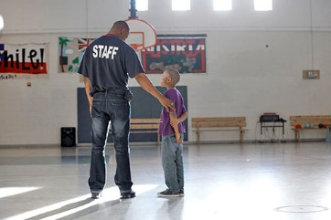

Program of the Month Distinction

Hello Youth Development Professional,

Your commitment and passion for the Boys & Girls Club is so much appreciated. In an attempt to increase recognition for your hard work and dedication to serving Springfield youth, I have developed a Program of the Month Distinction. This distinction is intended to highlight a premier program/club/event run by Boys & Girls Club Youth Development Professionals. We are looking for a program/club/event that:

1. Highlights one or more of the Boys & Girls Club’s Priority Outcomes.
2. Provides opportunity.
3. Increases member knowledge base.
4. Makes a difference.

Why is this an important program?

1. We have the opportunity to recognize Youth Development Professionals.
2. We have the opportunity to recognize quality programs/clubs/events.
3. This kind of recognition is an excellent resume builder.
4. This kind of recognition can help retain quality Youth Development Professionals.
5. This kind of recognition can give members and parents a better idea of what the Boys & Girls Club offers to members.

What do winning staff members gain?

1. Recognition for their hard work and dedication to the movement.
2. A program/club/event highlight spot in the Club hallway.
3. A program/club/event highlight spot on the website.
4. A program/club/event highlight in the Challenge Newsletter.
5. $10-$20 extra area budget to run the program/club.

**You may nominate a program, club, or event each month**. One winner per month will be recognized. Once applications are received, the Director of Programs and a team of anonymous judges will pick a winning program/club/event. **Applications are due the 1st Tuesday of each month by 11:59pm.** Please complete the attached application and turn it in with any additional necessary documents to your Program Director. He/She will be responsible for choosing the featured application and submitting the completed application to the Director of Programs. Only complete applications will be accepted. If you have any questions, please ask your Program Director or Ms. Brandy. Thank you so much for all of your hard work. I hope you understand how valuable you are to this organization!

Brandy Harris  
The Boys & Girls Clubs of Springfield  
Director of Programs   
Sertoma Unit Director   
417.523.3882 (direct line)  
417.523.3880 (main line)  
bharris@bgclubspringfield.org

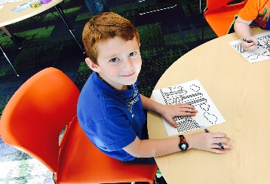

[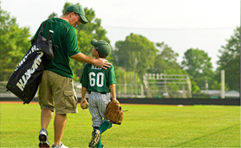](http://www.bgclubspringfield.org/programs/youth-baseball-program/)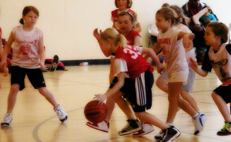[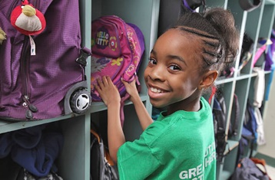](javascript:popThumbnail('https://images.printable.com/printonelogos/images/bgca_17840/GIRL_GETTING_BACKPACK_preview.JPG');)[](javascript:popThumbnail('https://images.printable.com/printonelogos/images/bgca_17840/BOY_PLAYING_POOL_preview.JPG');)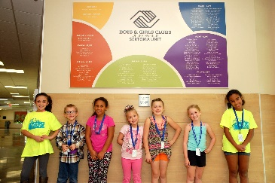



Program of the Month Application

Staff Name: ______________________________________________________________

Email Address: ____________________________________________________________

Phone Number: ___________________________________________________________

Program Area: ____________________________________________________________

Program Title: ____________________________________________________________

Program Mission: __________________________________________________________

***After completing this application, please include or attach any additional items you deem necessary. Pictures of your program are also welcomed and encouraged.***

Please provide an overview of your program/club/event. Include its purpose, daily activities, and main goals.

__________________________________________________________________________________________________________________________________________________________________________________________________________________________________________________________________________________________________________________________________________________________________________________________________________________________________________________

What is the impact of your program/club?

__________________________________________________________________________________________________________________________________________________________________________________________________________________________________________________________________________________________________________________________________________________________________________________________________________________________________________________



**

[](http://www.bgclubspringfield.org/programs/youth-baseball-program/)[](javascript:popThumbnail('https://images.printable.com/printonelogos/images/bgca_17840/GIRL_GETTING_BACKPACK_preview.JPG');)[](javascript:popThumbnail('https://images.printable.com/printonelogos/images/bgca_17840/BOY_PLAYING_POOL_preview.JPG');)



How do you ensure the success and impact of your program/club/event? (I.e. observation, pre and post-test, survey, etc.)

__________________________________________________________________________________________________________________________________________________________________________________________________________________________________________________________________________________________________________________________________________________________________________________________________________________________________________________

Please share a specific member success story regarding your program/club/event.

__________________________________________________________________________________________________________________________________________________________________________________________________________________________________________________________________________________________________________________________________________________________________________________________________________________________________________________

What priority outcome does your program/club/event highlight? How?

__________________________________________________________________________________________________________________________________________________________________________________________________________________________________________________________________________________________________________________________________________________________________________________________________________________________________________________

What materials and or resources are needed to take your program/club/event to the next level? Be specific.

______________________________________________________________________________________________________________________________________________________________________________________________________________________________________________________________________________________________________________________________________________________________________________________________________________________________________________________________________________



**

[](http://www.bgclubspringfield.org/programs/youth-baseball-program/)[](javascript:popThumbnail('https://images.printable.com/printonelogos/images/bgca_17840/GIRL_GETTING_BACKPACK_preview.JPG');)[](javascript:popThumbnail('https://images.printable.com/printonelogos/images/bgca_17840/BOY_PLAYING_POOL_preview.JPG');)